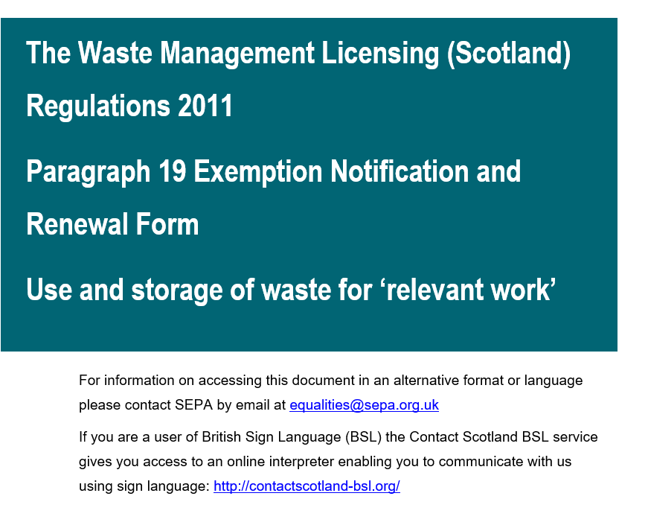

How we use your personal information
Under the Data Protection Act 2018 (DPA 2018), we must have a legal basis for processing your information – in this case, processing personal information is necessary to perform our statutory duties (‘Public Task’).
Some of the ways in which we collect and use the information may be through:
- granting and administering of authorisations and maintaining registers
- investigating environmental complaints
- undertaking formal enforcement action
- maintaining our own accounts and records
The personal information we collect, and use may include the following: name; address, including postcode; email address and telephone number. SEPA is required, by law, to organise and maintain public registers, and make these registers available for public inspection. We do this by collecting and using the personal information that notifiers (or their agents) share in their notifications for SEPA registrations. After the notification form has been processed, some of the information from the form is added to the public register and becomes available for public inspection. Signatures, personal email addresses, and telephone numbers are not published, unless publication is statutorily required.
There may be occasions when we are required by law to share your personal information with other organisations, e.g. for regulatory reasons, or because doing so is in the general public interest. Any sharing will be carried out lawfully and securely in accordance with the SEPA Data Protection Policy.
For more information on how SEPA handles personal information, please refer to our general Privacy Policy at https://www.sepa.org.uk/help/privacy-policy/

Waste for construction and other ‘relevant work’
SEPA registers the storage and use of specified wastes for the purposes of ‘relevant work’ under Paragraph 19 of Schedule 1 of The Waste Management Licensing (Scotland) Regulations 2011. This is the correct notification form if:
- You intend to use specified waste for the purpose of relevant work with or without associated storage of specified waste on the same site it is to be used.
‘Relevant work’ means the use of waste –
a) for the construction, maintenance or improvement of –
- a building, road, railway, airport, dock or other transport facility;
- recreational facilities; or
- drainage; or
b) for engineering works relating to or adjacent to any part of the water environment.
It does not include work involving land reclamation.
This notification form must be received by us at least 21 days before the activity begins or the expiry of the 12 months for renewals.
Please note that SEPA do not expect to receive Notifications for renewals more than 2 months before the renewal date.
We would strongly encourage you to use our ‘Guidance Document for notifying SEPA of a Waste Management Licensing (Scotland) Regulations 2011 Paragraph 19 Exempt Activity and the carrying out of that Activity’ to help complete this notification form. This guidance will provide further detail on the process and the terms used within this form.
You must have the permission of the landowner and ensure all necessary consents are in place before the activity takes place.

Notification Form Requirements:
To complete your notification form you must:
- complete the following relevant sections.
- submit a plan of the place where the exempt activity will be carried out clearly showing the boundary of the site and locations where the activity will be carried out and where any storage will take place.
- where more than 2,500 cubic metres of waste is used, submit cross-section plans showing the proposed levels.
- where clean shells are to be used, submit evidence to confirm the waste is treated in accordance with the Animal By-Products Regulations.
- where the notification is for a renewal of an activity where the volume of waste used is over 2,500m³, submit data returns.
- pay the appropriate fee.
Failure to provide all this information may result in your notification being refused.
1 - General Details

1.1 Location of Activity
Address:
National Grid Reference:
NGR Tool (sepa.org.uk)
A location plan must be provided showing the site boundary, locations of the exempt activity and, if applicable, where storage will take place.
Reference of attached document:
Where more than 2,500 m³ of waste is used, a cross-section plan showing the existing and the proposed final ground levels must be provided.
Reference of attached document (if required):
1.2 Contact details of who will be carrying out the activity:
Organisation Name:
Registered/Principal
Office Address:
Company Registration Number (if relevant):
Contact Name:
Phone:
Email:
1.3 Contact details of who SEPA can contact regarding this notification:
Name:
Organisation:
Address:
Phone:
Email:
2 - Type of Notification

2.1 What are you looking to do? (Please select one)
- Register the exempt activity for the first time |  | ☐
- Renew a current registration (renewals must be submitted at least 21 days prior to the expiration date) |  | ☐
Please state the existing exemption number:
Please state the expiration date of the current registration:
Proceed to Section 7 - Renewals
- Register an activity that was previously registered but is not currently |  | ☐
Please state the previous exemption number(s):
Please provide the reasons why the activity is no longer registered:

3 - The Relevant Activity

3.1 What is the ‘relevant work’ being carried out? (Please select one)
The construction, maintenance or improvement of a building, road, railway, airport, dock or other transport activity. | ☐
The construction, maintenance, or improvement of recreational facilities. | ☐
The construction, maintenance, or improvement of drainage. | ☐
Engineering works relating to or adjacent to any part of the water environment. | ☐

3.2 Describe the activity you wish to carry out in your own words
The description of the activity should also include:
- full justification of the tonnages of waste needed to complete the activity; and
- how the waste is suitable for the activity.
For activities over 2,500m³, a cross section plan and full justification of the depths proposed must also be provided.
(Additional sheets may be appended if required).

3.3 Will the activity involve land reclamation? (Please select one)
SEPA has published guidance on our interpretation of 'drainage' and 'land reclamation' relating to paragraph 19 activities. It outlines what activities will be acceptable for consideration as an exempt activity.
Yes ☐  The activity does not fall within a Paragraph 19 exemption. |  | No ☐
3.4 How long will the activity take to complete?
Start Date:
End Date:
3.5 What is the total quantity of waste to be used for the entire project?
(Please express the total quantity of waste in tonnes and in m³)
 | Tonnes |  | m³
3.6 What is the total area of land to be subject to the activity?
 |  |  | m²
4 - Storage

4.1 Do you intend to store waste prior to use?
Yes ☐ |  | No ☐  (Proceed to Section 5)
4.2 Will the storage comply with the following restrictions?
- Storage will be on the same site where the waste will be used.
- Imported waste will be stored for less than 6 months.
- No more than 50,000 tonnes of waste will be stored on the site at any time or in the case of waste tyre bales, no more than 100 tonnes of the waste will be stored on the site at any one time.
Yes ☐ |  | No ☐  The activity does not fall within a Paragraph 19 exemption.
4.3 Provide an 8-figure grid reference for the storage location e.g. NS 1234 5678.
National Grid Reference:
NGR Tool (sepa.org.uk)
4.4 Describe how the waste will be stored and what reasonable precautions will be taken to mitigate any environmental risks from the storage.
5 - Location

5.1 Is the activity within, or within 100m of, a designated area?
Yes ☐ |  |  |  |  | No ☐
If yes, please state designations:
5.2 If the activity is within, or within 100m, of a designated area have you discussed the activity with the appropriate authority?
Yes ☐ |  | No ☐ |  |  |  | N/A ☐
If yes, please provide comments:
5.3 Will the activity be carried out on an area at risk of flooding or will development of the location increase flood risk elsewhere?
Yes ☐ |  |  |  |  | No ☐
If yes, a Flood Risk Assessment (FRA) must be provided.  Tick the box if the FRA has been included |  |  |  |  |  |  | ☐
5.4 Do you have the permission of the landowner and all necessary consents to undertake the activity?
Yes ☐ |  |  |  | No ☐  The activity does not fall within a Paragraph 19 exemption.
5.5 Please provide the following details for the landowner:
Name:
Address:
Phone:
Email:

6 - Waste
6.1 What waste(s) will be used?
(Refer to Appendix 1 for a full list of wastes permitted under a Paragraph 19)
EWC Code | Waste Description |  | Process from which waste has arisen | Proposed Quantity to be used (Tonnes)
Total (tonnes)
6.2 Will the wastes comply with the following restrictions?
- The waste is suitable for the purposes of the “relevant work”.
- If waste tyres are to be used, they will be baled to BSI PAS 108.
- If shells from fish processing are to be used, they will be used in accordance with The Animal By-Products (Enforcement)(Scotland) Regulations 2013.
Yes ☐ |  | No ☐  The activity does not fall within a paragraph 19 exemption.
6.3 For the waste types to be used, outline the measures that will be taken to classify the waste and to identify any potential risks to the environment and human health. This should include how any risks identified will be appropriately mitigated.
(Additional sheets may be appended if required).

7 – Renewals (do not complete this Section for new registrations)
7.1 What is the ‘relevant work’ being carried on? (Please select one)
The construction, maintenance or improvement of a building, road, railway, airport, dock or other transport activity. |  |  |  |  | ☐
The construction, maintenance, or improvement of recreational facilities. |  |  |  |  | ☐
The construction, maintenance, or improvement of drainage. |  |  |  |  | ☐
Engineering works relating to or adjacent to any part of the water environment. |  |  |  |  | ☐
7.2 Describe the relevant work you wish to carry on in your own words.
7.3 Do you intend to store waste prior to use?
Yes ☐ |  | No ☐
If yes, please provide an 8 figure grid reference for the storage location NGR Tool (sepa.org.uk):
If yes, will storage comply with the following restrictions?
- Storage will be on the same site where the waste will be used.
- Imported waste will be stored for less than 6 months.
- No more than 50,000 tonnes of waste will be stored on the site at any time or in the case of waste tyre bales, no more than 100 tonnes of the waste will be stored on the site at any one time.
Yes ☐ |  |  | No ☐  The activity does not fall within a Paragraph 19 exemption.
7.4 What was the total area of land to be subject to the activity at initial registration?
 |  |  |  |  |  | m²
7.5 What is the remaining area of land to be completed?
 |  |  |  |  |  | m²
7.6 How long will the activity take to complete?
End Date:

7.7 What was the total quantity of waste to be used for the entire project at initial registration?
(Please express the total quantity of waste in tonnes and in m³)
 |  | Tonnes |  |  |  | m³
7.8 How much waste has been used as part of the activity so far?
(Please express the total quantity of waste in tonnes and in m³)
 |  | Tonnes |  |  |  | m³
7.9 How much waste is still required to complete the activity?
(Refer to Annex 1 for a full list of wastes permitted under a Paragraph 19)
EWC Code | Waste Description |  |  | Process from which waste has arisen | Proposed Quantity to be used (Tonnes)
Total (Tonnes)

7.10 Provide an updated location plan showing the progress of the project, including areas already completed and areas still to be completed.
Reference of attached document
7.11 Where more than 2,500 m³ of waste is used, provide an updated cross-section plan showing the existing, current and the proposed final ground levels.
Reference of attached document
7.12 Have you submitted data returns to SEPA for waste imported in the previous year/s?
Yes ☐ |  | No ☐
7.13 Have there been any significant changes to the activity registered?
Yes ☐ |  | No ☐
If yes, provide detail of any changes.

8 - Fee
You must pay the correct fee – these are listed on our Charging Scheme.
8.1 Fee | ☐ No Fee (under 150 tonnes)
 | £
8.2 Payment Method:
BACS ☐  Proof of payment must be submitted. | Sort Code | 83 34 00
 | A/C number | 00137187
 | A/C Name | SEPA
 | Proof of payment submitted: | Yes ☐ | No ☐
 | Proof of payment reference:
Online Card Payment ☐  Proof of payment must be submitted. | Proof of payment submitted: | Yes ☐ | No ☐
 | Proof of payment reference:

9 - Declaration
It is an offence for a person to make a statement which they know to be false or misleading, or to recklessly make a statement which is false or misleading, in a notification.
I/we certify that, to the best of my/our knowledge:
  - The information provided in this notification form, including any associated documents, is correct; and
  - I/we will be carrying out the activity, or I/we have the authority to sign on their behalf.
Signature:
Name (printed):
Date:
Organisation:
Please submit your completed notification from and associated documents by email to wastepermitting@sepa.org.uk

Appendix 1 - Waste Types
Only waste types listed in Table 11 of Schedule 1 to the Waste Management Licensing (Scotland) Regulations 2011 can be used for relevant work under Paragraph 19. All allowable wastes are reproduced in the table below to aid completion of Sections 6.1 or 7.6.
In the table below, waste types in bold are mirror non-hazardous (MN) waste types and must be fully assessed and classified to ensure dangerous substances are not included. Those not in bold are absolute non-hazardous (AN).
EWC Code | Description of Waste | Entry Type
01 04 08 | Waste gravel and crushed rocks from physical and chemical processing of minerals | MN
01 04 09 | Waste sand and clays from physical and chemical processing of non-metalliferous minerals | AN
02 01 99 | Clean shells¹ | AN
02 04 01 | Soil from cleaning and washing beet from sugar processing | AN
10 01 01 | Bottom ash, slag and boiler dust¹ | AN
10 01 02 | Pulverised fuel ash from power stations and other combustion plant¹ | AN
10 01 99 | Gypsum from power stations and other combustion plant¹ | AN
10 02 02 | Unprocessed slag from the iron and steel industry | AN
10 09 03 | Furnace slag from the casting of ferrous pieces | AN
10 10 03 | Furnace slag from the casting of non ferrous pieces | AN
10 12 08 | Waste ceramics, bricks, tiles and construction products | AN
10 13 14 | Waste concrete and concrete sludge | AN
16 01 03 | Waste tyre bales¹ | AN
17 01 01 | Concrete | MN
17 01 02 | Bricks | MN
17 01 03 | Tiles & Ceramics | MN
17 01 07 | Mixtures of concrete, bricks, tiles and ceramics | MN
17 03 02 | Road base and road planings¹ | MN
17 05 04 | Soil and stones¹ | MN
17 05 06 | Dredging spoil | MN
17 05 08 | Track ballast | MN
19 01 12 | Bottom ash and slag from waste incineration/pyrolysis | MN
19 05 03 | Off-specification compost | AN
19 06 04 | Digestate consisting only of biodegradable waste¹ | AN
19 06 06 | Digestate from anaerobic treatment of animal and vegetable waste | AN
19 12 09 | Minerals from the mechanical treatment of waste e.g. sand, stones | AN
19 13 02 | Solid waste from soil remediation | MN
20 02 02 | Soil and stones from garden and park wastes | AN
¹ The wastes listed do not include all of the wastes specified in the European Waste Catalogue under the code referred to.

