Aquaculture Modelling Screening & Risk Identification Report: BILLY BAA (BLYB1)
June 2023

Scope of report

As part of the SEPA Aquaculture Regulatory Framework it is recommended that a proposed application for a marine fin fish aquaculture site should undergo a Screening Modelling and Risk Identification process. SEPA carries out this work and this is described on the SEPA aquaculture website Pre-application section:
(https://www.sepa.org.uk/regulations/water/aquaculture/pre-application/)
This report presents information arising from that process. Screening modelling methods are outlined and maps and tables describing the modelled impacts are shown. Risks arising from consideration of the model output are listed. Conclusions and recommendations are made regarding the proposed site.
Executive summary

SEPA has received a proposal for a new marine fin fish aquaculture site called Billy Baa (BLYB1). The site is located within The Deeps, Shetland, at location: 435921.6 1145858.4 (Easting, Northing). The proposed weight of fish to be farmed is 4278t.
Should this new farm be licenced, as agreed by the operator, the following farms would be relinquished: Brei Geo Offshore (BGEO1), Brei Geo Inshore (BGEO2), Flotta (WEI3), Fore Holm (FOR2), North of Hoy (WEI2), Sandsound Voe (SAND1), Sand Sound Bixter (SBIX1), Sound of Hoy (SHOY1), Weisdale Voe A (WEIA1) and Weisdale Voe B (WEIB1).
Following screening modelling and risk identification we have concluded the following:
- As an additional new farm, Billy Baa (BLYB1), would not be able to comply with the relevant aspects of the SEPA Aquaculture Regulatory Framework, due to it being within a Cat 1. Waterbody (Sandsound Voe). However, given this proposal is for the relinquishment of 10 other nearby farms, resulting in an overall biomass reduction of 666t within the waterbody, the impact on the Cat 1. Waterbody should be reduced. Therefore, it is likely this proposal will be able to comply with the relevant aspects of the SEPA Aquaculture Regulatory Framework.
- Features at risk, identified at this stage, do not appear to influence the feasibility of the proposed site with respect to the regulatory framework. These risks should be examined using a detailed marine model.
- Billy Baa (BLYB1), is suitable to progress to the next stage of the pre-application process outlined on the SEPA website.
- Contextual site information suggests Billy Baa (BLYB1), may be able to comply with mixing zone standards. NewDepomod modelling should be undertaken for the proposed site. It is strongly recommended that default NewDepomod modelling is undertaken prior to any marine modelling, to ensure the proposed biomass can be supported.
List of abbreviations

SEPA Scottish Environment Protection Agency

List of chemical abbreviations

AZA Azamethiphos

Contents
1 Introduction 8
1. 1 The objectives of screening modelling and risk identification 8
1.2 Screening modelling methods 10
2 Screening modelling 12
2.1 Site proposal 12
3 Risk Identification 15
3.1 Identified features which require attention 15
3.2 Additional comments on identified features 19
3.3 Risks identified from contextual site data 20
4 Conclusions of screening modelling and risk identification 0
4.1 Conclusions 0
4.2 Recommendations 2
5 References 4

List of Figures

Figure 1. Proposed pen layout for Billy Baa (BLYB1) 13
Figure 2. Shapefiles of identified features around the proposed site (Billy Baa (BLYB1)). (Where red stars represent farms to be relinquished). 19
Figure 3. Figure showing locations of nearby Cat 1. (red) and Cat 3. (green) waterbodies. 20

List of Tables

Table 1: Table of identified features 15
Table 2: Table of licenced biomass from farms identified as likely to add to cumulative risks. 20

Introduction
Screening Modelling and Risk Identification are important steps in the SEPA regulatory framework for marine pen fish farms. They are carried out by SEPA at the pre-application stage, which is described in detail at:
https://www.sepa.org.uk/regulations/water/aquaculture/pre-application/.
This document briefly describes the objectives of screening and risk identification and summarises the methods used. Screening output for the proposed site is then presented with comments. Risks identified from the screening output are detailed. Conclusions and recommendations about the suitability of the proposed site are then made.

1 The objectives of screening modelling and risk identification
A summary of the modelling methods employed during screening modelling is outlined in section 1.2. The objectives of screening modelling and risk identification are outlined below.

1.1.1 Screening modelling
Marine Modelling technology can be used to simulate and predict the potential influence of discharges on the marine environment. SEPA will require the majority of proposed farms to conduct detailed marine modelling, as outlined in our Aquaculture Modelling guidance [1] and on the SEPA Website.
Marine modelling can also be used at an earlier stage to provide an initial estimate of the influence of material discharged from a proposed site.
SEPA will carry out marine modelling at the screening and risk identification stage. This is a simplified version of the detailed modelling required of the applicant. However, it will be sufficient to perform an initial risk assessment of a proposal. Screening marine modelling will also include discharges from other relevant aquaculture sites and major sources.
The objectives of the simplified screening modelling are to:
- Produce maps of the predicted dispersive and erosive capacity of the sea areas in the vicinity of aquaculture sites
- Produce maps of the predicted spread of sediment discharged from aquaculture sites
- Produce maps of the predicted spread of bath treatment medicines from aquaculture sites
- Present an analysis of the potential influence of sediment and bath treatment discharges from the proposed site alongside existing sites within the surrounding sea area
- Present information on the sensitive features and sites of interest within the surrounding sea area, which must be addressed during pre-application work
- Present a summary of the suitability of the proposal with respect to the dispersal of waste and how this may be modelled.

Risk identification
Maps and analysis of screening output will be compared to information relating to sensitive features and relevant areas of interest. These may include:
- Marine Protected Area (MPA)
- Special Area of Conservation (SAC)
- Priority Marine Feature (PMF)
- Any site identified via consideration of other permitted or regulatory activities.
SEPA Staff will meet to discuss screening model output and the relevant sensitive features information. Following this meeting, a list of identified risks will be added to this report.

Conclusion of screening modelling and risk identification
Following the identification of risks, SEPA will present a summary of the suitability of the proposal with respect to the:
- Dispersal of waste from the proposed site and other sources
- Risks posed to sensitive features
- Likely level of modelling that will be required to address the risks identified.

Screening modelling methods
Marine models divide the sea up into a “grid” of boxes or triangles (often called cells). Each of these is given a water depth. This grid has been set up within a marine modelling software package called MIKE 21 which is manufactured by the company DHI A/S (https://www.dhigroup.com/).
Marine models carry out calculations across a grid to work out how seawater moves and mixes in response to tidal and weather forces. Marine models can also be used to simulate how seawater moves and mixes due to salinity and temperature differences across an area, particularly in response to inputs of freshwater from rivers. For pollutant influence assessments the mixing (dispersion) of dissolved (bath medicine) and particulate (sediment) pollutants can also be estimated. Calculations within a marine model can be performed in three dimensions (3D), where the grid is split into layers to better represent how properties of the sea change with depth. Two dimensional (2D) models can also be created where processes over the water depth are simplified. The amount of mixing in a marine model can be varied using settings in the software.

Screening modelling is currently carried out with 2D models using average mixing settings in the model software. In many areas, this approach will be sufficient to make an initial estimate of the influence of a proposed site. Our screening assessment will take into account factors which may limit a 2D approach. We will also consider whether a particular location is adequately represented by the available models.

Water movement and mixing modelling
Water movement and mixing modelling (hydrodynamics) has been carried out to generate one month of results. The boundaries (edge(s) of) the model have been driven using the “wider domain” Scottish Shelf Model [2]. Wind forces and freshwater inputs have been applied to the model from the same source. The results generated are an estimate of the average water movement and mixing conditions within the model area.

Sediment waste modelling
Screening modelling provides a precautionary and indicative estimate of the size, location and intensity of waste organic material released from aquaculture sites.
The release of sediment from sources within the model area is simulated using one month of hydrodynamic results along with particle tracking modelling technology. Virtual particles are continually introduced to the model grid to represent the potential dispersion of sediment from the sources. Particles in the model are moved and mixed by the hydrodynamics. Additionally, particles are assigned simplified properties, which allow them to settle through the water and be re-suspended (eroded and lifted) from the sea bed.

Bath medicine modelling
Screening modelling provides a precautionary and indicative estimate of the size, location and concentration of bath medicine releases.
The release of bath treatment medicine from sources within the model area is simulated using hydrodynamic results along with particle tracking modelling technology. Virtual particles are introduced to the model grid to represent the potential dispersion of bath medicines from the sources. Particles in the model are moved and mixed by the hydrodynamics. Releases of bath medicines are simulated under worst case mixing (dispersion) conditions, which occur under neap tides. The maximum treatment amount likely to be used at each site is released into the model at the same time and plumes are tracked over the following 96 hours (4 days). Treatment amounts used at screening have been derived from an analysis of historical data. Additionally, all bath medicine particles are concentrated within the top 5 m of the sea area. As all bath medicines are likely to disperse in a similar way, only Azamethiphos (AZA) has been modelled at the screening stage.

Nutrient assessment
Whilst nutrients are not directly modelled during screening, the dispersion of bath medicine releases will give an indication of the likely level of nutrient dispersion. This will be considered alongside any pre-existing nutrient assessment information that may be available.

Analysis of modelling output
SEPA processes the screening modelling output and places it into a standard analysis application built in TIBCO Spotfire. The application allows for the production of standard maps and tables, which are presented below.

Screening modelling

Site proposal
A risk assessment has been carried out for a new farm Billy Baa (BLYB1). The proposal is to site the farm at location: 435921.6, 1145858.4 (Easting, Northing). The proposed weight of fish to be farmed is 4278t.
Should this new farm be licenced, as agreed by the operator, the following farms would be relinquished: Brei Geo Offshore (BGEO1), Brei Geo Inshore (BGEO2), Flotta (WEI3), Fore Holm (FOR2), North of Hoy (WEI2), Sandsound Voe (SAND1), Sand Sound Bixter (SBIX1), Sound of Hoy (SHOY1), Weisdale Voe A (WEIA1) and Wesisdale Voe B (WEIB1) (Fig 1.).
For the risk assessment presented here all relevant licenced sites and current applications have been modelled in conjunction with the proposed site.

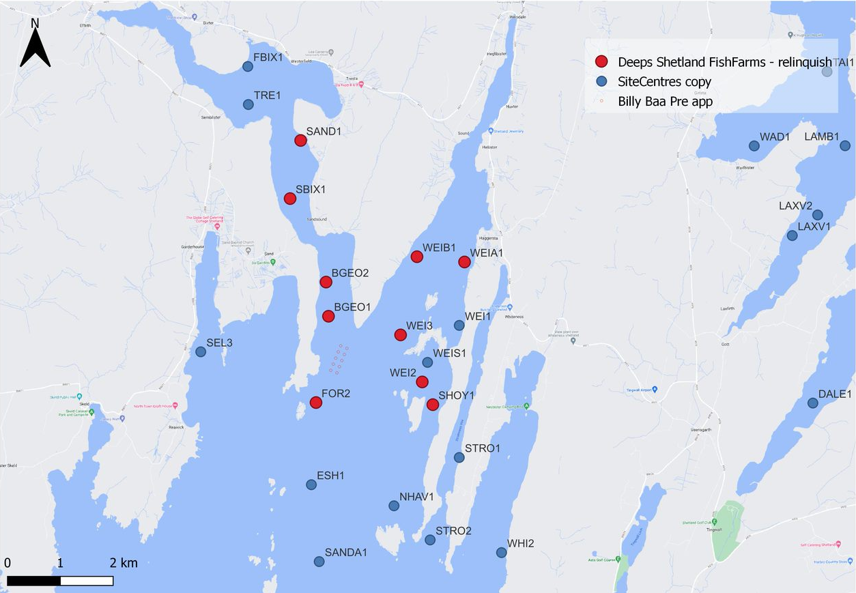
Figure 1. Proposed pen layout for Billy Baa (BLYB1)

Accuracy of model in the area surrounding the proposal
The Pentland Firth and Orkney Waters model which covers this area, has very low resolution over the entirety of Shetland, making it unusable for the purposes of screening modelling. A new Shetland model is currently in development, however for this application, screening modelling has not been undertaken, and other evidence has instead been considered.

Marine fin fish aquaculture farms using open-net pens will benefit from operating in locations where there are strong, repeating, water currents to erode and disperse waste.
For the purposes of screening we consider locations which meet the following water flow criteria to be generally suitable for larger farms:
Locations with average water flow speeds of greater than, or equal to, 0.12 metres per second (0.23 knots)
Locations where water flow speeds are often above the threshold of 0.095 meters per second (0.18 knots).
Locations with these properties are likely to disperse discharged material rapidly, and regularly erode sediment discharged to the seabed. In general, we would look for these properties to be maintained over a large area around a proposed site.
The thresholds stated above are indicative.

Based on the maps of the modelled water flow properties we can make the following observations about the proposed site location:
- It lies in a low dispersion area.
- It lies in an area where water flow has a relatively low capacity to erode material on the seabed.

Risk Identification
The screening modelling output summarised in section 2 is compared against available information on features of interest (see section 1.1.2). Features which require attention are presented with any additional comments. Identified features will need to be considered during the pre-application phase.
These should be addressed in the applicant “Method Statement”. Please refer to the Modelling Method Statement section on the SEPA Website.
(https://www.sepa.org.uk/regulations/water/aquaculture/pre-application/)

Identified features which require attention

Table of identified features
Based on screening output the following features of interest have been identified.
Table 1: Table of identified features
No. | Feature Name | Feature Type | Location (Easting, Northing) | Brief Reason For Identification
1 | BLYB1 | Fish Farm | (435921.6,145858.4)  (Fig.2) | At risk from sediment interaction
2 | BUR1 | Fish Farm | (438097, 1140499)  (Fig.2) | At risk from sediment interaction
3 | CLI4 | Fish Farm | (436565, 1138287)  (Fig.2) | At risk from sediment interaction
4 | EHIL3 | Fish Farm | (436517, 1140594)  (Fig.2) | At risk from sediment interaction
5 | ELAN1 | Fish Farm | (437692, 1139455)  (Fig.2) | At risk from sediment interaction
6 | ESH1 | Fish Farm | (435325, 1143470)  (Fig.2) | At risk from sediment interaction
7 | NHAV1 | Fish Farm | (436965, 1143086)  (Fig.2) | At risk from sediment interaction
8 | PVOE1 | Fish Farm | (438900, 1138900)  (Fig.2) | At risk from sediment interaction
9 | SANDA1 | Fish Farm | (435550, 1143030)  (Fig.2) | At risk from sediment interaction
10 | SEL3 | Fish Farm | (433310, 1146000)  (Fig.2) | At risk from sediment interaction
11 | SPO1 | Fish Farm | (435334, 1138344)  (Fig.2) | At risk from sediment interaction
12 | STRO1 | Fish Farm | (438200, 1144000)  (Fig.2) | At risk from sediment interaction
13 | STRO2 | Fish Farm | (437649, 1142440)  (Fig.2) | At risk from sediment interaction
14 | WHI2 | Fish Farm | (439000, 1142200)  (Fig.2) | At risk from sediment interaction
15 | Sea Grasses | PMF Habitat | Shapefile 1.  (Fig.2) | Risk from sediment and bath influence
16 | Maerl Beds | PMF Habitat | Shapefile 2.  (Fig.2) | Risk from sediment and bath influence
17 | Blue Mussel Beds | PMF Habitat | Shapefile 3.  (Fig.2) | Risk from sediment and bath influence
18 | Horse Mussel Beds | PMF Habitat | Shapefile 4.  (Fig.2) | Risk from sediment and bath influence
19 | South of Ness of Bixter | Shellfish farm | (433600, 1151100) | Risk from sediment and bath influence
20 | The Firth (Tresta North) | Shellfish farm | (434300, 1151400) | Risk from sediment and bath influence
21 | The Firth (Tresta South) | Shellfish farm | (434200, 1150800) | Risk from sediment and bath influence
22 | Northwest of Lunga | Shellfish farm | (435000, 1150700) | Risk from sediment and bath influence
23 | Lungness | Shellfish farm | (435100, 1149800) | Risk from sediment and bath influence
24 | Sandsound South | Shellfish farm | (434900, 1149100) | Risk from sediment and bath influence
25 | Mid Noost | Shellfish farm | (439000, 1151300) | Risk from sediment and bath influence
26 | NE of Vedri Geo Weisdale | Shellfish farm | (438000, 1148700) | Risk from sediment and bath influence
27 | Olligarth | Shellfish farm | (438300, 1147800) | Risk from sediment and bath influence
28 | Kirkaward | Shellfish farm | (437400, 1147900) | Risk from sediment and bath influence
29 | Oxa Geo | Shellfish farm | (436900, 1147200) | Risk from sediment and bath influence
30 | NW Greena, Weisdale Voe | Shellfish farm | (437600, 1147200) | Risk from sediment and bath influence
31 | North Flotta | Shellfish farm | (438100, 1146400) | Risk from sediment and bath influence

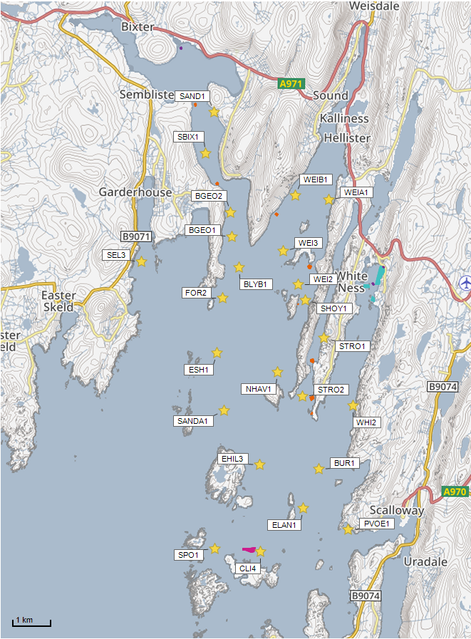
Sensitive Feature Shapefiles:
©Crown copyright. All rights reserved. SEPA lic. no. 100016991 (2019).
Figure 2. Shapefiles of identified features around the proposed site (Billy Baa (BLYB1)). (Where red stars represent farms to be relinquished).

Additional comments on identified features
Whilst screening modelling does not predict any significant sediment influence from Billy Baa (BLYB1), this site is near to several PMFs which are deemed to be at risk from sediment and bath influence. This proximity combined with the high proposed biomass, and lack of screening model for this area, means higher resolution marine modelling of sediment will be required. Particular focus should be on the identified features. Discharges of sediment from all identified sites will need to be included in this modelling, to determine the combined risk on these features.
The proposed farm is close to Sandsound Voe Shellfish Water Protected Area (SWPA) (associated Shellfish Production Area SPA Sandsound Voe for Common mussels) and Weisdale Voe SWPA (associated SPA Weisdale Voe and Weisdale Voe Upper both for Common Mussels). Within these areas, the water quality must be of a standard to ensure shellfish are safe for consumption. While the proposed application is deemed unlikely to affect the SWPA designations the potential impacts from sediments and bath chemicals on the identified active shellfish farms within these areas should be assessed (table 1).
This proposed site is within a Marine Scotland Cat 1. Waterbody (Sandsound Voe) (fig. 3). As an additional site Billy Baa (BLYB1), would lead to an increase in nutrients within this area, and be unacceptable. However, due to the proposed relinquishment of 4 other farms within the Cat 1. Waterbody, the overall licenced biomass within it would be decreased by 666t. Similarly, 5 farms within the other nearby Cat 1. Waterbody (Weisdale Voe) are also to be relinquished, resulting in a reduction in licenced biomass of 3952t.
An ECE calculation should be carried out to ensure nutrient enhancement levels from this new farm are acceptable. Baths modelling should also be used as a proxy for nutrients, to demonstrate that soluble nutrient discharges from Billy Baa do not pose a risk to any of the nearby Marine Scotland Cat 1. waterbodies (fig.3).
Calibration with drogues should be undertaken. Calibrating against observed advection patterns measured by drogues will particularly benefit the risk assessment of material entering the Cat 1. waterbody.
It is recommended that marine modelling of baths is undertaken to get a less conservative and therefore viable bath medicine quantity. Cumulative modelling of baths is however not required.

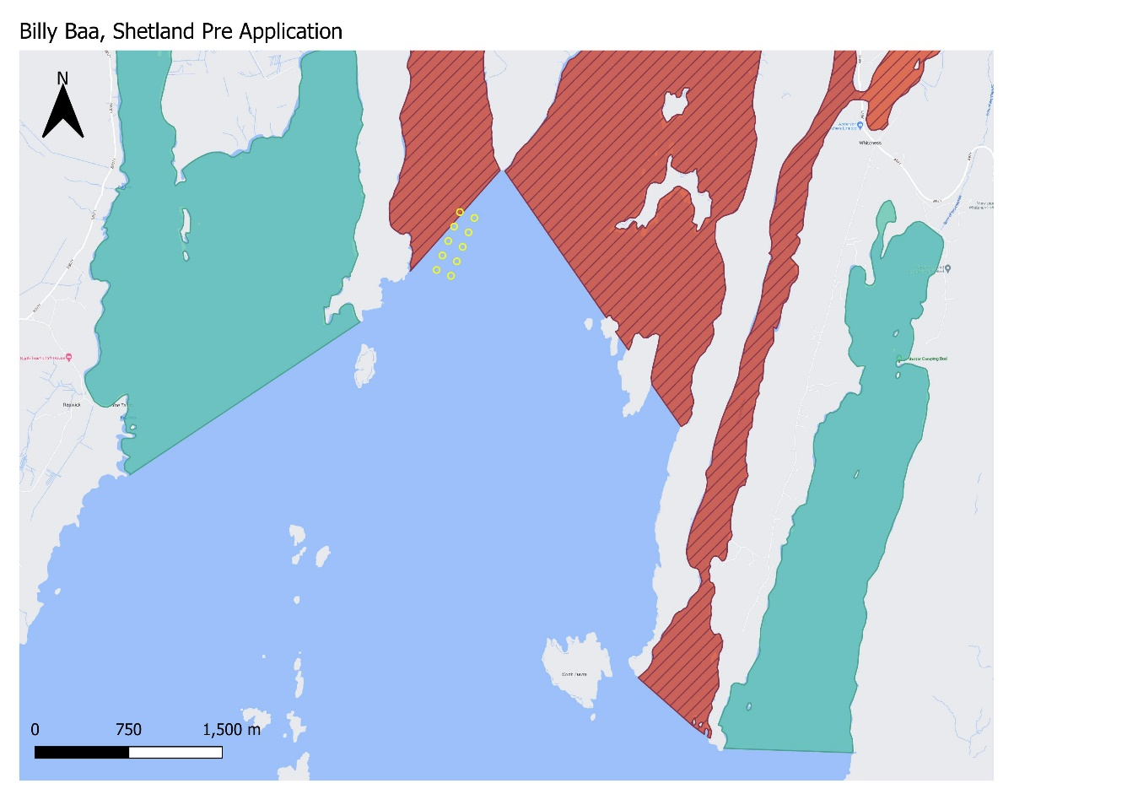

Figure 3. Figure showing locations of nearby Cat 1. (red) and Cat 3. (green) waterbodies.

3.3 Risks identified from contextual site data
Should this application proceed, the total licenced biomass in this area would be 32290t.
Table 2: Table of licenced biomass from farms identified as likely to add to cumulative risks.

Site Name | Location  (Easting, Northing) | Biomass (tonnes) | Last Production Cycle
BLYB1 | 435921.6,1145858.4 | 4278 | Proposed
BGEO1 | 435726, 1146673 | 2635 | Fish last on site Oct 08  (To Be Relinquished)
BGEO2 | 435680, 1147320 | 1209 | Fish last on site Oct 07  (To Be Relinquished)
BUR1 | 438123, 1140625 | 1922.6 | Currently Stocked  (since Oct 22)
CLI4 | 436565, 1138287 | 1332 | Currently Stocked  (since Mar 22)
EHIL3 | 436517, 1140594 | 1500 | Fish last on site Nov 08
ELAN1 | 437692, 1139455 | 1642.8 | Currently Stocked  (since Jan 22)
ESH1 | 435402, 1143485 | 3919.61 | Currently Stocked  (since Sep 22)
FOR2 | 435490, 1145040 | 1650 | Fish last on site Jun 17  (To Be Relinquished)
NHAV1 | 436965, 1143086 | 1496 | Fish last on site Aug 17
PVOE1 | 438900, 1138900 | 960 | Fish last on site Nov 13
SAND1 | 435200, 1150000 | 100 | Not stocked since records began (2002)  To Be Relinquished)
SANDA1 | 435550, 1142030 | 1500 | Fish last on site Sep 07
SBIX1 | 435000, 1148900 | 1000 | Fish last on site Mar 02  (To Be Relinquished)
SEL3 | 433310, 1146000 | 963 | Fish last on site Dec 07
SHOY1 | 437700, 1145000 | 1190.5 | Fish last on site Jan 09  (To Be Relinquished)
SPO1 | 435334, 113844 | 1500 | Fish last on site Sep 17
STRO1 | 438200, 1144000 | 150 | Not stocked since 2007
STRO2 | 437649, 1142440 | 1500 | Fish last on site Jan 09
WEI2 | 437500, 1145430 | 1190.5 | Fish last on site Jan 09  (To Be Relinquished)
WEI3 | 437090, 1146320 | 1221 | Fish last on site Jan 09  (To Be Relinquished)
WEIA1 | 438300, 1147700 | 100 | Not stocked since records began (2002)  (To Be Relinquished)
WEIB1 | 437400, 1147800 | 250 | Not stocked since records began (2002)  (To Be Relinquished)

The relatively low flow speeds in this area, mean this site is more likely to struggle with having high enough dispersion to meet mixing zone criteria. Given it is a new site, default NewDepomod modelling will be required. It is highly recommended that NewDepomod modelling is undertaken prior to proceeding further with this applicationConclusions of screening modelling and risk identification
Following screening modelling and risk identification we make a number of conclusions and recommendations.

Conclusions

4.1.1 Screening Modelling
- According to the risk assessment, the proposed site (Billy Baa (BLYB1)) is in an area of low dispersion and has a relatively low capacity for erosion of material on the seabed. (It is however, in an area of high wave exposure).
- From sediment and bath treatment modelling:
  - Information presented in section 3 indicates that the relative influence of Billy Baa (BLYB1) is likely to be high compared to other sites for a similar tonnage.
  - There is likely to be significant influence on the surrounding sea area from Billy Baa (BLYB1).
  - The areas of influence from Billy Baa (BLYB1), and other existing sites in the area (highlighted in Figure 1.) may interact.
  - It is likely that discharges of bath medicines from Billy Baa (BLYB1) will be dispersed to moderate levels over a moderate area.
  - Billy Baa (BLYB1) is likely to result in a moderate increase in the total influence of all sites modelled. Bath medicine interactions are likely to occur between other existing sites in the area (highlighted in Figure 1.)
- The proposed site, Billy Baa (BLYB1) is within Sandsound Voe, a Cat 1. Waterbod (no increase in solids or nutrients are allowed within this area), however due to the proposed relinquishment of 10 nearby farms, the overall biomass within this waterbody should be reduced and therefore the proposal is acceptable, subject to an adequate assessment of eutrophication risks. Baths modelling should be used as a proxy (calibrated with drogues), to demonstrate that there will be no net gain of nutrients to this waterbody, or any of the other nearby Marine Scotland Cat 1. locational guideline areas (Figure 3). An ECE calculation should also be undertaken.

4.1.2 Risk identification
The proposed site, Billy Baa (BLYB1) is within Sandsound Voe, a Cat 1. Waterbody (no increase in solids or nutrients are allowed within this area), however due to the proposed relinquishment of 10 nearby farms, the overall biomass within this waterbody should be reduced and therefore the proposal is acceptable, subject to an adequate assessment of eutrophication risks. Baths modelling should be used as a proxy (calibrated with drogues), to demonstrate that there will be no net gain of nutrients to this waterbody, or any of the other nearby Marine Scotland Cat 1. locational guideline areas (Figure 3). An ECE calculation should also be undertaken.
Although screening modelling has not been undertaken, due to the proximity and large combined tonnage of existing farms, there is significant potential for interactions between existing farms, as well as cumulative influence. Several features of interest have been identified, which require further attention during pre-application work. These are outlined in section 3. Further detailed modelling will need to demonstrate that the influence on these features is low and the additional biomass from this site would create no additional risk to the area.

The conservative nature of the simple BathAuto model means quantities of bath medicines may be limited to impractical amounts for this site. Use of marine modelling of bath influence will enable more realistic bath medicine treatment quantities to be determined. Cumulative modelling of identified sites will be required for solids but not for baths.

Calibration with drogues should also be undertaken. Calibrating against observed advection patterns measured by drogues will particularly benefit the risk assessment of material entering the Cat 1 waterbody.

Recommendations

Site suitability

Consideration of risk identification suggests that the current proposal may meet the Marine Scotland waterbody standards, with the relinquishment of the proposed farms. Therefore it is possible that discharges from the proposed site will be able to comply with the relevant aspects of the SEPA Aquaculture Regulatory Framework. This must be demonstrated with a detailed marine model.
The site may be able to comply with our mixing zone regulatory framework. This will need to be demonstrated using the NewDepomod model.
Features at risk, identified at this stage, do not appear to influence the feasibility of the proposed site, with respect to the regulatory framework. These risks should be examined using a detailed marine model.
Following the engagement meeting(s), this report will be revised and this should allow to the applicant to submit a method statement which address the issues raised in this document.

Further modelling
- Due to the identified risks, 2D marine modelling should be carried out.
- The size of the marine model should include discharges from all sites identified in this report. Cumulative modelling including these identified sites will be required for solids, but not baths.
- Due to the large biomass and identified Cat 1. waterbodies, drogues are required for model calibration.
- The resolution of the marine model should be relatively fine around the proposed site and identified features at risk.
- Baths modelling should also be used as a proxy for nutrients, to demonstrate the nutrients from this farm do not pose risk to Sandsound Voe, or any of the other nearby Marine Scotland Cat 1. waterbodies (fig.3). An ECE calculation should also be undertaken.
- NewDepomod modelling should be undertaken for the proposed site. It is strongly recommended that default NewDepomod modelling is undertaken prior to any marine modelling, to ensure the local impacts of the proposed biomass are acceptable.

References
[1] Regulatory Modelling Guidance For The Aquaculture Sector. Published on SEPA website.
[2] http://marine.gov.scot/information/wider-domain-scottish-shelf-model.

For information on accessing this document in an alternative format or language, please contact SEPA by emailing equalities@sepa.org.uk
If you are a user of British Sign Language (BSL), the Contact Scotland BSL service gives you access to an online interpreter, enabling you to communicate with us using sign language. contactscotland-bsl.org

