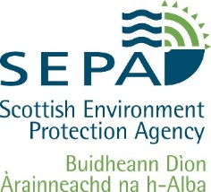

2nd Year Review – A Sustainable Growth Agreement with the 2050 Climate Group

June, 2020

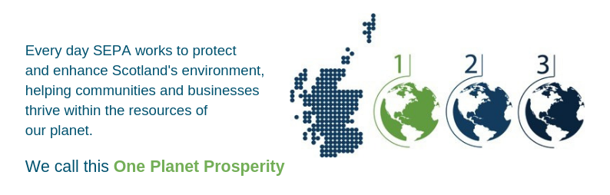

For information on accessing this document in an alternative format or language please either contact SEPA by telephone on 03000 99 66 99 or by email to equalities@sepa.org.uk
If you are a user of British Sign Language (BSL) the Contact Scotland BSL service gives you access to an online interpreter enabling you to communicate with us using sign language.

http://contactscotland-bsl.org/
www.sepa.org.uk
03000 99 66 99
Strathallan House, Castle Business Park, Stirling, FK9 4TZ

Foreword from SEPA and 2050 Climate Group
2050 Climate Group and SEPA began our Sustainable Growth Agreement in 2017. Through our Sustainable Growth Agreement we have developed a partnership that is supportive, flexible and adaptable – a way of working which we think is essential when addressing a problem as challenging and potentially overwhelming as climate change. We are excited to continue to combine the experience, reach and innovation of SEPA, with the unique approach of 2050 Climate Group.
Within 2050 Climate Group, it has also been a year of significant change. We have continued to develop and deliver our Young Leaders Development Programme, facilitate and train our network of hundreds of Young Leaders across Scotland, and contribute to youth representation and advocacy on climate change issues. But we have also developed and launched a new strategic plan, (2019-2022) which increases our ambitions around empowerment on climate action, skills and knowledge, and opportunities for young people (aged 18-35) to be catalytic leaders of change
In SEPA we are creating a radical way of regulating for the massive environmental challenges that humanity faces. Our role is to protect and enhance Scotland’s environment, helping communities and businesses thrive within the resources of our planet - we call this One Planet Prosperity. In the upcoming year, we will make a step change in One Planet Prosperity shifting from a strategy into practical implementation in the way we do more of our work. The SGA will help us to achieve the aims of One Planet Prosperity and will help us to shift to a Phase 2 way of working.

What are Sustainable Growth Agreements?
Currently, Scotland needs approximately three planets to sustain its current way of living¹, however, we only have one.
All parts of our communities, businesses and government have key roles to play to enable Scotland to tackle the challenge of creating social and economic success within planetary constraints. In terms of environmental regulation, this effectively means that SEPA needs to:
1. Get all those it regulates to meet their legal obligations and reach compliance; and
2. Help as many regulated entities as possible move beyond compliance.
Sustainable Growth Agreements are one way of helping achieve this. They are voluntary, non-legally binding, formal agreements through which an organisation (or organisations) and SEPA can explore new and innovative ways to improve environmental performance and focus on practical actions that deliver environmental, social and economic success.

A Sustainable Growth Agreement with the 2050 Climate Group
Scotland has committed to being a world leader in addressing climate change, and is already taking ambitious steps to drive a low carbon economy, creating new opportunities for a stronger and more inclusive economy and society. SEPA’s job is to help make this happen, including working with and supporting people and groups in Scotland who share this aim. SEPA knows that Scotland has, in the 2050 Climate Group, a unique asset for helping to achieve this goal.
The 2050 Climate Group is Scotland’s youth climate group and aims to lead a social movement by empowering, equipping and enabling young leaders to take climate action towards a just and sustainable society. The group is committed to leading the change, in establishing a ‘new normal’ where low carbon climate change action and environmental responsibility are mainstreamed across their generation so that future leaders can achieve a sustainable future beyond 2050.
This Sustainable Growth Agreement includes areas for joint working that support the 2050 Climate Group to create opportunities for climate change leadership, engaging young people from all backgrounds and locations and to share its work more internationally gaining global action.
SEPA and the 2050 Climate Group have been working closely over the past year towards the objectives of the Sustainable Growth Agreement. The achievements are summarised in the table below showing progress across all four areas of agreed joint working.

SGA Theme | SGA Outcome | Project
Influencing and Leadership | Enhanced recognition of the contributions of young people | - Involvement of 2050 Climate Group Young Leaders in the Low Carbon Energy Roundtables and Scottish Sustainable Development Goals working group  - 2050 Climate Group Leaders Network provided comments on sector plans out for consultation  - SEPA Board opportunity circulated to 2050 Climate Group Leaders Network  - SEPA Young Leaders (who have participated in 2050 Climate Group’s programme) presented at SEPA’s Green Network to establish links between climate leadership and SEPA’s internal objectives.
 | Increased participation in influencing opportunities
Inclusion and decision making | Reaching new audiences to ensure that young people from all backgrounds and locations are represented in decision making and have the opportunity to participate working with SEPA staff partners and other SGA organisations to create opportunities | - SEPA circulated the call for applications to 2050 Climate Group’s Young Leaders Development Programme (YLDP) application to other SGA leads to forward on to their businesses and grow participation and engagement in climate action across more sectors  - 2050 Climate Group attended the assessment centres for Graduate Trainees recruitment to connect with young people interested in working in environmental regulation  - Equalities Officer in SEPA provided advice in the development of the 2050 Climate Group strategic plan
 | Development opportunities for SEPA staff members | - 10 SEPA staff members participated in YLDP4, running September 2019 – March 2020  - Young people from 2050 Climate Group’s Malawi Climate Leaders project came from Malawi to ASB for presentations on waste management, SEPA’s project in Malawi, land degradation, flooding and biodiversity loss, and a tour of SEPA’s lab facilities  - Iris Krammer undertook a 3 months secondment to 2050 Climate Group
International co-operation | New networks, partners and audiences | - Joint involvement with UN Global Shapers in Edinburgh  - Commitment on attending the Low Carbon Roundtable events  - SEPA and 2050 Climate Group connected their shared work with the Scottish Government to facilitate more joined-up collaboration  - 2050 Climate Group and SEPA met with Paul Gilding (ex-CEO of Greenpeace International) to discuss ambitions for climate action in Scotland
Practical Support | Collaborating, sharing and maximising resources | - SEPA’s Edinburgh Office hosted the interview space for 2050 Climate Group’s Communications Officer appointment  - SEPA’s HR department provided support in the development of the job description for a new post for 2050 Climate Group  - SEPA’s Communications department provided support to 2050 Climate Group during key milestone events and initiatives

