PROCUREMENT ANNUAL REPORT

2019 – 2020

For information on accessing this document in an alternative format or language please contact SEPA by email at equalities@sepa.org.uk
If you are a user of British Sign Language (BSL) the Contact Scotland BSL service gives you access to an online interpreter enabling you to communicate with us using sign language.
http://contactscotland-bsl.org/

www.sepa.org.uk
Strathallan House, Castle Business Park, Stirling, FK9 4TZ

- Introduction

This Annual Report provides an account of SEPA’s procurement activity for 2019/20.

- Background and key statistics

The Scottish Procurement and Commercial Directorate of the Scottish Government commission an external body, Spikes Cavell, to conduct an annual national spend analysis programme. This is carried out by organisations submitting specific transactional data for the relevant financial year to Spikes Cavell. Data is verified and final publication is made on the Scottish Procurement Information Hub (The Hub).

The financial analysis has been carried out on data extracted from SEPA’s finance and procurement system, Agresso. Table 1 summarises SEPA’s key procurement statistics for the financial year 2019/20 and compares with the previous 2 years.

All figures in the Annual Report are exclusive of VAT at the current rate.

Table 1

Spikes Cavell Procurement Dashboard | Revenue &  Capital  FY 2019/20 | Revenue &  Capital  FY 2018/19 | Revenue &  Capital  FY 2017/18
Total value of transactions reported | £16,019,599 | £20,583,367 | £18,834,124
Number of transactions (Purchase Orders) | 4,040 | 4,720 | 4,904
Expenditure with SMEs | £8,330,191  (52%) | £9,880,016  (48%) | £8,663,697  (46%)
Active supplier accounts in this period: | 1,045 | 1,187 | 1,278
Total number of invoices | 7,189 | 8,313 | 8,552

- Tendering and contract activity

- Over Official Journal of the European Union Threshold

Four (4) Contract Notices were published in the Official Journal of the European Union (OJEU) in 2019/20.

Contract | Total term | Value over term | Awarded
Bathing Water VMS Signage | 4 years | £373,786 | November 2019
Legal Services Framework | 4 years | £600,000 | November 2019
Habits Surveys | 4 years | £390,990 | February 2020
Outstation, Shaft Encoder Replacement Framework | 4 years | £611,330 | February 2020

    - Non-competitive actions

Threshold | FY2019/20 |  | FY 2018/19 |  | FY 2017/18
 | Qty | Value | Qty | Value | Qty | Value
£5,000 - £20,833 | 46 | £493,956 | 60 | £760,112 | 55 | £673,957
>£20,833 | 21 | £976,619 | 18 | £786,977 | 23 | £1,349,326
Total | 67 | £1,470,575 | 84 | £1,547,089 | 78 | £2,023,283

Scottish Government is required to endorse non-competitive actions (NCAs) greater than £20,833 (excluding VAT) which do not relate to laboratory equipment or IS hardware/software maintenance contracts. Of the 21 above this threshold, 6 were forwarded and received endorsement by Scottish Government at a value of £280,556.

    - Procurement activity

Procurement activity was undertaken in line with the Procurement Strategy by appropriately utilising collaborative frameworks, ensuring Small to Medium Enterprises (SMEs) and local businesses were given the best opportunity to compete for work by publishing Notices on Public Contracts Scotland (PCS) https://www.publiccontractsscotland.gov.uk, and where possible, dividing contracts into Lots, for example, geographically whilst promoting the delivery of value for money.

Activity 2019/20
Threshold | Tenders  issued | Budget |  | Awarded  (incl. NCA) | Award value
<£10,000 | 0 | 0 |  | 29 | £217,662
£10,000 - £49,999 | 21 | £609,766 |  | 78 | £1,975,414
£50,000 - £181,301 | 6 | £423,194 |  | 28 | £2,451,491
£181,302 | 7 | £3,650,000 |  | 13 | £8,572,471
Totals | 34 | £4,682,960 |  | 149 | £13,217,038

    - Contract Notices published in 2019/20:

 |  | 2019/20 | 2018/19 | 2017/18
Site | Notices Published | Qty | Qty | Qty
PCS | OJEU | 4 | 1 | 2
 | Non-EU | 11 | 19 | 10
 | Quick Quote service | 22 | 40 | 40
Total |  | 37 | 60 | 52

The following table is a breakdown of contracts which were awarded reflecting the use of, for instance, collaborative frameworks (CAL) or Quick Quote (QQ), giving opportunities to SMEs and local businesses to bid. Non-competitive actions have been excluded.

Type | Description | Qty | Value
FRA | SEPA Framework | 3 | £1,255,330
CAL | Called from a National Framework | 40 | £7,565,003
 | Called from a SEPA Framework | 7 | £938,559
PUR | Contracts competitively tendered | 21 | £1,718,501
QQ | Contracts placed through PCS Quick Quote system | 8 | £269,071
Total contracts |  | 79 | 11,746,464

There were no regulated procurements i.e. >£50,000 which did not comply with the Procurement Strategy.

    - Savings and collaborative expenditure

Procurement continually strives to seek Best Value for the organisation. All tender evaluations consider environmental impact, equality and diversity, community benefits and whole life costing where appropriate.
The figures below represent the expenditure and benefits achieved through collaborative contracts and local contracts.

 | FY2019/20 |  | FY 2018/19 |  | FY 2017/18
Contract category | Contracted spend | % Annual spend | Contracted spend | % Annual spend | Contracted spend | %  Annual spend
Cat A Spend  Cash Savings | £2,524,871  £222,756 | 16% | £2,931,964  £301,781 | 14% | £2,363,257  £391,067 | 13%
Cat B Spend  Cash Savings | £77,075  £8,367 | 0.5% | £137,523  £17,828 | 1% | £266,779  £19,257 | 1%
Cat C Spend  Cash Savings | £6,696,834  £538,785 | 42% | £7,017,565  £258,560 | 34% | £6,633,152  £652,837 | 35%
Total Spend  Cash Savings | £9,298,780  £769,908 | 58% | £10,087,052  £578,169 | 49% | £9,236,188  £1,063,161 | 49%

- Specific duties under Public Reform (Scotland) Act 2014

Under the Public Reform (Scotland) Act 2014, specific duties have been placed on procurement in terms of the Sustainable Procurement Duty (paragraph 9), Supported Businesses (paragraph 11), and Community Benefits (paragraph 25).

- Sustainable Procurement

A formal sustainable procurement action plan has now been put in place which shows a roadmap to SEPA achieving level 3 on the flexible framework by the end of 2020/21. Procurement practice has been strengthened during 2019/20. This will enable effective sustainable procurement in future years. Individual projects which have supported SEPA’s wider objectives of One Planet Prosperity include:
- Procurement of six electric cars for use in the pool car fleet
- Procurement of three electric vans for the transfer of scientific samples
- Installation of car charging infrastructure across a number of SEPA offices
- Consolidation of paper supply requirements to a more sustainable alternative
- Improved sustainability criteria for Water Environment Fund direct commissioning

- Supported businesses

SEPA has made limited use of Supported Businesses in 2019/20 following the closure of a Supported Business used for a number of years. However, SEPA successfully used a document scanning service provided by Capture All Ltd with a value of £1,480. This position is being reviewed and it is expected that Supported Business spend will increase in 2020/21.

- Community benefits

Procurement are required to ‘consider whether to impose community benefits requirements as part of the procurement’ which has an estimated value of the contract equal to or greater than £4,000,000 over the term of the contract.

In 2019/20, no regulated procurements equal to or over the £4,000,000 were initiated or awarded, however, availability for sub-contracting opportunities are permanently included in our tenders.

- Small Medium Enterprises (SME)

As part of the public sector, SEPA acknowledges it has a role in contributing to Scotland’s economic success. In an effort to encourage SME suppliers, we advertise through Public Contracts Scotland and our Buyer Profile portal.
The Procurement Team have used the following opportunities to engage with potential suppliers:
- Supplier Development Programme Membership – This will offer SEPA capacity to engage with suppliers across Scotland in key sectors including construction.
- Supplier Development Programme Meet the Buyer – In November 2019 SEPA had a stand at this event offering potential suppliers the opportunity to speak about contract opportunities.
- Soft market tests and wider market engagement – Prior Information Notices (PINs) have been used to assess the state of markets and inform specifications prior to procurement exercises.

- Contract register

The Public Reform (Scotland) Act 2014 requires a register of current contracts to be published on the Internet.
SEPA’s contract register is accessible on our website: https://www.sepa.org.uk/media/219435/contract-register.pdf.
- Regulated contracts forward plan

Summary of contracts to commence in next 2 years, with a value greater than £50,000
Contract | Value | Planned contract start date
Ad-Hoc Environmental Radioactivity Monitoring | £180k | Nov 2020
Job Evaluation Scheme | ~£310k | Dec 2020
Winch and Electronic Travellers Framework | £520k | Sep 2020
Offsite Storage & Document Management | ~£150k | Jan 2021
Pluvial Mapping | ~£2m | Nov 2020
Flood Warning Dissemination | £2m | 2021/22
Contracts under consideration
Communications and Design Framework | TBA | TBA
Stack Emissions Monitoring Framework | ~£600k | TBA
Laboratory Consumables | £1m | TBA
Postage and Mail Management | TBA | TBA
Phase 2 Gauging Station Design | TBA | TBA

- Procurement Operating Plan 2019-21

The below offers a short summary of progress against the Procurement Operating Plan 2019-21.

  - Improving governance and processes

Summary – Improvements have been made across all areas of procurement governance. Particular focus has been given to making processes simpler and more proportionate. Where appropriate, processes have been made more robust to improve assurance in high risk areas.

- Non-Competitive Actions (NCA) – 2019/20 has seen a reduction in the number and value of NCAs.
- Greater challenge for suppliers – A greater level of commerciality in discussions with our suppliers has often led to savings in the region of 5-10%.
- Contract register – Our Contracts Register has been reviewed and updated; the Procurement Team now have a high degree of confidence in its accuracy.

  - Focusing on key contracts and prioritising associated support

Summary – Significant changes have been made in how the Procurement Team aligned to support the organisation. There is a much greater focus on the achievement of AOP and 1PP objectives.
Priority contracts have been identified and are receiving additional support.

- Contract classification – Contract classification has been undertaken and will now be used to prioritise support and allocate supplier relationship managers in line with AOP objectives.
- Supplier failure guidance – Significant work has been undertaken in response to COVID-19 to mitigate contract risk, in particular where there has been supply interruption.

  - Improving the sustainability of our contracts

Summary – Limited progress has been made against this objective and it will be a focus of the Team’s work in 2020/21. Contracts for 2020/21 have been prioritised, enabling proactive discussions around the effective delivery of sustainable procurement moving forward.

- Delivery of Level 3 on the SG Flexible Framework – The Flexible Framework is used to measure the maturity of sustainable procurement within an organisation. The initial assessment shows SEPA to be performing below Level 1 on a scale of 1-5. An action plan is now in place to take SEPA to level 3 of the flexible framework during 2020/21.

  - Fostering a more commercial culture:

Summary – It is perceived that things have started to change. The level of maturity in conversations associated with contracts around the organisation and with our suppliers is improving. Further work is still required to embed this in 2020/21.

- Aggregation of spend – Work has been commenced in a number of areas where spend can be aggregated to deliver improved value. Outstations and Shaft Encoders were completed in 2019/20 and a number of other projects have been commenced which are expected to conclude in 2020/21.
- Challenge our suppliers – It is now becoming commonplace to challenge our suppliers during contract management, at extension/break points in a contract and on the award of a new contract; asking them to deliver better value to SEPA. This is helping to instil a more commercial culture across the organisation.

  - Supporting the organisation through improvement

Summary – Progress against this objective has been limited. This is as a result of more extensive work being required on other objectives than was anticipated. This objective will be a key focus in 2020/21.

- Organisational spend activity FY 2019 - 20

Expenditure by Supplier

Total spend: £16,019,599
Top 20 suppliers: £7,147,102 (45% of organisational total expenditure).

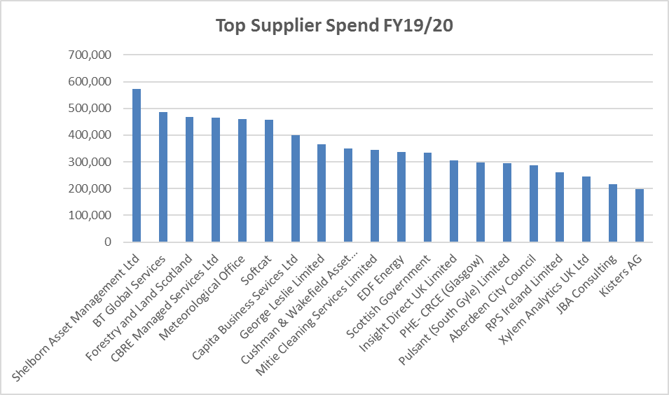

Key points

- Shelborn Asset Management relates to Angus Smith Building rent ((£515,370)
- BT Global Services relates to the Flood Warning dissemination service (£487,273)
- Forestry and Land Scotland relates to rent and services at Silvan House, Edinburgh (£468,593)

Commodity expenditure

Total spend: £16,019,599
Top 20 commodities: £12,434,561 (78% of all spend)

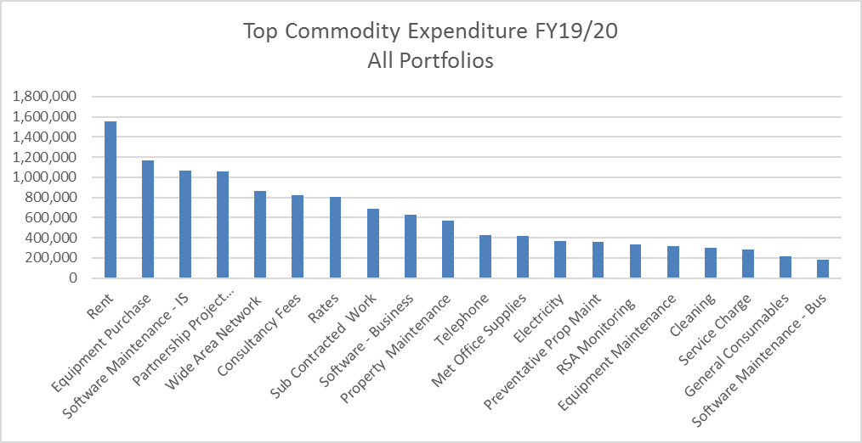
Key point

Overall highest expenditure relates to Rent. The top 10 companies to which this expenditure is attributed are provided below.

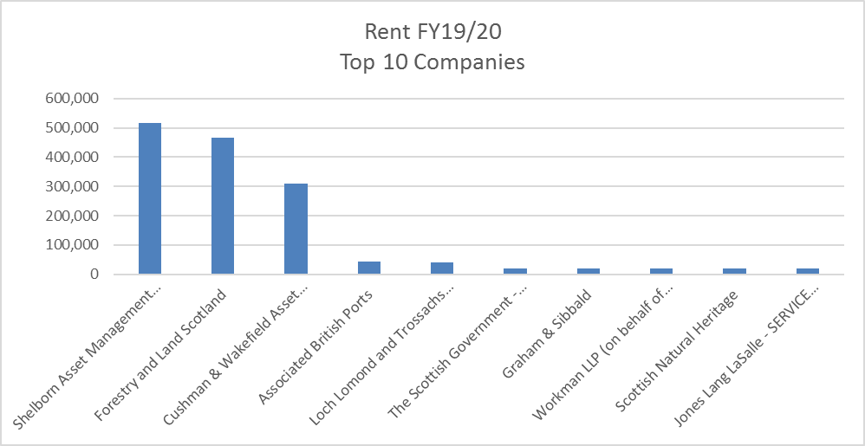

May 2020

Stuart McGregor
SEPA
Chief Officer Finance
Strathallan House
Castle Business Park
Stirling
FK9 4TZ

Telephone: 01786 452440

Contracts Awarded in FY19/20

Compliance and Beyond

Description | Date To | Ext (Mths) | Review Date | Value  (Ex. VAT)
Tarbolton Project 2 | 31/03/2020 | 0 | 31/01/2020 | 25,000.00
Support & Maintenance for Geofield and Geofield Exchange Software | 30/04/2021 | 12 | 01/03/2021 | 36,754.00
Secure Radio Network | 17/12/2022 | 0 | 18/10/2022 | 13,271.94
Habits Surveys | 18/02/2022 | 24 | 18/02/2022 | 390,990.00
IBM i2 maintenance package | 30/04/2020 | 0 | 01/03/2020 | 29,802.66
Coastal Monitoring - Additional Sites | 21/03/2020 | 0 | 21/03/2020 | 12,111.00
Clyde Habits Survey | 31/12/2019 | 0 | 01/12/2019 | 15,730.50
RIMNET Sampling - Additional Samples | 31/03/2020 | 0 | 31/03/2020 | 19,998.00
Radiation Protection Advisor | 22/03/2023 | 24 | 22/12/2022 | 20,000.00

Circular Economy

Description | Date To | Ext (Mths) | Review Date | Value  (Ex. VAT)
Source apportionment of metal mine pollution in Glengonnar & Wanlock Waters | 29/02/2020 | 0 | 02/09/2019 | 14,407.00
Gateside Mills Options Development | 31/10/2019 | 0 | 01/10/2019 | 34,835.00
Netregs software support & maintenance | 31/03/2021 | 24 | 30/01/2021 | 44,775.00
Maintenance of Air Sampling Network | 31/12/2020 | 0 | 31/12/2020 | 60,223.00
Gottar Water Works (WEF) | 31/01/2020 | 0 | 01/01/2020 | 346,042.65
Revision work for VIBES online application website | 30/03/2020 | 0 | 29/02/2020 | 8,075.00
Bronie Burn Design (WEF) | 30/09/2021 | 0 | 01/08/2021 | 49,505.01
Laserfiche Licencing/Support | 27/07/2020 | 12 | 28/04/2020 | 52,955.98
Rothes Burn (WEF) | 30/06/2020 | 0 | 31/05/2020 | 38,559.25
NetRegs Survey | 31/07/2020 | 0 | 01/06/2020 | 56,194.00
Leven Catchment - Masterplan Visioning | 30/06/2019 | 0 | 31/05/2019 | 28,405.00
Malawi in country support | 31/03/2023 | 0 | 30/01/2023 | 20,000.00

Evidence and Flooding

Description | Date To | Ext (Mths) | Review Date | Value  (Ex. VAT)
Board Management Software | 23/05/2021 | 0 | 24/03/2021 | 35,000.00
Replacement Sensors | 29/02/2020 | 0 | 30/01/2020 | 10,356.50
Freshwater Sondes | 31/03/2020 | 0 | 31/01/2020 | 25,000.00
Sondes - Marine | 31/03/2020 | 0 | 31/01/2020 | 37,000.00
Annual ProXed Support & Maintenance 2020-2021 | 31/03/2021 | 0 | 01/03/2021 | 6,366.50
Annual ProXed Support & Maintenance 2019-2020 | 30/04/2020 | 0 | 31/03/2020 | 6,366.50
Scotland´s Aquaculture Website ProcXed Migration | 31/03/2020 | 0 | 01/03/2020 | 16,440.00
Aberfoyle Flood Forecasting System | 01/11/2020 | 0 | 02/10/2020 | 29,980.05
Sophos Anti Virus Renewal | 15/09/2022 | 0 | 17/07/2022 | 29,649.20
iGas 7 Burner | 31/03/2020 | 0 | 31/01/2020 | 5,400.00
Osiris Dust Monitor Kit | 31/03/2020 | 0 | 31/01/2020 | 7,840.00
Gasmet FTIR Analysers Maintenance | 04/04/2020 | 0 | 05/03/2020 | 7,997.68
UKAS 2020 Surveillance Visits | 31/05/2020 | 0 | 01/05/2020 | 26,222.75
RICT Rebuild & Rehost | 31/03/2020 | 0 | 31/01/2020 | 19,032.00
WISKI servers upgrade for Cyber Essentials | 09/08/2019 | 0 | 09/08/2019 | 9,915.00
Tuflow Modelling Software Support and Maintenance | 31/03/2020 | 0 | 01/03/2020 | 15,481.88
Flood Modeller & TUFLOW Annual Maintenance | 31/03/2021 | 0 | 30/01/2021 | 16,156.88
DNA Sequencer | 31/03/2020 | 0 | 01/03/2020 | 84,496.14
Underwater Camera | 31/03/2020 | 0 | 17/03/2020 | 19,793.85
SODA Driver Configuration | 31/03/2020 | 0 | 31/01/2020 | 7,560.00
AQ Sensor Project | 02/03/2023 | 0 | 01/01/2023 | 45,250.00
Met Office Evaporation Data Licence Renewal | 31/01/2021 | 0 | 01/01/2021 | 5,235.40
Low Flows Enterprise Support & Maintenance | 31/03/2021 | 0 | 30/01/2021 | 10,909.00
PAC & Fluoride Analysis Software Upgrade | 31/01/2020 | 0 | 01/01/2020 | 6,515.40
ICS Ion Chromatorgraph PM | 31/12/2020 | 0 | 01/11/2020 | 7,868.32
Salt Dilution Kits | 31/03/2020 | 0 | 01/03/2020 | 30,300.00
Spotfire Licences S&M | 24/03/2021 | 0 | 23/01/2021 | 53,250.00
Spotfire Annual Software Maintenance | 23/02/2021 | 0 | 23/02/2021 | 77,382.00
River Carron & Forth, Aberfoyle Survey | 10/04/2020 | 0 | 11/03/2020 | 24,750.00
Ayr and Annick River FF System | 30/11/2019 | 0 | 31/10/2019 | 70,843.08
FHRC Middle University MCM licence acquisition | 30/04/2020 | 0 | 01/03/2020 | 20,000.00
CEH 900 Licence | 31/03/2020 | 0 | 31/01/2020 | 25,056.88
CEH 828 Licence | 31/03/2020 | 0 | 31/01/2020 | 28,084.38
CEH 828 & 900 Licences | 31/03/2021 | 0 | 30/01/2021 | 56,472.95
National FRM Appraisal Contract | 30/06/2020 | 0 | 01/05/2020 | 696,982.50
MIKE Marine Modelling Software Maintenance (SMA) | 21/02/2021 | 0 | 23/12/2020 | 16,107.86
Pulse Security Gateway | 31/03/2023 | 0 | 30/01/2023 | 5,961.82
RSA SecureID | 30/01/2023 | 0 | 01/12/2022 | 8,269.39
Maintenance for RSA Appliance and Authentication Manager | 18/04/2020 | 0 | 18/02/2020 | 9,102.50
Cyber Security Consultancy | 31/03/2021 | 0 | 01/12/2020 | 10,080.00
Video External Gateway Maintenance | 19/03/2021 | 0 | 18/01/2021 | 14,099.77
RSA Secure Demand Maintenance | 30/03/2021 | 0 | 29/01/2021 | 14,414.33
Restorepoint | 13/02/2023 | 0 | 13/02/2023 | 16,911.74
Cisco Support Agreement | 28/02/2021 | 0 | 30/12/2020 | 20,238.04
Service Support Agreement - Softcat | 24/02/2023 | 0 | 26/12/2022 | 25,500.00
Data Centre Hosting | 30/03/2021 | 0 | 29/01/2021 | 26,320.58
Raydan Professional Services | 08/07/2020 | 24 | 09/05/2020 | 27,835.50
Egress Software Licence and Support | 31/03/2023 | 0 | 30/01/2023 | 31,161.00
Cisco Voice Gateways | 13/02/2021 | 0 | 15/12/2020 | 41,695.02
PSN Connect Service | 31/03/2021 | 0 | 31/12/2020 | 59,756.00
Cisco Video Security Gateway Package | 31/03/2020 | 0 | 31/01/2020 | 84,015.50
Outer Hebrides Coast - Land survey | 31/12/2019 | 0 | 01/12/2019 | 24,828.00
Arial Imagery Contract 2019/20 Payment | 31/03/2021 | 0 | 30/01/2021 | 14,099.00
Seric Call Handling Support | 31/12/2020 | 0 | 01/12/2020 | 18,354.00
Active Directory Servers rollour to SEPA offices | 11/02/2023 | 0 | 31/03/2020 | 19,644.26
Netcall EDRMS Licence for Serengeti | 25/02/2021 | 0 | 27/12/2020 | 22,734.00
Pure Warranty Support | 30/04/2021 | 0 | 01/03/2021 | 24,926.88
Laptops Refurbished | 31/03/2020 | 0 | 31/01/2020 | 28,000.00
NetHelpDesk Maintenance & Support incl Webapp | 25/03/2021 | 0 | 24/01/2021 | 30,363.46
Panasonic Laptops | 31/03/2020 | 0 | 31/03/2020 | 32,401.00
Lenovo Service Suite | 14/01/2021 | 0 | 15/11/2020 | 35,158.80
IBM Storage for V7000 | 28/02/2021 | 0 | 30/12/2020 | 40,752.17
Labware, LIMS Maintenance & Support | 31/01/2021 | 0 | 02/12/2020 | 48,622.00
Oracle ULA Support Agreement 2019-20 | 31/03/2020 | 0 | 05/07/2019 | 84,712.42
Vodafone Narrowband IoT Project | 30/03/2022 | 0 | 30/11/2021 | 101,328.00
Pure Storage Expanson | 29/01/2021 | 0 | 30/12/2020 | 110,549.64
Azure Cloud Services for SEPA´s Digital Licensing Environment | 11/02/2023 | 0 | 14/10/2022 | 152,506.80
Fixed Telephony Services (Landlines) | 21/07/2021 | 12 | 26/07/2020 | 328,372.00
Cloud and Hosting Service | 31/12/2022 | 0 | 02/09/2022 | 637,352.00
Microsoft Enterprise Agreement | 31/03/2022 | 0 | 30/01/2022 | 925,590.15
Outer Hebrides (Eilean Siar) Flood Forecasting Scheme | 30/09/2020 | 0 | 31/08/2020 | 75,445.00
North Cableway Upgrade 2019-20 | 31/03/2020 | 0 | 31/03/2020 | 38,078.04
Bathing Water Signage - Annual Repair and Maintenance | 30/04/2020 | 0 | 31/03/2020 | 15,000.00
Bathing Water VMS System | 11/11/2022 | 24 | 15/05/2022 | 373,786.00
Cableway Gauging Winch Trial | 31/12/2019 | 0 | 31/12/2019 | 9,350.00
Flying Fox Trial | 01/12/2020 | 0 | 01/11/2020 | 12,000.00
Load Limiters | 31/03/2020 | 0 | 01/03/2020 | 12,300.00
Ormiston Mill Winch Station | 31/03/2020 | 0 | 01/03/2020 | 19,696.26
Cableway Remote Travellers | 31/01/2020 | 0 | 01/01/2020 | 21,000.00
Shewlton Hut Replacement | 31/03/2020 | 0 | 01/03/2020 | 39,922.85
Manual Winch Replacement | 31/03/2020 | 0 | 01/03/2020 | 40,000.00
Cableway Remote Travellers | 31/03/2020 | 0 | 01/03/2020 | 71,998.83
Boat of Garten Rebuild | 31/12/2019 | 0 | 01/12/2019 | 105,999.11
PSTA Accessibility Testing & Training | 08/09/2019 | 0 | 12/03/2019 | 8,200.00
Customer Platform Project Pilot | 15/11/2019 | 0 | 16/09/2019 | 99,675.00
Remote Noise Monitoring Kit | 31/03/2020 | 0 | 31/03/2020 | 18,305.00
Replacement Trailer for the SV Kelpie | 31/01/2020 | 0 | 01/01/2020 | 8,266.00
SODA Box Replacement | 31/01/2020 | 0 | 01/01/2020 | 9,845.00
Logger and Shaft Encoder Replacement Project | 17/02/2023 | 12 | 19/12/2022 | 110,654.00
Logger and Shaft Encoder Replacement Project | 17/02/2023 | 12 | 19/12/2022 | 157,320.00
Logger and Shaft Encoder Replacement Project | 17/02/2023 | 12 | 19/12/2022 | 343,356.00
Pressure Sensors | 23/11/2022 | 24 | 24/09/2022 | 100,000.00
Real Time Observation Pilot | 09/04/2029 | 0 | 08/02/2029 | 17,800.00
ChemData Subsciption | 31/03/2020 | 0 | 01/03/2020 | 6,410.00
Resource Scheduler Maintenance & Support | 31/03/2021 | 0 | 30/01/2021 | 10,238.88
BOD analysers, maintenance contract | 03/02/2021 | 0 | 04/01/2021 | 6,792.00
Nutrient Analyser Maintenance | 01/05/2020 | 0 | 02/03/2020 | 17,839.00
InfoWorks ICM Annual Maintenance | 14/03/2021 | 0 | 13/01/2021 | 7,630.48
ISIS/Flood Modeller Pro Software | 31/03/2020 | 0 | 31/01/2020 | 7,027.50
Delft-FEWS Support & Maintenance | 31/03/2023 | 0 | 31/12/2022 | 171,000.00
Provision of Solvents and Fixatives | 17/09/2022 | 12 | 20/05/2022 | 70,000.00

Performance and Innovation

Description | End date | Ext  (Mths) | Review date | Value  (Ex. VAT)
Media Planning, Buying and Associated Services | 31/08/2023 | 0 | 02/06/2023 | 190,000.00
ENDS Library & Information Service Subscription | 31/05/2020 | 0 | 01/05/2020 | 21,327.00
NLA Newspaper Licensing | 22/09/2020 | 0 | 23/08/2020 | 10,936.80
Central Government Copyright Licence 2020-2021 | 31/03/2021 | 0 | 01/03/2021 | 6,093.00
Copyright Licence | 31/03/2020 | 0 | 01/03/2020 | 6,187.00
PR Services for DecomRegHub | 28/02/2020 | 0 | 29/01/2020 | 44,000.00
Asset Bank Cloud | 06/10/2020 | 24 | 07/08/2020 | 13,200.00

People and Property

Description | Date To | Ext  (Mths) | Review Date | Value  (Ex. VAT)
1 x e-NV200 Nissan Electric Van | 31/03/2020 | 0 | 31/03/2020 | 19,834.00
2 x e-NV200 Nissan Electric Vans | 31/03/2020 | 0 | 31/03/2020 | 50,047.20
3 x Black Renault Zoe Hatchback | 31/03/2020 | 0 | 31/03/2020 | 54,957.51
E-Volt Car Chargers | 30/09/2019 | 0 | 31/08/2019 | 126,001.00
Provision of Temporary and Interim Staff Services | 12/04/2023 | 0 | 12/01/2023 | 2,800,000.00
Mind Manager Corporate License | 30/03/2021 | 0 | 29/01/2021 | 9,146.00
Vehicle Purchase | 30/04/2020 | 0 | 31/03/2020 | 53,707.50
Legal Services Framework | 01/12/2021 | 24 | 01/11/2021 | 600,000.00
Offroad 4 x 4 Driver Training | 31/08/2022 | 12 | 03/05/2022 | 32,000.00
Health & Safety E-Learning | 30/04/2022 | 24 | 30/01/2022 | 38,500.00
People Survey 2020 | 30/06/2020 | 0 | 30/06/2020 | 9,145.00

Finance

Description | Date To | Ext  (Mths) | Review Date | Value  (Ex. VAT)
Agresso System Support 2020/2021 | 30/04/2021 | 0 | 01/03/2021 | 40,221.25
Travel Services | 31/03/2022 | 0 | 01/12/2021 | 750,000.00
Sourcing & Booking of Meeting Rooms and Conference Venues | 31/08/2023 | 0 | 02/06/2023 | 190,000.00
360 Control licence and Support & Maintenance | 15/03/2020 | 0 | 14/02/2020 | 6,250.00
360 Control Licence, Support and Maintenance | 16/03/2021 | 0 | 14/02/2021 | 6,250.00
Prodacapo Support & Maintenance | 31/03/2021 | 0 | 30/01/2021 | 8,596.67
Debt Recovery Service | 06/03/2023 | 24 | 06/11/2022 | 100,000.00
Audit Scotland 2019-20 Fees | 31/12/2020 | 0 | 01/11/2020 | 41,350.00

Cat A are national contracts placed by Scottish Procurement and figures reflect actual spend /savings are calculated and recorded by them.
Please note the cash savings quoted are not cash savings that SEPA has made in year, these are the savings calculated by Spikes Cavell for Scottish Government procurement.
Cat B are contracts put in place by Scottish Procurement for use by "central government" family and figures reflect actual spend/savings recorded by them.
Cat C are local contracts put in place by SEPA Procurement and figures reflect anticipated spend

