**AMT REGULATION COMMITTEE**

**Production of 2019 Report**

|  |
| --- |
| **Issue**  SEPA produced a Compliance and Beyond Report for 2018.  This AMT paper concerns the production of the 2019 Report and discusses the possible content of the report.  There is considerable press interest in the scale of work undertaken by the agencies. This has been expressed in terms of criticism, for example, of the EA because of reduced levels of monitoring and enforcement. The trends in activity across the agencies are difficult to explain if we only talk about compliance and enforcement. It is suggested that we widen the scope of the report to cover a much wider range of regulatory activities. This will allow us to talk about the activities that are decreasing and the those that are increasing.    There will still remain some challenging presentational issues but they will be easier to manage with a fuller picture. It will also provide a more comfortable basis from which to discuss our ambitions for the future. |
| **Decision**  AMT for guidance on approach, format and timing. |
| **Rationale**  Approach  We proposed telling a broad regulatory story using strong case studies. We want to create a powerful narrative based around 1PP and the urgent need to tackle the big systemic problems that humanity faces. See annex for suggested outline.  We propose to expand the focus of the report from enforcement and compliance assessment for licences. This would allow us to include areas of our work which have expanded over the last five years such as:   * activity-based regulation (eg SWCN & TFS) that supports the move to the circular economy; * pollutant-based regulation (eg ETS and f-gas) that drives reductions in GHG emissions; and * science-based regulation (eg new aquaculture framework).   This SEPA-wide perspective will allow us to describe our AOP objectives using twin lenses of sector and place and will finish the report with examples of how this way of working is driving beyond compliance successes.  Timing  We have been working on collating and quality-assuring the data over the past six months. We are developing the stories and case studies so that AMT can review and early version of the proposed report in mid-January. On the basis of the feedback from AMT, we would aim to publish the report by mid-February (latest end of March). We have a relatively small window of opportunity with the parliamentary elections in May. |
| **Communication** |
| **Consultation**  This proposal has been developed by Jen Shearer, Chris Dailly, Jo Zwitserlood, Alison York, Martin Grey, David Harley, Gayle Howard, Martin Marsden, Paula Brown, Lorna McIver & Beth Fotheringham. The work has been supported by a data collation group.    We have not discussed the proposals with SG but Bridget Marshall has been involved in discussion. Bridget will organize a meeting with SG if the proposal is approved by AMT. |
| **Recovery Phase Action** |

Approved by AMT/CEO on [INSERT DATE] *(This includes homologation approval.)*

**Annex I. Proposed structure of 2019 report**

Propose putting planning before permitting.

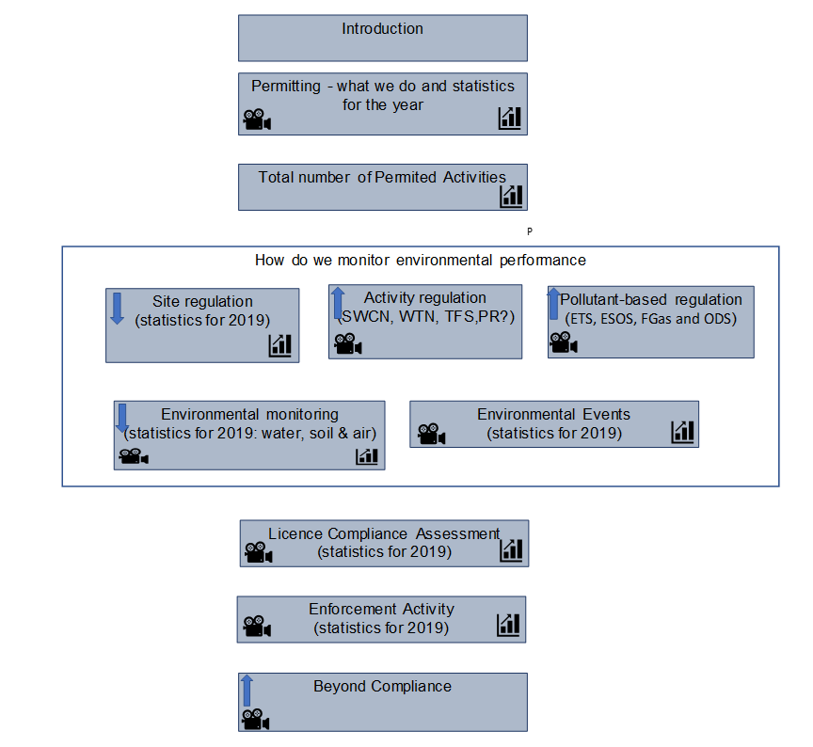

Story: plastics, MRFs and TRS

Story: climate change & action taken

Case study: sector work driving improvements in compliance

Case study

Sector approach Aquaculture New Framework

Case study: Mossmorran/forensic approach

Case study. Proactive intervention Edinburgh

Place-based work River Leven catchment

Story: new permitting function – efficiency & outcome based