SEPA’s Regulatory Guidance on the Placement of Pipelines in the Water Environment  July 2021 | 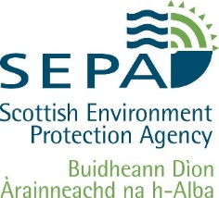

Purpose
This document sets out SEPA’s regulatory guidance relating to the placement of small water supply pipelines within the water environment.

Background
The Water Environment (Controlled Activities) (Scotland) Regulations 2011 (As Amended) (referred to as CAR) regulates activities associated with the water environment.
SEPA are aware that in rural locations small water supply pipelines (abstraction systems) can be used for livestock or drinking water supply. Any abstraction of water from the water environment requires to be authorised however SEPA will not normally require an engineering authorisation for the installation of these type of small pipelines that are laid in inland surface waters provided that good practice is followed to prevent significant impact on the surface water (see below).
Where pipes laid do not follow this good practice or where it is not possible to lay the pipework in this way, an authorisation for the engineering works may be required (under the Controlled Activities Regulations) and if in doubt you should discuss this with your local SEPA team.

Installing pipework within surface waters can have significant impacts on aquatic life if not carried out in line with good practice or an authorisation. Disturbing river beds can result in direct harm, cause sedimentation downstream and potentially destroy fish spawning beds or pearl mussel habitat. Likewise creating fish barriers can restrict fish movement and impact significantly on the ecology of a river. It’s important that the water carried in the abstraction system comes from the same catchment it’s laid in to help prevent the spread of non-native invasive species.
Good Practice requires that:
- Wherever possible, pipelines should be laid underground on land and not on the bed of a watercourse.
- If pipeline is laid on the bed of a watercourse:
  - the construction of the abstraction system should not involve digging or installation that affects the banks or bed of the watercourse.
  - the abstraction system should use a pipe with an outside diameter of under 65mm, unless the abstraction is limited to 10m³ per day by other means.
  - the abstraction system must only take water from the catchment it is placed in.
  - the abstraction system should not prevent the free passage of migratory fish.
  - the abstraction system should be maintained in a good state of repair and kept clear of debris and obstructions.
  - the abstraction system should be removed if no longer required/used.

Good practice pipes
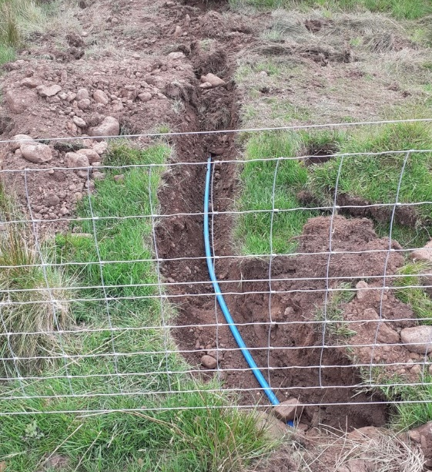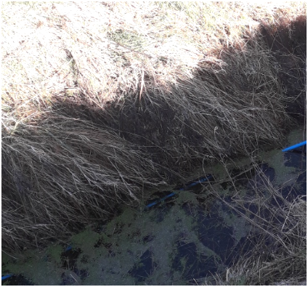
Laid underground on land Laid along watercourse

Following good practice when carrying out such activities or ensuring that the correct authorisation is in place, where one is required, will avoid the risk of the activity being considered an offence under the Controlled Activities Regulations which could result in enforcement action and/or the requirement to remove or alter the structure.
For more information on alternative water supplies for field grazed livestock please see https://www.farmingandwaterscotland.org/downloads/technical-note-tn665-alternative-watering-for-field-grazed-livestock-i-abstraction-systems/

For information on accessing this document in an alternative format or language please contact SEPA by email at equalities@sepa.org.uk
If you are a user of British Sign Language (BSL) the Contact Scotland BSL service gives you access to an online interpreter enabling you to communicate with us using sign language.
http://contactscotland-bsl.org/

www.sepa.org.uk
Strathallan House, Castle Business Park, Stirling, FK9 4TZ

