Fences in Inland Surface Waters-SEPA’s Good Practice Guidance
SEPA will not normally require authorisation for fencing that crosses inland surface waters provided that good practice is followed to prevent significant impact on the watercourse (see below).
Where fencing does not follow this good practice, an application for a licence as an in-stream structure will be required (under the Controlled Activities Regulations). See guidance on engineering activities in the CAR practical guide, if in doubt you should discuss this with your local SEPA team.
Good Practice requires that:
- The structure should not prevent the free passage of migratory fish.
- Wooden posts/stobs supporting the fence should be land based and set back from the channel edge.
- The activity should not involve digging or installation that affects the banks or bed of the watercourse.
- Any wiring should be above high water flows such that it does not act as a screen to mammals or collect debris.
- The structure should be a ‘watergate’ feature that has the ability to swing open.¹
- Any wood used in the construction of the watergate should be untreated.
- Structures should be maintained in a good state of repair and kept clear of debris and obstructions.
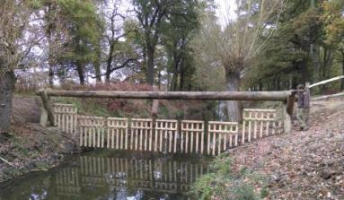
Good practice Watergates. All wiring above high water flow and wooden supporting posts are set back
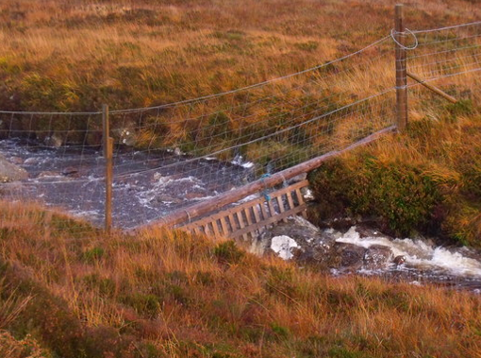
Watergate does not meet good practice. Debris caught in wiring which is below high water flows and supporting posts are in the river.
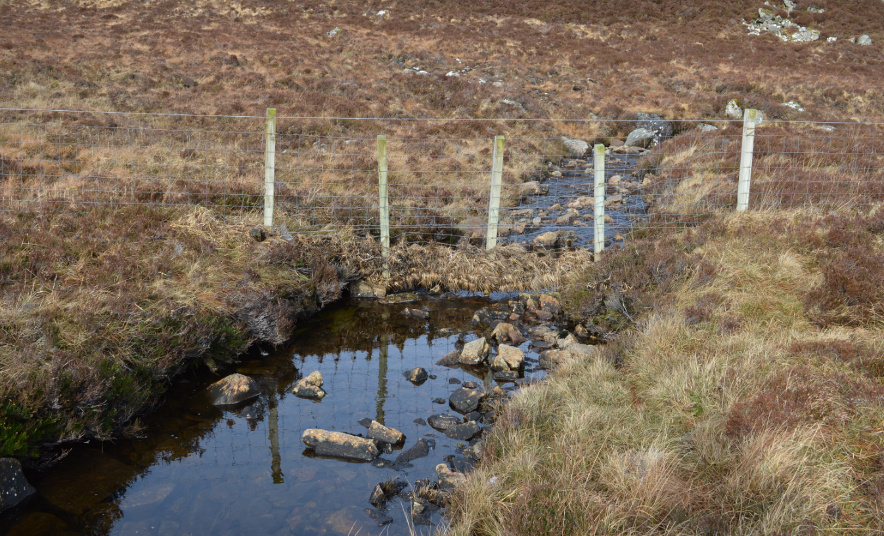
SEPA will consider people carrying out the above activity who do not follow good practice and who do not have the correct SEPA authorisation, to be committing an offence under CAR and may take enforcement action or ask for the structure to be removed or altered.
¹Information on Watergates can be found at http://adlib.everysite.co.uk/adlib/defra/content.aspx?id=000HK277ZX.0HAMAXCK1XW7SWA

