State of Scotland’s Water
Environment 2019
Summary Report

What was the state of the water environment in 2019 classification
The information in this report is based on the 2019 State of the Water Environment classification.

Note: “Good” means conditions consistent with good status or, in the case of heavily modified and artificial water bodies, good ecological potential. Bodies of surface water include rivers, lochs, estuaries and coastal waters. Fish migration and water flows are not relevant to the marine environment, and so are excluded from the graph above. Our monitoring and modelling networks are designed to assess the greatest risks to the environment. Where we do not have evidence to the contrary we report status as high.
Overview of the state of bodies of groundwater in 2019 classification
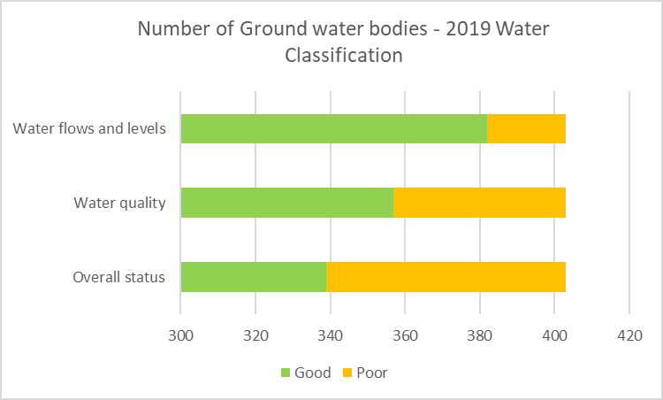
Note: Groundwaters are only classified as Good or Poor status.
Overall, 65.4% of our surface and groundwater water bodies are at good or better status. This is very similar to 2018 classification results. (2018 = 65.7%)
2014 Classification was used for the baseline of RBMP Cycle 2, where 63.5% of water bodies were at good or better.
2019 Overall Classification
 |  | Rivers | Lochs | Estuaries | Coastal | GW | Total
High/Good | Number | 1323 | 231 | 42 | 455 | 339 | 2390
 | Percent | 54.9 | 69.2 | 87.5 | 99.6 | 84.1 | 65.4
< Good | Number | 1087 | 103 | 6 | 2 | 64 | 1262
 | Percent | 45.1 | 30.8 | 12.5 | 0.4 | 15.9 | 34.6
Total | Number | 2410 | 334 | 48 | 457 | 403 | 3652

What’s changed since 2018?
Due to technical issues associated with the cyber attack which SEPA suffered in late 2020 we have been unable to carry out the usual detailed comparison between the 2019 results and previous years. In particular, we cannot currently make the required quantitative assessment of the reasons behind any classification changes. We are working to recover the necessary information, and a detailed assessment of classification changes throughout the 2nd RBMP period between 2015 and 2020 will be included as part of the 3rd River Basin Plan, which will be published in December 2021.

