Environmental Monitoring Plan
Guidance to be deleted - Please save document as: Site Name EMP, SEPA version number, Date of document.
Permit Number: CAR/L/Click or tap here to enter text.
Marine Pen Fish Farm: Click or tap here to enter text.
Responsible company: Click or tap here to enter text.
Version: Click or tap here to enter text.
Date: Click or tap to enter a date.

The purpose of this EMP is to monitor seabed impacts from the marine fish farm in order to assess compliance with the seabed standards specified in schedule 4 of the permit.
This plan has been developed in accordance with SEPA guidance: “Version 1 May 2022 Seabed Environmental Standards - Demonstrating Compliance”.
Two environmental monitoring survey designs are required:
- Biological Sampling
- Chemical Residues Sampling

- Biological sampling
This sampling is designed to collect the required seabed data that will allow an assessment of compliance against schedule 4.1 of the permit.
The default monitoring layout will be followed, with the direction of each transect as follows:
- Transect 1 - bearing * degrees.
- Transect 2 - bearing * degrees.
- Transect 3 - bearing * degrees.
- Transect 4 - bearing * degrees.
Guidance to be deleted and replaced – The 4 bullet points and sentence above can be deleted if you are not using the default monitoring layout, and replaced with proposed monitoring and justification for not using the default monitoring layout.
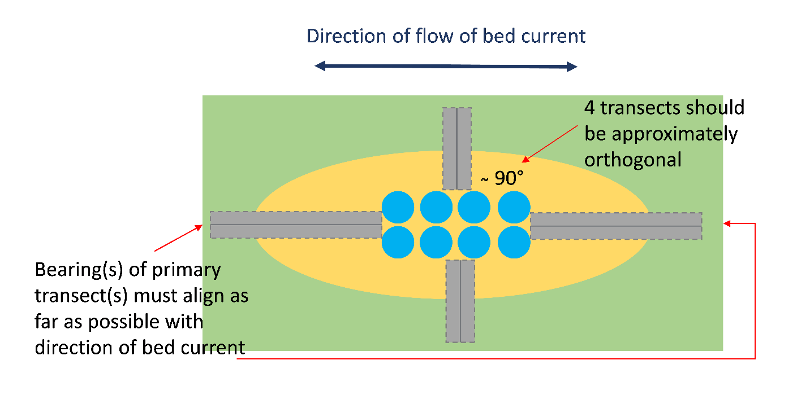
Figure 1 - This is an example monitoring diagram with the pen group aligned with the direction of the main bed current. For a default design, transects should be broadly orthogonal to the direction of the main bed current irrespective of the orientation of the pen group. Please delete and insert relevant site monitoring diagram.

At each sample station samples of sediment will be collected and analysed for:
- benthic infauna
- Particle size analysis (PSA).

If a suitable seabed sample cannot be collected at one or more monitoring stations on a transect:
- the collection of a suitable sample (or samples) will be attempted at different locations on the transect concerned.
- if sufficient suitable samples cannot be collected on the transect after trying to sample at different locations, the collection of samples along a replacement transect will be attempted.
If it is necessary to attempt collection of samples on a replacement transect, the identification of that transect will consider:
- Any relevant information about the seabed to help choose a replacement that maximises the likelihood of being able to collect sufficient samples.
- In the light of (i) above, moving the origin for the transect on the pen group.
- In the light of (i) above, orienting the transect on a different bearing within ± 5° of the predominant direction of the bed current in the case of a replacement primary transect or, in the case of a replacement minor transect, within ± 20° of orthogonal to the direction of the predominant bed current.
- A combination of (ii) and (iii) above.

- Chemical Residues Sampling
This sampling is designed to collect the required seabed data that will allow an assessment of compliance against schedule 4.2 of the permit.
Samples will be collected at the locations specified above.
Guidance to be deleted - The 2 bullet points above are not required if a site is on a single transect Emamectin Benzoate monitoring programme (0.736 ig/kg standard), in which case monitoring location details will conditioned in the permit.
At each sample station samples of sediment will be collected and analysed for:
- Organic carbon
- Particle size analysis (PSA)
- Emamectin Benzoate

- Sampling and analyses, will be carried out in accordance with the following MACS documents:
- Performance Standard MACS-FFA-PSO1 - Version 1 March 2022
- Performance Standard MACS-FFA-PSO2 - Version 1 March 2022
- Performance Standard MACS-FFA-PSO3 - Version 1 March 2022

