AQUACULTURE MODELLING SCREENING & RISK IDENTIFICATION REPORT:
CAOLAS A DEAS WEST (CDSW1)

May, 2023
For information on accessing this document in an alternative format or language please contact SEPA by emailing to equalities@sepa.org.uk

If you are a user of British Sign Language (BSL) the Contact Scotland BSL service gives you access to an online interpreter enabling you to communicate with us using sign language.

http://contactscotland-bsl.org/

Scope of report

As part of the SEPA Aquaculture Regulatory Framework it is recommended that a proposed application for a marine fin fish aquaculture site should undergo a Screening Modelling and Risk Identification process. SEPA carries out this work and this is described on the SEPA aquaculture website Pre-application section:

(https://www.sepa.org.uk/regulations/water/aquaculture/pre-application/)

This report presents information arising from that process. Screening modelling methods are outlined and maps and tables describing the modelled impacts are shown. Risks arising from consideration of the model output are listed. Conclusions and recommendations are made regarding the proposed site.

Executive summary

SEPA has received a proposal to vary an existing marine fin fish aquaculture site called Caolas A Deas West (CDSW1). The site is located in Loch Shell, on the East coast of the Isle of Lewis, at location: 136014, 910228 (Easting, Northing). The existing maximum biomass is 1701t at this location and there is not proposed change to the weight of fish to be farmed. It is proposed that the existing bath treatment chemical (Azamethiphos) treatment mass be increased from 190.6g to 1020 g per 24hrs.

Following screening modelling and risk identification we have concluded the following:

- It is possible that discharges from Caolas A Deas West (CDSW1) will be able to comply with the relevant aspects of the SEPA Aquaculture Regulatory Framework.
- Features at risk, identified at this stage, do not appear to influence the feasibility of the proposed site with respect to the regulatory framework. These risks should be examined using a detailed marine model.
- Caolas A Deas West (CDSW1) is suitable to progress to the next stage of the pre-application process outlined on the SEPA website.
- Use of marine modelling of bath influence will enable more realistic bath medicine treatment quantities to be determined.
- 2D marine modelling should be carried out.
- The size of the marine model should include discharges from all sites identified in this report. However, cumulative modelling including these identified sites will not be required for baths.
- The resolution of the marine model should be relatively fine around the proposed site.
- Due to the low risk to priority marine features at this site, calibration of marine modelling with dye/drogue data is not required, however would lend greater confidence to model results if performed.

List of abbreviations

SEPA Scottish Environment Protection Agency

List of chemical abbreviations

AZA Azamethiphos

Contents

1 Introduction 8

1.1 The objectives of screening modelling and risk identification 8

1.2 Screening modelling methods 9

2 Screening modelling 12

2.1 Site proposal 12

2.2 Dispersion and erosion capacity maps 12

2.3 Bath medicine influence maps and analysis 14

3 Risk Identification 20

3.1 Identified features which require attention 20

3.2 Additional comments on identified features 20

3.3 Risks identified from contextual site data 21

4 Conclusions of screening modelling and risk identification 22

4.1 Conclusions 22

4.2 Recommendations 23

5 References 24

List of Figures

Figure 1: East Coast, Lewis and Harris model grid 11
Figure 2: Modelled average water speed (metres per second – m/s) in the sea area surrounding the proposed site (Caolas A Deas West (CDSW1)). 16
Figure 3: Modelled percentage of time the water flow speed is above 0.095 m/s in the sea area surrounding the proposed site (Caolas A Deas West (CDSW1)). 17
Figure 4: Modelled average Azamethiphos concentration over four days from neap tide release for the proposed site only (Caolas A Deas West (CDSW1)). 18
Figure 5: Modelled average Azamethiphos concentration over four days from neap tide release for the proposed site (Caolas A Deas West (CDSW1)) and other relevant sites. This is provided for illustrative purposes only, and cumulative modelling of bath treatments is not required at this time. 19

List of Tables

Table 1: Azamethiphos influence information for each site. 15
Table 2: Table of licenced biomass from farms identified as likely to add to cumulative risks. 21

Introduction

Screening Modelling and Risk Identification are important steps in the SEPA regulatory framework for marine pen fish farms. They are carried out by SEPA at the pre-application stage, which is described in detail at:

https://www.sepa.org.uk/regulations/water/aquaculture/pre-application/.

This document briefly describes the objectives of screening and risk identification and summarises the methods used. Screening output for the proposed site is then presented with comments. Risks identified from the screening output are detailed. Conclusions and recommendations about the suitability of the proposed site are then made.

The objectives of screening modelling and risk identification

A summary of the modelling methods employed during screening modelling is outlined in section 1.2. The objectives of screening modelling and risk identification are outlined below.

Screening modelling

Marine Modelling technology can be used to simulate and predict the potential influence of discharges on the marine environment. SEPA will require the majority of proposed farms to conduct detailed marine modelling, as outlined in our Aquaculture Modelling guidance [1] and on the SEPA Website.

Marine modelling can also be used at an earlier stage to provide an initial estimate of the influence of material discharged from a proposed site.
SEPA will carry out marine modelling at the screening and risk identification stage. This is a simplified version of the detailed modelling required of the applicant. However, it will be sufficient to perform an initial risk assessment of a proposal. Screening marine modelling will also include discharges from other relevant aquaculture sites and major sources.

The objectives of the simplified screening modelling are to:
- Produce maps of the predicted dispersive and erosive capacity of the sea areas in the vicinity of aquaculture sites
- Produce maps of the predicted spread of sediment discharged from aquaculture sites
- Produce maps of the predicted spread of bath treatment medicines from aquaculture sites
- Present an analysis of the potential influence of sediment and bath treatment discharges from the proposed site alongside existing sites within the surrounding sea area
- Present information on the sensitive features and sites of interest within the surrounding sea area, which must be addressed during pre-application work
- Present a summary of the suitability of the proposal with respect to the dispersal of waste and how this may be modelled.

Risk identification

Maps and analysis of screening output will be compared to information relating to sensitive features and relevant areas of interest. These may include:
- Marine Protected Area (MPA)
- Special Area of Conservation (SAC)
- Priority Marine Feature (PMF)
- Any site identified via consideration of other permitted or regulatory activities.
SEPA Staff will meet to discuss screening model output and the relevant sensitive features information. Following this meeting, a list of identified risks will be added to this report.

Conclusion of screening modelling and risk identification

Following the identification of risks, SEPA will present a summary of the suitability of the proposal with respect to the:
- Dispersal of waste from the proposed site and other sources
- Risks posed to sensitive features
- Likely level of modelling that will be required to address the risks identified.

Screening modelling methods

Marine models divide the sea up into a “grid” of boxes or triangles (often called cells). Each of these is given a water depth. For the screening modelling presented in this report the Marine Scotland “East Coast, Lewis and Harris” (ECLH) has been used. An image of the ECLH model grid is shown in Figure 1. This grid has been set up within a marine modelling software package called MIKE 21 which is manufactured by the company DHI A/S (https://www.dhigroup.com/).

Marine models carry out calculations across a grid to work out how seawater moves and mixes in response to tidal and weather forces. Marine models can also be used to simulate how seawater moves and mixes due to salinity and temperature differences across an area, particularly in response to inputs of freshwater from rivers. For pollutant influence assessments the mixing (dispersion) of dissolved (bath medicine) and particulate (sediment) pollutants can also be estimated. Calculations within a marine model can be performed in three dimensions (3D), where the grid is split into layers to better represent how properties of the sea change with depth. Two dimensional (2D) models can also be created where processes over the water depth are simplified. The amount of mixing in a marine model can be varied using settings in the software.

Screening modelling is currently carried out with 2D models using average mixing settings in the model software. In many areas, this approach will be sufficient to make an initial estimate of the influence of a proposed site. Our screening assessment will take into account factors which may limit a 2D approach. We will also consider whether a particular location is adequately represented by the available models.

Water movement and mixing modelling

Water movement and mixing modelling (hydrodynamics) has been carried out to generate one month of results. The boundaries (edge(s) of) the model have been driven using the “wider domain” Scottish Shelf Model [2]. Wind forces and freshwater inputs have been applied to the model from the same source. The results generated are an estimate of the average water movement and mixing conditions within the model area.

Sediment waste modelling

Screening modelling provides a precautionary and indicative estimate of the size, location and intensity of waste organic material released from aquaculture sites.

The release of sediment from sources within the model area is simulated using one month of hydrodynamic results along with particle tracking modelling technology. Virtual particles are continually introduced to the model grid to represent the potential dispersion of sediment from the sources. Particles in the model are moved and mixed by the hydrodynamics. Additionally, particles are assigned simplified properties, which allow them to settle through the water and be re-suspended (eroded and lifted) from the sea bed.

Bath medicine modelling

Screening modelling provides a precautionary and indicative estimate of the size, location and concentration of bath medicine releases.

The release of bath treatment medicine from sources within the model area is simulated using hydrodynamic results along with particle tracking modelling technology. Virtual particles are introduced to the model grid to represent the potential dispersion of bath medicines from the sources. Particles in the model are moved and mixed by the hydrodynamics. Releases of bath medicines are simulated under worst case mixing (dispersion) conditions, which occur under neap tides. The maximum treatment amount likely to be used at each site is released into the model at the same time and plumes are tracked over the following 96 hours (4 days). Treatment amounts used at screening have been derived from an analysis of historical data. Additionally, all bath medicine particles are concentrated within the top 5 m of the sea area. As all bath medicines are likely to disperse in a similar way, only Azamethiphos (AZA) has been modelled at the screening stage.

Nutrient assessment

Whilst nutrients are not directly modelled during screening, the dispersion of bath medicine releases will give an indication of the likely level of nutrient dispersion. This will be considered alongside any pre-existing nutrient assessment information that may be available.

Analysis of modelling output

SEPA processes the screening modelling output and places it into a standard analysis application built in TIBCO Spotfire. The application allows for the production of standard maps and tables, which are presented below.

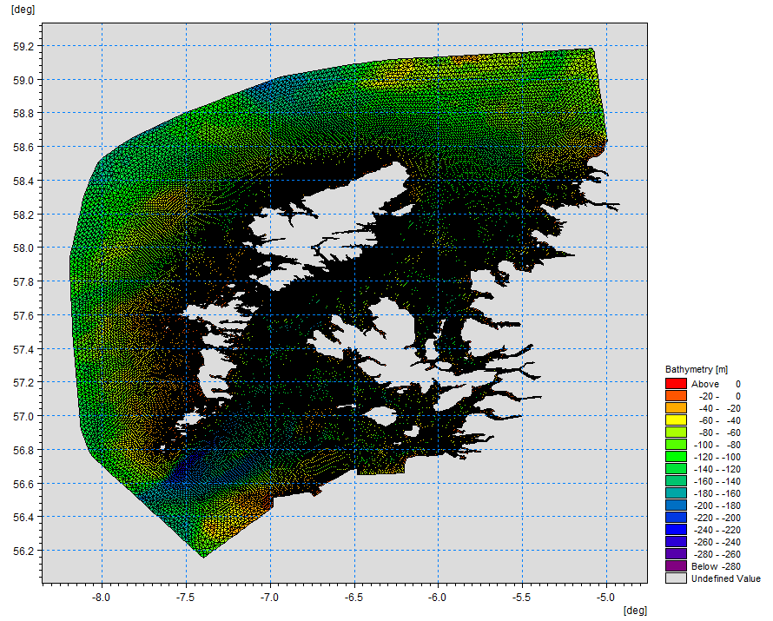
Figure 1: East Coast, Lewis and Harris model grid

Screening modelling

Site proposal

Screening modelling has been carried out for a proposal to vary an existing farm: Caolas A Deas West (CDSW1). The proposal is to site the farm at location: 136014, 910228 (Easting, Northing). The existing maximum biomass is 1701t at this location and there is no proposed change to the weight of fish to be farmed. It is proposed that the existing bath treatment chemical (Azamethiphos) treatment mass be increased from 190.6g to 1020 g per 24hrs. For the screening modelling presented here all relevant licenced sites and current applications have been modelled in conjunction with the proposed site. As this application is to increase allowed bath medicine limits only, no solids screening has been undertaken.

Accuracy of model in the area surrounding the proposal

The East Coast, Lewis and Harris model used for screening modelling has a relatively high resolution in this area. Comparison against various sources of observed current meter data indicates that the model provides a reasonable description of the physical processes in the vicinity of the proposed site.

Dispersion and erosion capacity maps

Modelled water movement in a sea area can be analysed and presented to show the capacity of the water to move and disperse discharged substances. It is also possible to show the capacity available to erode substances from the seabed. This information is a useful guide to the potential size of a marine fin fish aquaculture farm at a particular location.

Marine fin fish aquaculture farms using open-net pens will benefit from operating in locations where there are strong, repeating, water currents to erode and disperse waste.

For the purposes of screening we consider locations which meet the following water flow criteria to be generally suitable for larger farms:

Locations with average water flow speeds of greater than, or equal to, 0.12 metres per second (0.23 knots)
Locations where water flow speeds are often above the threshold of 0.095 meters per second (0.18 knots).

Locations with these properties are likely to disperse discharged material rapidly, and regularly erode sediment discharged to the seabed. In general, we would look for these properties to be maintained over a large area around a proposed site.

The thresholds stated above are indicative.

A map of modelled average water flow speed for the area surrounding the proposed site is shown in Figure 2. The average water flow speed in each cell of the model grid (see section 1.2) has been assigned a shade. The key for the shading is shown in the top left of the figure. Grid cells that have average speeds less than 0.12 m/s (metres per second) are marked on the figure. The greater the shading, the slower the average current speed and the lower the capacity for dispersion.

Figure 3 is a map of the percentage of time the modelled water flow speed in a grid cell is above 0.095 m/s (metres per second). The greater the shading, the lower the capacity for material to be eroded from the seabed.

Licenced aquaculture farms in the vicinity of the proposed site are also marked on Figure 2 and Figure 3. Discharges of material from these sites have been included in the screening modelling.
Based on the maps of the modelled water flow properties we can make the following observations about the proposed site location:
- It lies in a low dispersion area.

Bath medicine influence maps and analysis

Modelled particles in a sea area can be analysed for each modelled grid cell and presented to show the potential influence of discharged bath medicine on the surrounding sea area. Results presented are for the AZA medicine (see section 1.2.3).

Figure 4 shows a map of the modelled average AZA concentration over four days for the proposed site only. Grid cells within the model which experience an AZA influence are shaded according to the concentration of AZA in nanograms per litre (ng/l).

Values less than 10 ng/l have been excluded from the map and subsequent calculations. These low concentration cells are produced by the particle tracking approach but they are not considered to be representative of the main influence of a discharge.

Please note that the Environmental Standard for Azamethiphos with the lowest concentration is 40 ng/l. This must be met 72 hours after the material has been discharged. The estimate of influence detailed here is precautionary. In the information presented below areas of influence above 40 ng/l have been quoted. However the average and median concentrations are quoted for the entire area of influence above 10 ng/l.

The shading key is shown in the top left of the figure. Cells which are shaded black are similar to the average concentration in the total area of influence shown in the map. Cells shaded pink are similar to the median (middle value in the range) concentration shown on the map. White shaded cells are similar to the minimum concentration value shown on the map.

- The average and median concentration over the total area of influence is 32.44 ng/l and 19.70 ng/l respectively.
- Cells influenced by the proposed site appear to lie close to other modelled farm sites.

Figure 5 shows a map of the modelled average AZA influence over four days for the proposed site and other relevant sites. The average AZA influence, after including all relevant sites, is increased.

- The average and median AZA concentration over the total area of influence is 38.14 ng/l and 23.10 ng/l respectively.
- Cells influenced by other modelled sites appear to lie close to the proposed site.

Bath medicine influence analysis

Model grid cells can be analysed to estimate the size and concentration of the potential AZA influence from the modelled sites.

- The area of AZA influenced above 40 ng/l from all sites modelled is estimated to be 2.79 square kilometres (km2).
- As shown in Figure 5, the average and median concentration over the total area of influence is 38.14 and 23.10 ng/l respectively.
- The total weight of fish that generates this modelled influence is 13933.9 tonnes.

Table 1 shows the information for each individual site modelled. It is important to note that the total area of influence above 40ng/l for all sites quoted above is not the sum of the numbers in Table 1. The total area of influence worked out above takes into account that the individual areas of influence above 40 ng/l from different sites will overlap.

Table 1: Azamethiphos influence information for each site.
Site Name | Average Conc. (ng/l) | Area of Influence Above 40 ng/l (km2) | Median Conc. (ng/l) | Weight Of Fish (tonnes)
CDSW1 | 32.44 | 0.90 | 19.70 | 1701
CDSE1 | 28.60 | 0.93 | 19.00 | 1701
GVRN1 | 13.59 | 0 | 13.17 | 4680
GVRW1 | 23.42 | 0.20 | 18.13 | 515.7
ODH1 | Less than 10 | 0 | Less than 10 | 2285.2
SHEO1 | Less than 10 | 0 | Less than 10 | 620
SHNEM1 | 19.97 | 0.06 | 16.01 | 1331
SHNEM2 | 16.24 | 0 | 13.95 | 1100
Please note that the Environmental Standard for Azamethiphos with the lowest concentration is 40 ng/l. This must be met 72 hours after the material has been discharged. The estimate of influence detailed above is precautionary. The values presented are close to the 40 ng/l standard. Detailed modelling will be required to demonstrate compliance with all Environmental Standards.

©Crown copyright. All rights reserved. SEPA lic. no. 100016991 (2019).
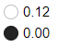
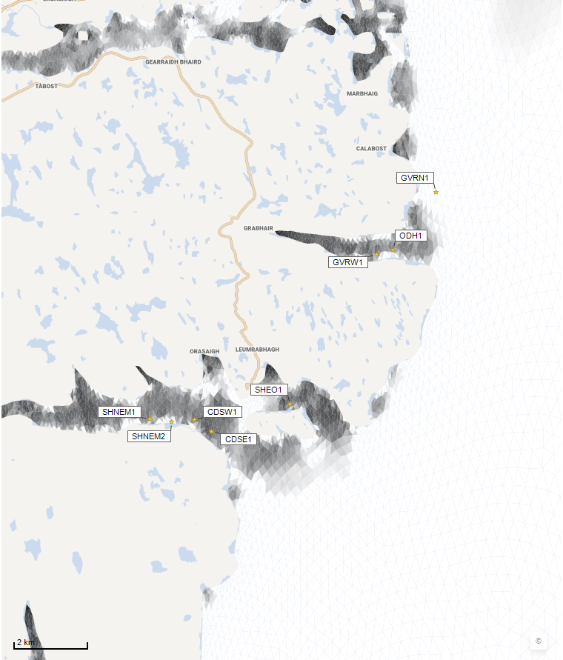
©Crown copyright. All rights reserved. SEPA lic. no. 100016991 (2019).
Average water speed (m/s)
Figure 2: Modelled average water speed (metres per second – m/s) in the sea area surrounding the proposed site (Caolas A Deas West (CDSW1)).

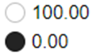
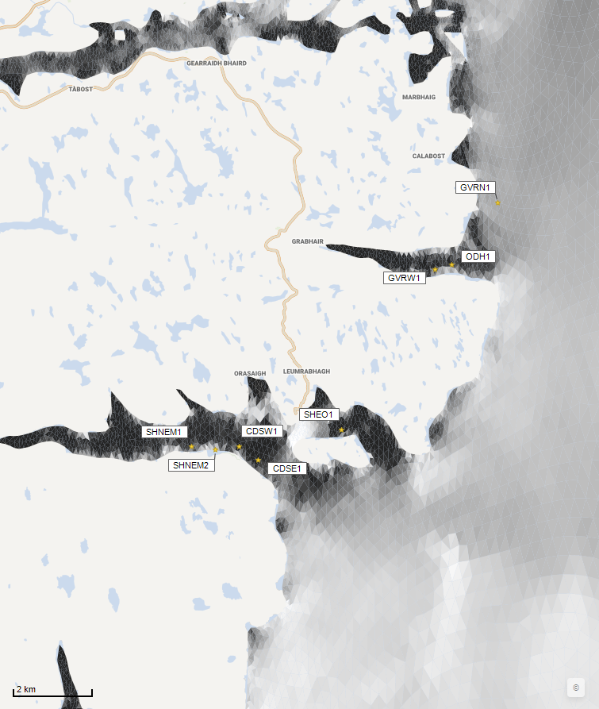
Percentage time (%)
©Crown copyright. All rights reserved. SEPA lic. no. 100016991 (2019).
Figure 3: Modelled percentage of time the water flow speed is above 0.095 m/s in the sea area surrounding the proposed site (Caolas A Deas West (CDSW1)).
©Crown copyright. All rights reserved. SEPA lic. no. 100016991 (2019).

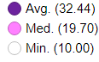
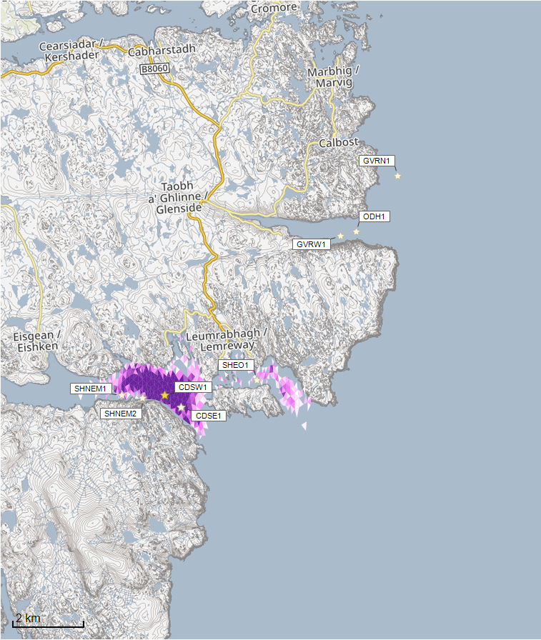
Azamethiphos Conc. (ng/l)

Concentrations of AZA presented on this map are less than the 40 ng/l Environmental Standard and are presented for information only.

©Crown copyright. All rights reserved. SEPA lic. no. 100016991 (2019).
Figure 4: Modelled average Azamethiphos concentration over four days from neap tide release for the proposed site only (Caolas A Deas West (CDSW1)).

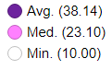
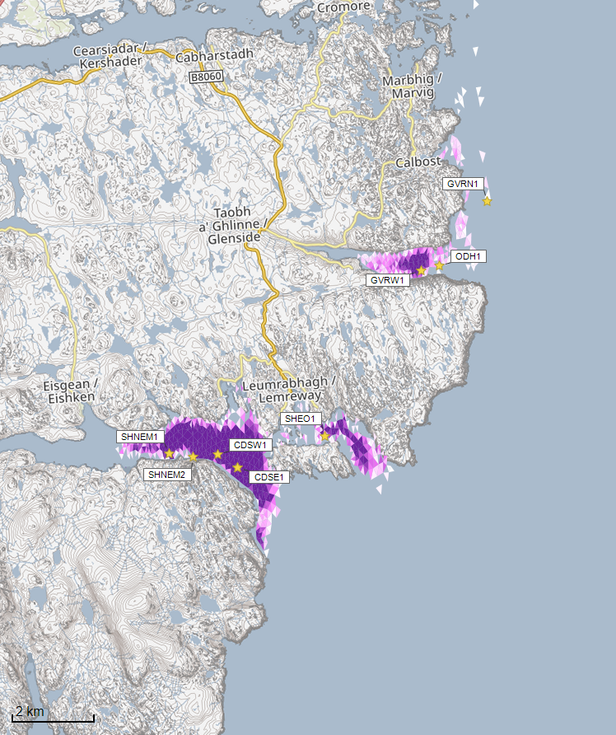
Azamethiphos Conc. (ng/l)

Concentrations of AZA presented on this map are less than the 40 ng/l Environmental Standard and are presented for information only.

©Crown copyright. All rights reserved. SEPA lic. no. 100016991 (2019).
Figure 5: Modelled average Azamethiphos concentration over four days from neap tide release for the proposed site (Caolas A Deas West (CDSW1)) and other relevant sites. This is provided for illustrative purposes only, and cumulative modelling of bath treatments is not required at this time.

Risk Identification

The screening modelling output summarised in section 2 is compared against available information on features of interest (see section 1.1.2). Features which require attention are presented with any additional comments. Identified features will need to be considered during the pre-application phase.

These should be addressed in the applicant “Method Statement”. Please refer to the Modelling Method Statement section on the SEPA Website.
(https://www.sepa.org.uk/regulations/water/aquaculture/pre-application/)

Identified features which require attention

Based on screening output, no features of interest have been identified.

Additional comments on identified features

Screening modelling does not predict any significant bath influence from Caolas A Deas West (CDSW1), however due to the large treatment mass for Azamethiphos proposed, and the conservative nature of the simple BathAuto model, quantities of bath medicines may be limited to impractical amounts for this site. Use of marine modelling of bath influence will enable more realistic bath medicine treatment quantities to be determined. Cumulative modelling for bath treatments is not required. Dye/drogue calibration will not be required, however if conducted this may benefit the model calibration and lend confidence to the modelled bath treatment chemical dispersion.

Risks identified from contextual site data

Should this application proceed, the total licenced biomass in this area would remain 13933.9t.

Table 2: Table of licenced biomass from farms identified as likely to add to cumulative risks.
This is provided for illustrative purposes only in this instance, as cumulative modelling of baths is not required at this time.
Site Name | Location  (Easting, Northing) | Biomass (tonnes) | Last Production Cycle
CDSW1 | 136014, 910228 | 1701 | Currently stocked  (Since Nov 22)
CDSE1 | 136476, 909866 | 1701 | Currently stocked  (Since Dec 22)
GVRN1 | 143036, 915999 | 4680 | Proposed site.
GVRW1 | 141310, 914410 | 515.7 | Currently stocked  (Since Sep 22)
ODH1 | 141750, 914500 | 2285.2 | Currently stocked  (Since Aug 22)
SHEO1 | 138663, 910486 | 620 | Fish last on site Dec 2013
SHNEM1 | 134811, 910321 | 1331 | Fish last on site Jan 2014
SHNEM2 | 135400, 910200 | 1100 | Fish last on site Jan 2014

Conclusions of screening modelling and risk identification

Following screening modelling and risk identification we make a number of conclusions and recommendations.

Conclusions

Screening Modelling

- According to screening modelling, the proposed site (Caolas A Deas West (CDSW1)) is in an area of low dispersion.
- From bath treatment modelling:
  - Information presented in section 2 indicates that the relative influence of Caolas A Deas West (CDSW1) is likely to be similar to other sites for a similar tonnage.
  - The influence on the surrounding sea area from Caolas A Deas West (CDSW1) is likely to be low.
  - The areas of influence from Caolas A Deas West (CDSW1), and other sites modelled do appear to interact.
  - It is likely that discharges of bath medicines from Caolas A Deas West (CDSW1) will be dispersed to low levels over a moderate area.
  - Caolas A Deas West (CDSW1) is likely to result in a small increase in the total influence of all sites modelled. This is coinciding with areas of influence generated by existing sites, however cumulative modelling of bath treatments is not required at this time.

Risk identification

Although the modelled influence from Caolas A Deas West (CDSW1) appears to be low, the large treatment mass proposed at this site means bath influence needs to be assessed using further detailed marine modelling. Given the predicted low risk from screening, a 2D model will suffice.
The conservative nature of the simple BathAuto model means quantities of bath medicines may be limited to impractical amounts for this site. Use of marine modelling of bath influence will enable more realistic bath medicine treatment quantities to be determined. Cumulative modelling of identified sites will not be required for baths.

Recommendations

Site suitability

Consideration of screening modelling and risk identification suggests that it is possible that discharges from the proposed site will be able to comply with the relevant aspects of the SEPA Aquaculture Regulatory Framework. This must be demonstrated with a detailed marine model.

Features at risk, identified at this stage, do not appear to influence the feasibility of the proposed site, with respect to the regulatory framework.

Following the engagement meeting(s), this report will be revised and this should allow to the applicant to submit a method statement which address the issues raised in this document.

Further modelling

- Use of marine modelling of bath influence will enable more realistic bath medicine treatment quantities to be determined.
- 2D marine modelling should be carried out.
- The size of the marine model should include discharges from all sites identified in this report. However, cumulative modelling including these identified sites will not be required for baths.
- The resolution of the marine model should be relatively fine around the proposed site.
- Due to the low risk to priority marine features at this site, calibration of marine modelling with dye/drogue data is not required, however would lend greater confidence to model results if performed.

References

[1] Regulatory Modelling Guidance For The Aquaculture Sector. Published on SEPA website.

[2] http://marine.gov.scot/information/wider-domain-scottish-shelf-model.

