

# Aquaculture Modelling Screening and Risk Identification Report:

Report date: June 2025

# MORRISONS ROCK (MORR1)

**CAR/L/5002079**

# VERSION 1

## Scope of report

As part of the SEPA Aquaculture Regulatory Framework it is recommended that a proposed application for a marine finfish aquaculture site should undergo a Screening Modelling and Risk Identification process. SEPA carries out this work and this is described on the SEPA aquaculture website [**Pre-application section**](https://www.sepa.org.uk/regulations/water/aquaculture/pre-application/).

This report presents information arising from that process. Screening modelling methods are outlined and maps and tables describing the modelled impacts are shown. Risks arising from consideration of the model output are listed. Conclusions and recommendations are made regarding the proposed site.

## Executive summary

SEPA has received a proposal for a new marine pen finfish farm called Morrisons Rock (MORR1). The proposed MPFF is at: 89768.97, 852420.90 (Easting, Northing). Pre-application advice has been requested early in the process and consequently the proposal is still in development and subject to change, however the maximum proposed weight of fish to be farmed is 5050t.

The final layout of the MPFF has also yet to be finalised but proposed is an 8 x 160m pen configuration (arranged in an 2x4 setup) with top nets and a 600T feed barge. Farmed species could be either Rainbow Trout or Atlantic Salmon. The finite location of the farm will be dependent on feedback from this pre-application process.

Following screening modelling and risk identification we have concluded the following:

* It is possible that discharges from Morrisons Rock (MORR1) will be able to comply with the relevant aspects of the SEPA Aquaculture Regulatory Framework.
* Due to the fast flow speeds and lack of sensitive features at risk from solids, marine modelling for solids is not required for this site
* Marine modelling of baths may be used to get a less conservative bath medicine quantity compared to BathAuto.
* Baseline surveys will be required if this pre application should advance with the application process. These surveys should include residue sampling due the proximity of other MPFFs in the vicinity.
* Standard default NewDepomod has been undertaken to demonstrate the proposed biomass can be supported.
* The proximity to locational guidelines waterbodies has been assessed and not considered a risk, however the open water ECE calculation will still be required.
* Sea lice screening has shown a very small effect on the exposure risk. No criteria for further work have been triggered. The outcome of current screening is that this site will not require a lice permit condition. No further modelling work is required, at this time.

## List of abbreviations

SEPA Scottish Environment Protection Agency

MPFF Marine Pen Fish Farm

CTG Consenting Task Group

AMZ Allowable Mixing Zone

PMF Priority Marine Feature

EIA Environmental Impact Assessment

HRA Habitats Regulations Appraisals

SAC Special Area of Conservation

SPA Special Protected Area

SSSI Site of Special Scientific Interest

MPA Marine Protected Area

AZA Azamethiphos

Contents

Aquaculture Modelling Screening & Risk Identification Report: 1

MORRISONS ROCK (MORR1) 1

VERSION 1 1

Scope of report 2

Executive summary 3

List of abbreviations 5

List of Figures 7

List of Tables 8

SEPA: Introduction 9

SEPA: Screening modelling 10

SEPA: Risk Identification 18

SEPA: Conclusions 27

## List of Figures

Figure 1. East Coast Lewis and Harris model grid. 10

Figure 2: Modelled average water speed (metres per second – m/s) around the proposed site (Morrisons Rock (MORR1)). 12

Figure 3: Modelled average sediment intensity over one month from the proposed site only (Morrisons Rock (MORR1). 14

Figure 4: Modelled average sediment intensity from the proposed site and other relevant sites. 15

Figure 5: Modelled average Azamethiphos concentration over four days from neap tide release for the proposed site only (Morrisons Rock (MORR1). 17

Figure 6: Map of the average modelled lice concentration over the simulated April and May period (in lice/m2) within the top two meters of the sea area. MORR1 site location shown as a blue circle. Fish tracks are shown as green lines with the WSPZs, which are highlighted by a white boundary. 21

## **List of Tables**

Table 1: Table of identified features of interest 18

Table 2: Influence of modelled sea lice from MORR1 on exposure in the relevant affected WSPZs. 22

Table 3: Location of MORR1 within the assessment matrix framework of WSPZ capacity and site contribution. 24

Table 4: Table of farms which should be included in any cumulative modelling. 26

## SEPA: Introduction

Screening Modelling and Risk Identification are important steps in the SEPA regulatory framework for marine pen fish farms. SEPA carries out this work and this is described on the SEPA aquaculture website [**Pre-application section**](https://www.sepa.org.uk/regulations/water/aquaculture/pre-application/)

This section presents screening output for the proposed site with comments. Risks identified from the screening output are detailed. Conclusions and recommendations about the suitability of the proposed site are then made.

A summary of the modelling methods employed during screening modelling can be found alongside this document on the SEPA website.

## SEPA: Screening modelling

#### Accuracy of model in the area surrounding the proposal

The East Coast Lewis and Harris model used for screening modelling has a relatively low resolution in this area.

Comparison against observational current meter data indicates that the model provides a reasonable performance of the physical processes in the vicinity of the proposed site.

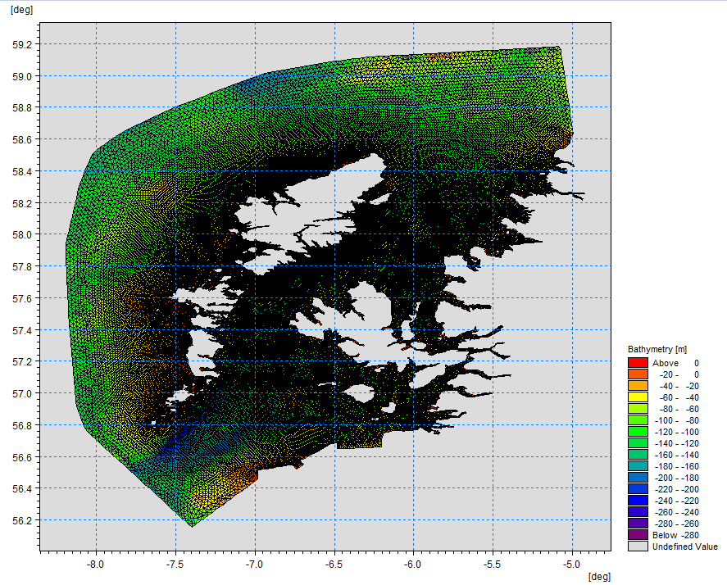

Figure 1. East Coast Lewis and Harris model grid.

### Dispersion and erosion capacity maps

Modelled water movement in a sea area can be used to show the capacity of the water to move and disperse discharged substances. It is also possible to show the capacity available to erode substances from the seabed. This information is a useful guide to the potential size of a marine pen fish farm at a particular location.

Marine pen fish farms using open-net pens will benefit from operating in locations where there are strong, repeating, water currents to erode and disperse waste.

Locations with average water flow speeds of greater than, or equal to, 0.12 metres per second (0.23 knots) are for screening purposes, considered generally suitable for larger farms.

A map of modelled average water flow speed for the area surrounding the proposed site is shown in Figure 2. The average water flow speed in each cell of the model grid has been assigned a shade. The darker the shading, the slower the average current speed and the lower the capacity for dispersion.

Licenced aquaculture farms in the vicinity of the proposed site are shown and discharges of material from these sites have been included in the screening modelling.

#### Modelled flow properties

Based on the maps of the modelled water flow properties we can make the following observations about the proposed site location:

* It lies in a high dispersion area.
* It lies in an area where water flow has a high capacity to erode material on the seabed.

©Crown copyright. All rights reserved. SEPA lic. no. 100016991 (2019).

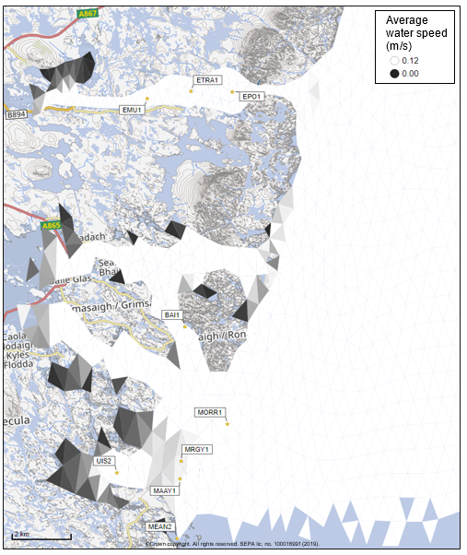

Figure 2: Modelled average water speed (metres per second – m/s) around the proposed site (Morrisons Rock (MORR1)).

### Sediment influence maps and analysis

Modelled particles in a sea area can be analysed for each modelled grid cell and presented to show the potential influence of discharged sediment on the surrounding sea area.

Values less than 1 g/m2 have been excluded from the map and subsequent calculations. These low concentration cells are produced by the particle tracking approach but they are not considered to be representative of the main influence of a discharge.

Figures 3 and 4 show maps of the modelled average sediment intensity over one month (time average). Grid cells within the model that are influence by modelled sediment are shaded according to the intensity of the influence in grams per square metre (g/m2). Cells which are shaded purple are similar to the average and those shaded pink are similar to the median (middle value in the range) intensity value shown on the map.

Sediment intensity values presented on this map are low and are presented for information only.

©Crown copyright. All rights reserved. SEPA lic. no. 100016991 (2019).

©Crown copyright. All rights reserved. SEPA lic. no. 100016991 (2019).

Sediment intensity values presented on this map are low and are presented for information only.

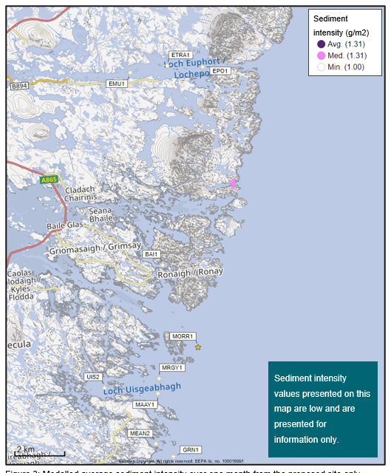

Figure 3: Modelled average sediment intensity over one month from the proposed site only (Morrisons Rock (MORR1).

©Crown copyright. All rights reserved. SEPA lic. no. 100016991 (2019).

Sediment intensity values presented on this map are low and are presented for information only.

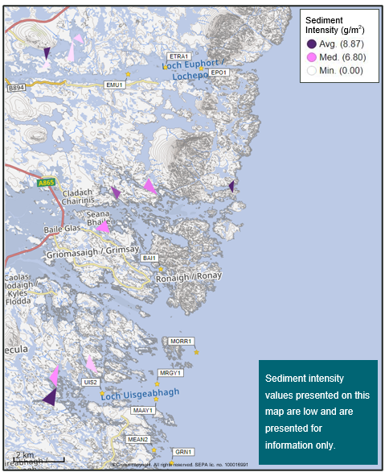Figure 4: Modelled average sediment intensity from the proposed site and other relevant sites.

### Bath medicine influence maps and analysis

Modelled particles in a sea area can be analysed for each modelled grid cell and presented to show the potential influence of discharged bath medicine on the surrounding sea area. Results presented are for the Azamethiphos medicine.

Figure 5 shows a map of the modelled average AZA concentration over four days for the proposed site only. Grid cells within the model which experience an AZA influence are shaded according to the concentration of AZA in nanograms per litre (ng/l). Cells which are shaded purple are similar to the average and those shaded pink are similar to the median (middle value in the range) intensity value shown on the map.

Values less than 10 ng/l have been excluded from the map. These low concentration cells are produced by the particle tracking approach, but they are not considered to be representative of the main influence of a discharge.

Please note that the Environmental Standard for Azamethiphos with the lowest concentration is 40 ng/l. This must be met 72 hours after the material has been discharged. The estimate of influence detailed here is precautionary.

©Crown copyright. All rights reserved. SEPA lic. no. 100016991 (2019).

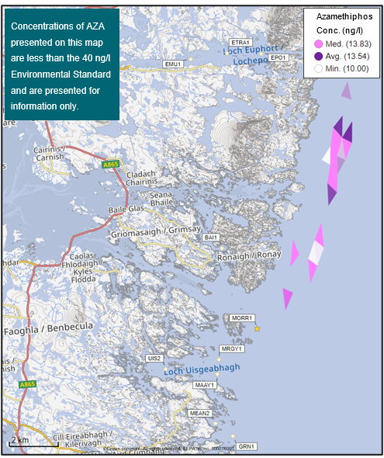

Figure 5: Modelled average Azamethiphos concentration over four days from neap tide release for the proposed site only (Morrisons Rock (MORR1).

## SEPA: Risk Identification

The screening modelling output summarised in the screening modelling section is compared against available information on features of interest. Features which require attention are presented with any additional comments and will need to be considered during the pre-application phase.

### Features of Interest which require attention

Sensitive features in the area have been assessed, those considered at risk and therefore requiring additional consideration, can be found in the table below.

Table 1: Table of identified features of interest

| **Feature Name** | **Feature Type** | **Location (Easting, Northing)** | **Brief Reason for Identification** |
| --- | --- | --- | --- |
| Ocean quahog | PMF | 089202, 853138 | At risk from bath influence |
| Northern seafan | PMF | 089202, 853138 | At risk from bath influence |
| Northern sea fan and sponge communities and | PMF | PMF features identified in 2022 visual survey report | At risk from bath influence |
| Kelp beds (on rock) | PMF | PMF features identified in 2022 visual survey report | At risk from bath influence |

### Baseline Surveys

Visual and benthic baseline surveys will be required to assess and characterise the seabed under the proposed farm and will be required to cover the new area of seabed not assessed in the 2022 survey. Chemical residue samples will also be required due to the presence of other MPFFs in the vicinity of the proposed farm.

### Additional comments on sediment influence

Screening modelling does not predict any significant sediment influence from Morrisons Rock (MORR1), and no Priority Marine Features have been highlighted as potentially at risk from sediment influence. Therefore, marine modelling of solids will not be required for this site. However, NewDepomod will be required.

### Additional comments on bath influence

The conservative nature of the simple BathAuto model in areas of high current speeds, means quantities of bath medicines may be limited to impractical amounts for this site. Use of marine modelling of bath influence will enable more realistic bath medicine treatment quantities to be determined. Features identified as at risk within this area will need to be addressed in any marine modelling, however cumulative modelling of baths is not required. Dye/drogue calibration will not be required.

### Nutrient influence

The proximity to locational guidelines waterbodies has been assessed and not considered a risk, however the standard ECE calculation will still be required to ensure nutrient enhancement levels from this new farm are acceptable.

### Sea Lice Screening

Sea lice screening was carried out using our standard method with the translated Scottish Shelf ECLH (East Coast Lewis & Harris) sub area model.  This method is outlined in in Appendix 4 of the May 2023 second consultation document: [Managing interactions between sea lice from finfish farms and wild salmonids, Proposed new regulatory framework, May 2023.](https://consultation.sepa.org.uk/regulatory-services/detailed-proposals-for-protecting-wild-salmon/)

### Modelled Sea Lice Concentration Map – MORR1

Figure 6 shows a map of the average modelled lice concentration over the simulated April and May period (in lice/m2) within the top two meters of the sea area. Model grid cells (triangles) are coloured according to the amount of sea lice particles within them.

#### Indicative Influence

The map serves as an indicative influence under average tidal and weather conditions. The focus is on areas of potential high influence for further fish track analysis within WSPZs.

#### Exclusion of Low Concentrations

Any grid cells with concentrations below 0.01 lice/m² are not shown on the map. This exclusion helps focus on more influential concentrations on the fish track analysis and WSPZs. However, these concentrations are not excluded from fish track exposure analysis below.

#### Colour Intensity, 90th Percentile and Median Concentrations

The more intense the colour in the grid cells, the closer the concentration is to the 90th percentile of all concentrations within the model cells. This brings attention to areas of higher modelled influence.  The 90th percentile of sea lice concentrations is 0.06 lice/m², meaning that 90% of the concentrations are below this value.  The median concentration is 0.02 lice/m², suggesting that half of the values are below this number. At baseline (before the introduction of the proposed site), the average 90th percentile concentration across modelled sites was 0.04 lice/m².

#### Focus Area

The fish track exposure assessment, on which the screening outcome is based, is on the zone where the influence is highest. In this case, the highest modelled influence occurs in the Loch Maddy WSPZ.  This does not mean the actual modelled exposure will be high.

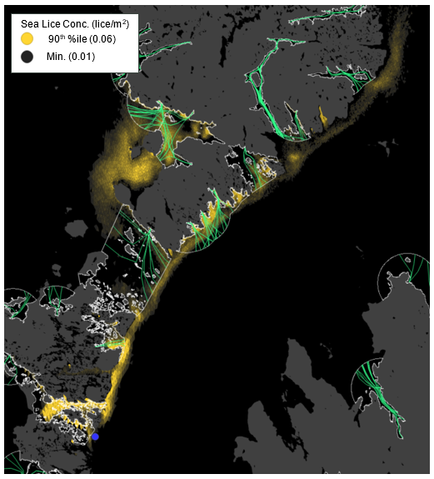

Figure : Map of the average modelled lice concentration over the simulated April and May period (in lice/m2) within the top two meters of the sea area. MORR1 site location shown as a blue circle. Fish tracks are shown as green lines with the WSPZs, which are highlighted by a white boundary.

### Modelled Sea Lice Concentrations – Single Site Influence on Exposure – MORR1

Table 2 shows information relating to the influence of modelled lice concentrations, from MORR1 alone, on fish track exposure levels within the relevant WSPZs.

Table : Influence of modelled sea lice from MORR1 on exposure in the relevant affected WSPZs.

| **Wild Salmon Protection Zone (WSPZ)** | **95th %ile of Fish Track Exposure (lice/m2 days)** | **% of Exposure Threshold (0.7 lice/m2 days)** |
| --- | --- | --- |
| Loch Maddy | 0.09 | 12.26 |
| Loch Stocinis / Loch Fleòideabhagh / Loch Fhionnsabhaigh | 0.09 | 12.03 |
| Loch a Siar | 0.06 | 8.17 |
| Loch Tarbert (Harris) | 0.05 | 6.40 |
| Sound of Harris | 0.04 | 4.76 |
| Oitir Mhor and Traigh Leathann | 0.01 | 1.40 |

#### WSPZ Influence

Six WSPZs are influenced to a medium to low degree.  Six other WSPZs are influenced to a very low degree. Exclusion of these from the table brings focus on the areas of highest influence. However, all influences are included in the combined exposure analysis below.

#### Exposure Threshold

The percentage of the exposure threshold is shown to illustrate the scale of a single site influence. The exposure influence of all sites is not simply the sum of the individual site percentages.  The overlapping influence of all sites on modelled screening exposure is shown below.

#### Assessment Matrix

An assessment matrix is presented on page 57 of the SEPA December 2023 response to consultation feedback: Managing interactions between sea lice from finfish farms and wild salmonids, SEPA response to [consultation feedback](https://consultation.sepa.org.uk/regulatory-services/detailed-proposals-for-protecting-wild-salmon/), December 2023.

Using the fish track exposure method, we establish the location of MORR1 within the assessment matrix framework of WSPZ screening capacity and site contribution.  To assess the capacity influence, we take the WSPZ which experiences the greatest influence, in this case it is Loch Maddy. Table 3 shows that MORR1 lies within cell B1 (Small, Large).

Table : Location of MORR1 within the assessment matrix framework of WSPZ capacity and site contribution.

| **Contribution to infective-stage sea lice exposure** | **Remaining available capacity in WSPZ** | | |
| --- | --- | --- | --- |
| **Large (1)** | **Intermediate (2)** | **Little or none (3)** |
| **Negligible (A)** | A1 | A2 | A3 |
| **Small (B)** | B1 **MORR1** | B2 | B3 |
| **Moderate (C)** | C1 | C2 | C3 |
| **Substantial (D)** | D1 | D2 | D3 |
| **Table Cell Colour Key (Permit conditions controlling on farm sea lice levels (19th March to 31st May)** | | | |
| A1 to A3, B1 to B2, C1 | No sea lice limit conditions. | | |
| B3, C2, D1 | Sea lice limits proposed by the developer and used in the screening assessment. | | |
| C3, D2 | Sea lice limits derived from an appropriate modelling assessment demonstrating that the farm will not compromise achievement of the sea lice exposure threshold. | | |
| D3 | Sea lice limits derived from an appropriate modelling assessment demonstrating that the farm will not compromise achievement of the sea lice exposure threshold. | | |

### Combined Influence of MORR1 on all Wild Salmon Protection Zones

Using the fish track exposure method, we can calculate the latest combined influence of all sources on the exposure threshold within all WSPZs, including the proposed at the time of its submission.  MORR1 mainly affects the Loch Maddy WSPZ.  Its inclusion has reduced some of the remaining capacity in Loch Maddy, but does not, on its own, cause the exposure threshold upper limit to be exceeded.  MORR1 has also reduced the screening capacity in several nearby WSPZs but to a small/very small degree.

### Conclusion of Sea Lice Screening

The outcome of current screening is that this site will not require a lice permit condition. No further modelling work is required, at this time.

### Risks identified from contextual site data

Table 4: Table of farms which should be included in any cumulative modelling.

| **SITE ID** | **Location (Easting, Northing)** | **Biomass (Tonnes)** | **Last production Cycle** | **Include in solids marine modelling?** |
| --- | --- | --- | --- | --- |
| BAI1 | 88585, 855818 | 50 | 2020 | No |
| EMU1 | 87900, 863600 | 450 | Not in use since records began (2002) | No |
| EPO1 | 90800, 863600 | 675 | 2021 | No |
| ETRA1 | 89396, 863743 | 450 | 2019 | No |
| GRN1 | 88,447, 848121 |  | 2023 | No |
| MAAY1 | 88018, 850698 | 2000 | 2023 | No |
| MEAN2 | 87770, 848690 | 200 | 2010 | No |
| MORR1 | 89769, 852421 | 5050 (proposed) |  | No |
| MRGY1 | 88110, 851290 | 2150.8 | 2024 | No |
| UIS2 | 85900, 851080 | 1103.50 | 2021 | No |

## SEPA: Conclusions

### Conclusions

* According to screening modelling, the proposed site (Morrisons Rock (MORR1)) is in an area of high dispersion and has a relatively high capacity for erosion of material on the seabed.
* The screening model provides a reasonable performance in the vicinity of the site when compared to observational data.

### Recommendations and Further Modelling

Following the engagement meeting(s), this report may be revised and this should allow the applicant to submit a method statement which address the issues raised in this document.

The proximity to locational guidelines waterbodies has been assessed and not considered a risk, however the open water ECE calculation will still be required.

* Due to the fast flow speeds and lack of identified risks, marine modelling is not required for this site, unless marine modelling for baths is to be undertaken. Neither cumulative modelling of baths and dye/drogues are required.
* Standard NewDepomod was carried out and shows the proposed biomass can be supported.
* Sea lice screening has shown a very small effect on the exposure risk. No criteria for further work have been triggered. The outcome of current screening is that this site will not require a lice permit condition. No further modelling work is required, at this time.

For information on accessing this document in an alternative format or language, please contact SEPA by emailing [equalities@sepa.org.uk](mailto:equalities@sepa.org.uk)

If you are a user of British Sign Language (BSL), the Contact Scotland BSL service gives you access to an online interpreter, enabling you to communicate with us using sign language. [contactscotland-bsl.org](http://contactscotland-bsl.org/)