Antimicrobial resistance (AMR) in the environment
September 2023

SEPA Information Note

The silent pandemic of antimicrobial resistance
Antimicrobials (including antibacterials (of which antibiotics are a sub-group), antivirals, antifungals, and antiparasitics) are medicines that are used widely to prevent and treat infections in humans, animals, and plants. Other pharmaceuticals and many other chemicals (such as heavy metals, fungicides and herbicides) also have antimicrobial properties. Antimicrobial resistance (AMR) occurs when bacteria, viruses, fungi, and parasites change and no longer respond to antimicrobial treatment. Coupled with limited production of new antimicrobials, infections can be more difficult to treat, with an increasing risk of disease spread, severe illness and death. Whilst AMR has occurred naturally for millennia, the misuse and overuse of antimicrobials in humans, animals, and agriculture in some parts of the world is accelerating the production of clinically important resistant microbes. Antibiotic resistant bacteria are routinely found in the digestive tracts of humans and animals and in environmental media, such as water, sewage, soil, and air. Resistant microbes and genes can subsequently spread and be transmitted to humans, food, animals, plants, and wildlife posing a significant and increasing threat to them.

AMR has emerged as one of the leading human health threats of the 21st century. A review on AMR commissioned by the UK Government predicts that AMR could cause the death of 10 million people per year by 2050. Research published in the Lancet estimated that in 2019, 4.95 million deaths were associated with bacterial AMR worldwide, including 1.27 million which were directly attributable to it. AMR also presents a significant threat to animal health, food security, economic development, and equity. AMR is a massive global challenge, on a par with the triple planetary crises of climate change, biodiversity loss and pollution (and is exacerbated by them and needs to be considered in conjunction with them), and tackling it effectively requires increased and concerted effort at global, national, and regional levels using a One Health, approach.

The environment plays an important role in the spread (selection, dissemination and transmission) of AMR and this has implications for plant, animal and human health,. There are various sectors and activities that SEPA regulates that have the potential to exacerbate the spread of AMR through the environment (see figure appended). For example, wastewater treatment, healthcare facilities, animal farming and crop production are all known sources and pathways for the spread of AMR through the environment. There are many pollutants in the environment (such as heavy metals and biocides) that are known to cause or exacerbate AMR through a process known as co-selection.

Wastewater treatment works (WWTWs) can act as ‘hotspots’, where antimicrobials and AMR genes and microbes meet, resulting in the selection of resistant genes and their subsequent release to the water environment. Chemical contaminants in wastewater can also drive selection for AMR microbes in WWTWs. Organic biosolids (sludge) from human wastewater treatment and animal slurries and manures can harbour resistance genes and the soil environment (to which they are often applied) can act as a pathway for AMR transmission through the environment and then potentially back to humans.

Scotland and UK action on AMR
The Scottish Government is committed to contributing to the delivery of the UK National AMR Action Plan 2019-2024 (NAP). The NAP recognises the need to develop an improved evidence base on AMR including identifying and assessing the sources, pathways, and exposure risks to people, animals, and ecosystems. Some of this evidence is being gathered through surveillance of AMR in the environment. The plan also requires that our regulatory system for the water environment is kept up to date in response to scientific developments in environmental standards.
The following three NAP policy commitments provide the focus for Scotland’s work on AMR in the environment:
- To minimise the spread of AMR in the environment, look to maintain legislation to control the release of harmful substances in the aquatic environment which might otherwise contribute to its spread; and to amend our lists of priority substances and contaminants of emerging concern (including antimicrobials) and their corresponding standards in future to take account of technical and scientific developments.
- Gather evidence to understand the possible risks and hazards that AMR in the environment pose to the public; develop and appraise policy options guided by this knowledge and increase public awareness of the hazard and risk of AMR in the environment.
- Explore the establishment of a river catchment-based research programme with clear standards for sample collection, analysis, and review, with the aim of delivering AMR monitoring data that can be used to evaluate existing management interventions and inform any new policy initiatives.

The NAP for 2024-2029 has been developed and the Scottish Government has engaged closely with Scottish stakeholders on the production of it. It sets out (as part of a One Health approach) a set of commitments for the surveillance of AMR and AMR driving chemicals in air, land and water environments and the use of this evidence to inform interventions to minimise the spread of AMR in the environment.

SEPA contribution to the UK action plan
The AMR in the Environment in Scotland Stakeholder Group (AESS) is chaired by the Scottish Government and brings together key stakeholders working in this area (including SEPA) to help deliver the environmental policy aspects of the NAP in a One Health way. It has the following general aims:
- Improve understanding of the spread of AMR through the environment in Scotland, in light of surveillance data and research, and
- Identify and recommend appropriate interventions to minimise that spread.

and objectives:
- Determine priorities for surveillance of AMR in the environment in Scotland
- Using data from this surveillance and other evidence, assess trends in the environmental spread of AMR and its contribution to the public health threat posed by AMR in Scotland.
- Consider and make recommendations on (new or existing) interventions to minimise the spread of AMR through the environment, taking into account risk/benefit and cost-effectiveness.
The AESS group reports to the Scottish One Health National AMR Action Plan Group (SOHNAAP) (SEPA is a member of both groups) that has overall responsibility for coordinating the delivery of Scotland’s work for the NAP.
ARHAI Scotland produces the annual Scottish One Health Antimicrobial Use and Antimicrobial Resistance report (SONAAR) report for publication in November each year (during World AMR Awareness Week): this provides information on antibiotic use and antibiotic resistance in humans and animals and considers antibiotic resistance in the environment.

SEPA environmental AMR surveillance
SEPA has, since 2018, been testing for cefotaxime resistance in E. coli bacteria at designated bathing water sites across Scotland. SEPA has produced a bespoke web-based data visualisation tool for the sharing, assessing, and presenting its bathing waters AMR surveillance data and published a link to this information in the SONAAR report.
SEPA extended this antibiotic resistance testing in 2022 to include vancomycin resistance in enterococci (VRE) and is contributing to an ARHAI Scotland led project on surveillance of VRE in human and bathing water isolates. The level of VRE in Scotland is one of the highest in Europe and much higher than that in England and is the subject of multi-agency action.

Research to inform policy and regulation
The NAP recognises the need for further research to deepen understanding about AMR in the environment and design effective interventions to minimise risk and protect public health, food production and natural ecosystems. It also recognises it is critical that policy and regulatory regimes are guided by robust evidence and scientific advice.
SEPA is involved in some focused research initiatives to this end and examples include collaborations with Edinburgh Napier University, Scottish Water, and the Scottish Government (RESAS) on AMR and AMR driving chemicals in Scotland’s water environment.
Some pharmaceuticals are known to be ecotoxic and exacerbate the spread of AMR in the environment. SEPA, as a member the One Health Breakthrough Partnership (OHBP), is working to reduce pharmaceutical pollution through improved prescribing, use and disposal of medicines. The OHBP commissioned the CREW report on “Pharmaceuticals in the water environment: baseline assessment and recommendations”. Data from SEPA formed an important part of this CREW research and, when combined with information from other sources, the report provides a valuable step forward to better understanding the presence, levels, and risks (AMR and ecotoxicity) of pharmaceuticals in Scotland’s water environment. The report’s findings have important implications for future environmental monitoring, policy, and regulation. It provides a robust baseline which (when combined with the use of a bespoke Pharmaceutical Data Visualisation Tool) can be used to inform and evaluate the effectiveness of interventions. The OHBP work also focuses on awareness raising activities to drive better practice on pharmaceutical use and disposal, thereby helping to reduce pharmaceutical pollution and the spread of AMR.

The UK Chemical Investigations Programme (CIP) brings together the UK water industry and regulators to investigate chemicals and other substances of emerging concern in the water environment. CIP Phase 3 (which ran from 2020-2022) conducted research on AMR genes and AMR driving chemicals (pharmaceuticals) in wastewater and sludge at different types of wastewater treatment plants in England (see report). The main conclusion was that wastewater treatment works are effective at reducing the abundance of antibiotic resistant genes in the final effluent at 83-98% removal. However, this removal is to the sludge and subsequent use of this may present AMR risks. These research findings are likely to be very applicable to Scotland. Further work in CIP Phase 4 (2023 to 2026) will look in more detail at how different sludge treatment practices influence AMR in the final sludge and the potential AMR risks when sludge is applied to land.
Building on the success of Scotland’s surveillance of the SARS-COV-2 virus in wastewater during the COVID pandemic, the Scottish Government commissioned CREW to review wastewater monitoring applications for public health and novel aspects of environmental quality. The report recognised that the ability of wastewater-based epidemiology to monitor long term trends will be key for AMR surveillance, as observing population-wide trends over several years will be required.
The Scottish Government commissioned CREW in 2021 to review activities relating to AMR research associated with Scotland that had taken place in the previous five years, and to relate them to the UK National Action Plan (2019-2024). It generated a register of activities: the Scottish One Health AMR register (SOHAR) and consideration is being given to developing this as an easily accessible electronic register that can be used to keep this record up to date.
The Scottish Government commissioned Scotland’s Centre of Expertise for Waters to produce a Policy Note and Policy Brief on AMR in Scotland’s Waters. This will help to inform SEPA’s future work on this topic.

Looking to the future
In June 2023 the Council of the European Union adopted a recommendation on stepping up EU actions to combat AMR, including a requirement for more work to be done on the environmental dimension of AMR (e.g. surveillance, assessment and management) as part of a One Health approach. The recast Urban Wastewater Treatment Directive (UWWTD) proposes the monitoring of large wastewater treatment works for AMR. There are also EU proposals to update the Water Framework, the Groundwater and the Environmental Quality Standards Directives which aims to strengthen AMR control and develop a methodology for the measurement and monitoring of antimicrobial resistance genes in surface water and groundwater, with a view to listing it as a pollutant in future. In 2022 the European Commission proposed the addition of new environmental standards which include three antibiotics. These shifts in focus towards a greater understanding and control of AMR will start to influence and inform Scottish policy and legislation in this area in due course.
SEPA recognises that there are many sectors and activities that it regulates that may exacerbate the spread of AMR through the environment. The work of the AESS group and associated projects (as detailed above) will provide important evidence to inform future SEPA work on this topic. There is a need to consider antimicrobial resistant microbes, antimicrobial resistance genes, and a wide range of common pollutants (such as heavy metals, biocides, and pesticides) as well as antimicrobial compounds (such as antibiotics) in air, land and water environments in developing interventions to minimise the spread of AMR in the environment. There is also a need to consider sources, pathways and receptors for the selection, dissemination, and transmission of AMR through the environment and design and target the delivery of interventions in such a way that provides cost-effective and lasting protection and improvement.
We do not yet have enough scientific evidence to develop environmental standards for AMR and set limits on its discharge to the environment and such regulation may not be the best way to address it. Rather, reducing the use of antimicrobials and the discharge of untreated effluents, combined with a review of sludge management and use practices may provide a more effective and sustainable way of minimising this risk. SEPA is actively exploring these options in collaboration with partner organisations. AMR is a complex global challenge, and one of a number of issues of increasing environmental concern that are difficult to deal with using traditional pollution control measures and require multi-agency working through a One Health approach.

Appendix
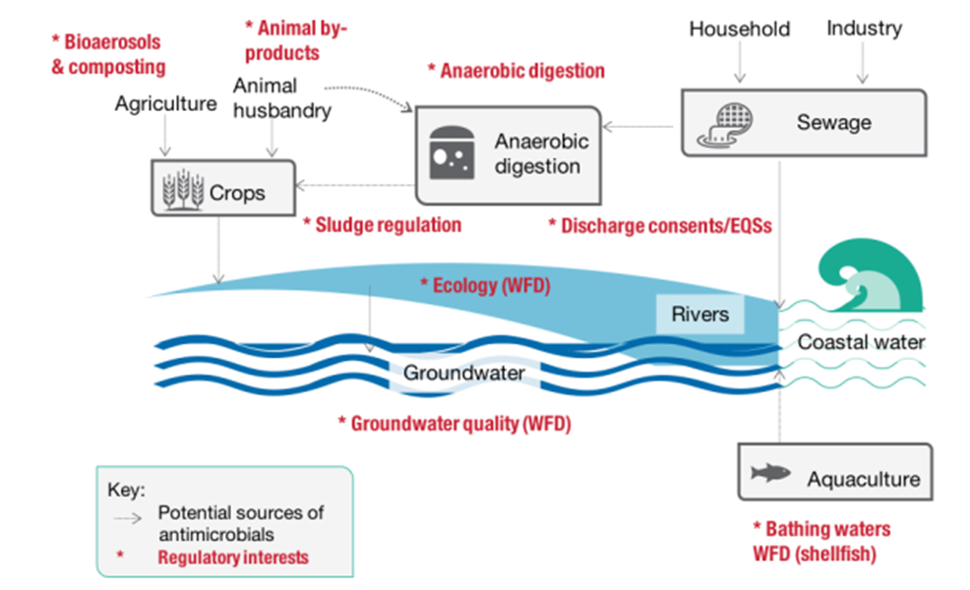
Figure 1: Regulatory interests that impact on human sources of antimicrobials and antimicrobial resistance in the environment (Source: UK National AMR Action Plan 2019-2024)

For information on accessing this document in an alternative format or language, please contact SEPA by emailing equalities@sepa.org.uk
If you are a user of British Sign Language (BSL), the Contact Scotland BSL service gives you access to an online interpreter, enabling you to communicate with us using sign language. contactscotland-bsl.org

World Health Organisation – Antimicrobial resistance
O'Neill J. Review on Antimicrobial Resistance Antimicrobial Resistance: Tackling a crisis for the health and wealth of nations. London: Review on Antimicrobial Resistance; 2014
Global burden of bacterial antimicrobial resistance in 2019: a systematic analysis - The Lancet
One Health recognises that the health of humans, domestic and wild animals, plants, and the wider environment (including ecosystems) are closely linked and inter-dependent and should be considered together to foster wellbeing and tackle threats to health and ecosystems.
Larsson, D.G.J., Gaze, W.H., Laxminarayan, R. et al. AMR, One Health and the environment. Nat Microbiol 8, 754–755 (2023)
UNEP Report February 2023 Bracing for Superbugs
Stanton, I.C., Bethel, A., Leonard, A.F.C. et al. Existing evidence on antibiotic resistance exposure and transmission to humans from the environment: a systematic map. Environ Evid 11, 8 (2022)
Frontiers – Review of Antimicrobial Resistance in the Environment and Its Relevance to Environmental Regulators
Antimicrobial resistance: information - gov.scot (www.gov.scot)
UK 5-year action plan for antimicrobial resistance 2019-2024
SONAAR 2021
Scottish One Health Antimicrobial Use and Antimicrobial Resistance in 2021
Antimicrobial resistance in the EU/EEA (EARS-Net) Report for 2021
English surveillance programme for antimicrobial utilisation and resistance (ESPAUR) 2021-2022
One Health Breakthrough Partnership (ohbp.org)
Pharmaceuticals in the water environment: baseline assessment and recommendations | CREW | Scotland's Centre of Expertise for Waters
Chemical Investigations Programme (ukwir.org)
The National Chemical Investigations Programme 2020-2022 Volume 1 - Investigations into changes to Antimicrobial Resistance through wastewater and sludge treatment processes (ukwir.org)
Review of wastewater monitoring applications for public health and novel aspects of environmental quality | CREW | Scotland's Centre of Expertise for Waters
Scottish One Health AMR Register (SOHAR) | CREW | Scotland's Centre of Expertise for Waters
Antimicrobial Resistance in Scotland’s Waters - Status and Solutions | CREW | Scotland's Centre of Expertise for Waters
Council Recommendation on stepping up EU actions to combat antimicrobial resistance in a One Health approach (europa.eu)
Recast UWWTD
Hart Alwyn, Warren Jonathan, Wilkinson Helen, Schmidt Wiebke Environmental surveillance of antimicrobial resistance (AMR), perspectives from a national environmental regulator in 2023. Euro Surveill. 2023;28(11)

