

Report date: May 2025



# Aquaculture Modelling Screening and Risk Identification Report:

Report date: March 2025

# SOUND OF HARRIS (SOH1)

# VERSION 1

## Scope of report

As part of the SEPA Aquaculture Regulatory Framework it is recommended that a proposed application for a marine finfish aquaculture site should undergo a Screening Modelling and Risk Identification process. SEPA carries out this work and this is described on the SEPA aquaculture website [**Pre-application section**](https://www.sepa.org.uk/regulations/water/aquaculture/pre-application/)

This report presents information arising from that process. Screening modelling methods are outlined and maps and tables describing the modelled impacts are shown. Risks arising from consideration of the model output are listed. Conclusions and recommendations are made regarding the proposed site.

## Executive summary

SEPA has received a proposal for a new marine pen finfish farm called Sound of Harris (SOH1). The proposed MPFF is at: 101607, 879290 (Easting, Northing). Pre-application advice has been requested early in the process and consequently the proposal is still in development and subject to change, however the maximum proposed weight of fish to be farmed is 2805t and proposed is a layout of up to 8 x 120m circumference pens arranged in 1 group of 2 x 4 pens. The existing site Groay Lingay (GRL1) with a biomass of 2132t, will be surrendered should this application be approved.

Following screening modelling and risk identification we have concluded the following:

* It is possible that discharges from Sound of Harris (SOH1) will be able to comply with the relevant aspects of the SEPA Aquaculture Regulatory Framework.
* The site Sound of Harris (SOH1) is likely to be of similar influence and occupying similar areas as the existing site in the total influence of all sites modelled. Due to relinquishing of Groay Lingay (GRL1), which has a similar combined biomass to the proposed site, nutrient discharges from Sound of Harris (SOH1) are unlikely to have a significant additional influence on the surrounding sea area.
* Marine modelling for solids is not required for this site. However, marine modelling of baths may be used to get a less conservative bath medicine quantity compared to BathAuto.
* Standard default NewDepomod modelling is required to demonstrate the proposed biomass can be supported.
* The proximity to locational guidelines waterbodies has been assessed and is not considered a risk, however an Open Water ECE calculation will still be required.
* Sea lice screening has shown that SOH1 leads to a small increase in influence in on the same WSPZs as GRL1. The sea lice permitting approach taken for GRL1 should be applied to SOH1. No further modelling work is required, at this time.
* Sound of Harris (SOH1) is suitable to progress to the next stage of the pre-application process outlined on the SEPA website.

## List of abbreviations

SEPA Scottish Environment Protection Agency

MPFF Marine Pen Fish Farm

CTG Consenting Task Group

AMZ Allowable Mixing Zone

PMF Priority Marine Feature

EIA Environmental Impact Assessment

HRA Habitats Regulations Appraisals

SAC Special Area of Conservation

SPA Special Protected Area

SSSI Site of Special Scientific Interest

MPA Marine Protected Area

AZA Azamethiphos

Contents

Aquaculture Modelling Screening & Risk Identification Report: 1

SOUND OF HARRIS (SOH1) 1

VERSION 1 1

Scope of report 2

Executive summary 3

List of abbreviations 5

List of Figures 7

List of Tables 8

SEPA: Introduction 9

SEPA: Screening modelling 10

SEPA: Risk Identification 18

SEPA: Conclusions 32

## List of Figures

Figure 1. East Coast Lewis and Harris model grid. 10

Figure 2: Modelled average water speed (metres per second – m/s) around Sound of Harris and the proposed site (Sound of Harris (SOH1)). 12

Figure 3: Modelled average sediment intensity over one month for the proposed site only (Sound of Harris (SOH1)). 14

Figure 4: Modelled average sediment intensity over one month for the proposed site (Sound of Harris (SOH1)) and other relevant sites. 15

Figure 5: Modelled average Azamethiphos concentration over four days from neap tide release for the proposed site only (Sound of Harris (SOH1)). 17

Figure 6. Map of identified features 19

Figure 7. Map of additional sensitive features 20

Figure 8. Map of the average modelled lice concentration over the simulated April and May period (in lice/m2) within the top two meters of the sea area. SOH1 site location shown as a blue circle. Fish tracks are shown as green lines with the WSPZs, which are highlighted by a white boundary. 24

Figure 9. modelled average sediment intensity over one month for the existing site (GRL1) and other relevant sites. Right figure: modelled average sediment intensity over one month for the proposed site (SOH1) and other relevant sites. 30

Figure 10. Left figure: Modelled average Azamethiphos concentration over four days from neap tide release for the existing site (GRL1) and other relevant sites. Right figure: Modelled average Azamethiphos concentration over four days from neap tide release for the proposed site (SOH1) and other relevant sites. 31

## **List of Tables**

Table 1: Table of identified features of interest 21

Table 2: Influence of modelled sea lice from SOH1 on exposure in the relevant affected WSPZs. 25

Table 3: Location of SOH1 within the assessment matrix framework of WSPZ capacity and site contribution. 27

Table 4: Table of farms which should be included in any cumulative modelling. 28

## SEPA: Introduction

Screening Modelling and Risk Identification are important steps in the SEPA regulatory framework for marine pen fish farms. SEPA carries out this work and this is described on the SEPA aquaculture website [**Pre-application section**](https://www.sepa.org.uk/regulations/water/aquaculture/pre-application/)

This section presents screening output for the proposed site with comments. Risks identified from the screening output are detailed. Conclusions and recommendations about the suitability of the proposed site are then made.

A summary of the modelling methods employed during screening modelling can be found alongside this document on the SEPA website.

## SEPA: Screening modelling

#### Accuracy of model in the area surrounding the proposal

The East Coast Lewis and Harris model used for screening modelling has a relatively low resolution in this area.

Comparison against observational current meter data indicates that the model provides a reasonable performance of the physical processes in the vicinity of the proposed site, with a slight underestimation of current speeds.

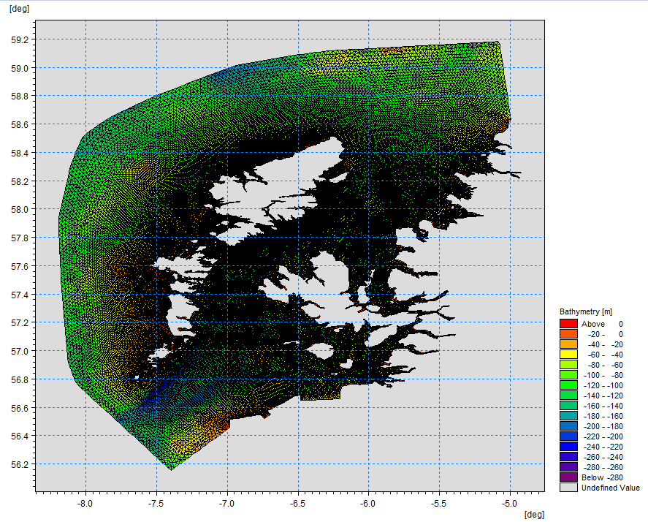

Figure 1. East Coast Lewis and Harris model grid.

### Dispersion and erosion capacity maps

Modelled water movement in a sea area can be used to show the capacity of the water to move and disperse discharged substances. It is also possible to show the capacity available to erode substances from the seabed. This information is a useful guide to the potential size of a marine pen fish farm at a particular location.

Marine pen fish farms using open-net pens will benefit from operating in locations where there are strong, repeating, water currents to erode and disperse waste.

Locations with average water flow speeds of greater than, or equal to, 0.12 metres per second (0.23 knots) are for screening purposes, considered generally suitable for larger farms.

A map of modelled average water flow speed for the area surrounding the proposed site is shown in Figure 2. The average water flow speed in each cell of the model grid has been assigned a shade. The darker the shading, the slower the average current speed and the lower the capacity for dispersion.

Licenced aquaculture farms in the vicinity of the proposed site are shown and discharges of material from these sites have been included in the screening modelling.

#### Modelled flow properties

Based on the maps of the modelled water flow properties we can make the following observations about the proposed site location:

* It lies in a moderate dispersion area.
* It lies in an area where water flow has a moderate capacity to erode material on the seabed.

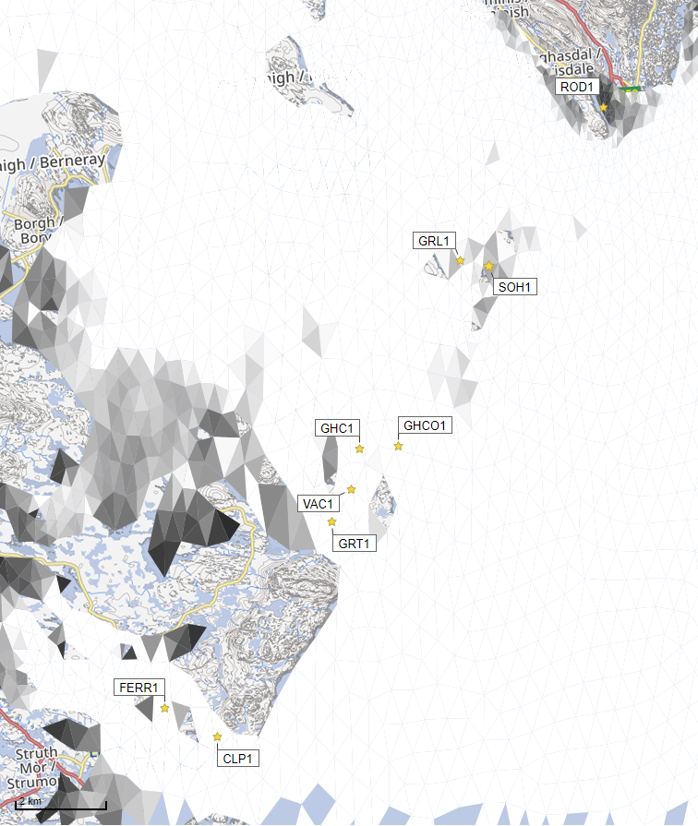



Average water speed (m/s)

©Crown copyright. All rights reserved. SEPA lic. no. 100016991 (2019).

Figure 2: Modelled average water speed (metres per second – m/s) around Sound of Harris and the proposed site (Sound of Harris (SOH1)).

### Sediment influence maps and analysis

Modelled particles in a sea area can be analysed for each modelled grid cell and presented to show the potential influence of discharged sediment on the surrounding sea area.

Values less than 1 g/m2 have been excluded from the map and subsequent calculations. These low concentration cells are produced by the particle tracking approach but they are not considered to be representative of the main influence of a discharge.

Figures 3 and 4 show maps of the modelled average sediment intensity over one month (time average). Grid cells within the model that are influence by modelled sediment are shaded according to the intensity of the influence in grams per square metre (g/m2). Cells which are shaded purple are similar to the average and those shaded pink are similar to the median (middle value in the range) intensity value shown on the map.

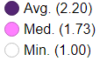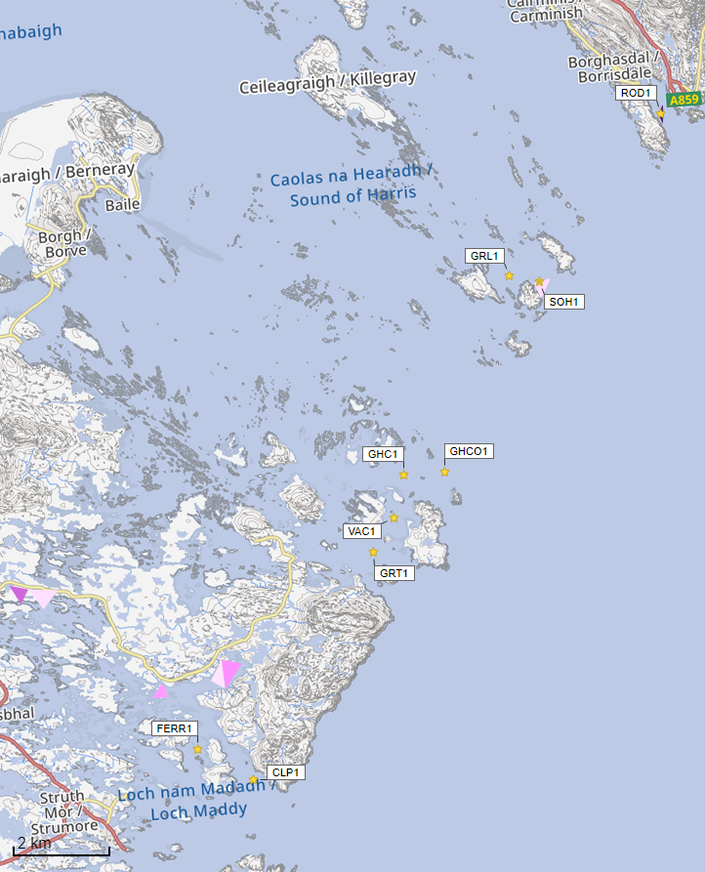

Sediment Intensity (g/m2)

Sediment intensity values presented on this map are low and are presented for information only.

©Crown copyright. All rights reserved. SEA lic. no. 100016991 (209).

Figure 3: Modelled average sediment intensity over one month for the proposed site only (Sound of Harris (SOH1)).

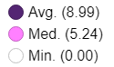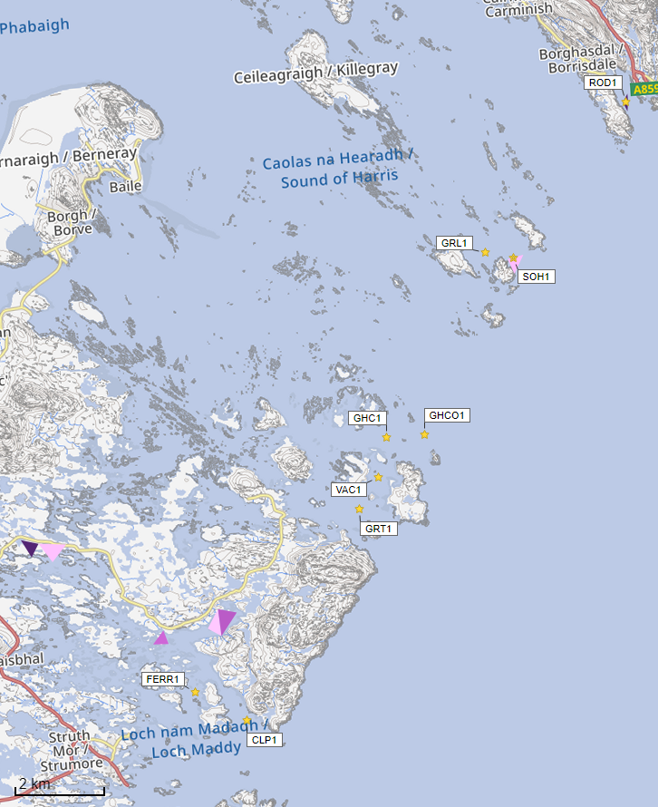

Sediment Intensity (g/m2)

Sediment intensity values presented on this map are low and are presented for information only.

©Crown copyright. All rights reserved. SEPA lic. no. 100016991 (2019).

Figure 4: Modelled average sediment intensity over one month for the proposed site (Sound of Harris (SOH1)) and other relevant sites.

### Bath medicine influence maps and analysis

Modelled particles in a sea area can be analysed for each modelled grid cell and presented to show the potential influence of discharged bath medicine on the surrounding sea area. Results presented are for the Azamethiphos medicine.

Figure 5 shows a map of the modelled average AZA concentration over four days for the proposed site only. Grid cells within the model which experience an AZA influence are shaded according to the concentration of AZA in nanograms per litre (ng/l). Cells which are shaded purple are similar to the average and those shaded pink are similar to the median (middle value in the range) intensity value shown on the map.

Values less than 10 ng/l have been excluded from the map. These low concentration cells are produced by the particle tracking approach but they are not considered to be representative of the main influence of a discharge.

Please note that the Environmental Standard for Azamethiphos with the lowest concentration is 40 ng/l. This must be met 72 hours after the material has been discharged. The estimate of influence detailed here is precautionary.

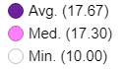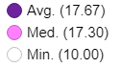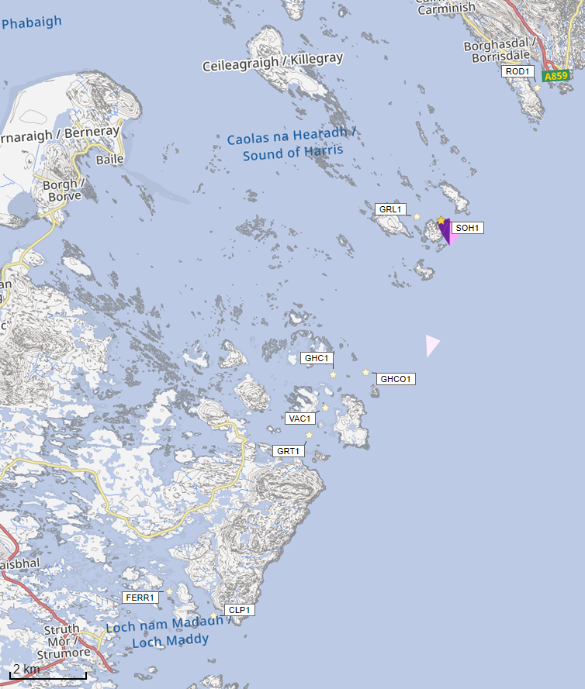

Azamethiphos Conc. (ng/l)

Concentrations of AZA presented on this map are less than the 40 ng/l Environmental Standard and are presented for information only.

©Crown copyright. All rights reserved. SEPA lic. no. 100016991 (2019).

Figure 5: Modelled average Azamethiphos concentration over four days from neap tide release for the proposed site only (Sound of Harris (SOH1)).

## SEPA: Risk Identification

The screening modelling output is compared against available information on features of interest. Features which require attention are presented with any additional comments and will need to be considered during the pre-application phase. NatureScot have highlighted that the proposed site lies within the West Coast of the Outer Hebrides Special Protection Area (SPA). The potential impacts on the SPA will be fully assessed as part of the application process; however, screening has indicated that solid deposition will be retained within the immediate vicinity of the farm. From early NewDepomod modelling the predicted area of impact (>0.64 IQI good status) is likely to be very small and any potential risk on foraging areas will be addressed via marine modelling.

### Features of Interest which require attention

Sensitive features in the area have been identified and those considered at potential risk and therefore requiring additional consideration, can be found in figures 6, 7 and table 1.

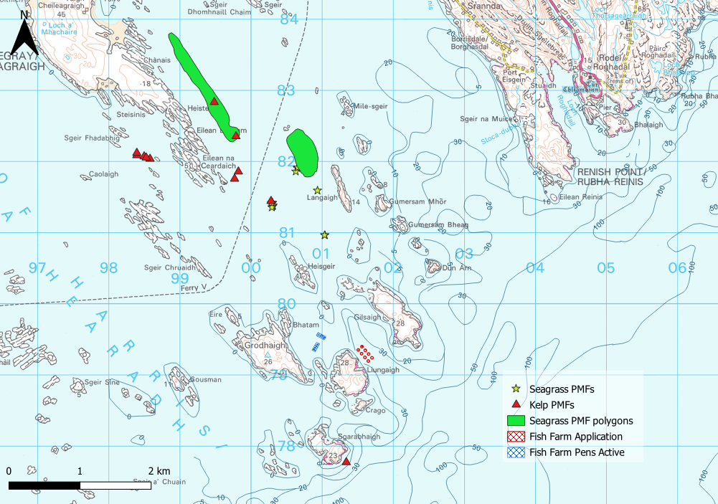

Figure 6. Map of identified features

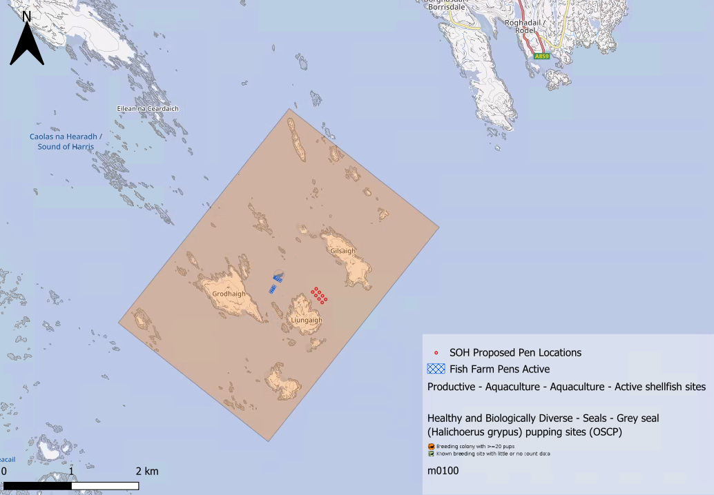

Figure 7. Map of additional sensitive features

Table 1: Table of identified features of interest

|  | **Feature Name** | **Feature Type** | **Location (Easting, Northing)** | | **Brief Reason for Identification** |
| --- | --- | --- | --- | --- | --- |
| 1. | Seagrass beds | PMF | 100294.9  100307.4  100311.5  100764.0  100295.1  100653.8  100631.5  100305.7  100289.8  100659.3  100936.6  101040.9  101036.2 | 881405.6  881366.5  881380.1  882155.1  881352.8  881904.3  881857.2  881416.5  881416.7  881913.6  881588.9  880960.9  880960.3 | At risk from baths |
| 2. | Seagrass beds | PMF | Shapefiles figure 6 | | At risk from baths |
| 3. | Kelp and seaweed communities on sublittoral sediment and Kelp beds | PMF | |  |  | | --- | --- | | 101341 | 877765 | | 100283 | 881440 | | 99770 | 881753 | | 99823 | 881855 | | 98581 | 882035 | | 98395 | 882085 | | 98395 | 882118 | | 98498 | 882068 | | 98527 | 882052 | | 99789 | 882353 | | 99483 | 882833 | | | At risk from baths  (Foraging area for SPA qualifying feature -NatScot) |
| 4. | Sound of Harris Islands | Grey seal pupping site and Seal haul out site | 1102123.0  (centre point) | 879970.0 | At risk from baths |

### Additional comments on sediment influence

Solids marine modelling not required due to the fast currents and the dispersive nature of the site.

### Additional comments on bath influence

The conservative nature of the simple BathAuto model in areas of high current speeds, means quantities of bath medicines may be limited to impractical amounts for this site. Use of marine modelling of bath influence will enable more realistic bath medicine treatment quantities to be determined.

Several Priority Marine Features have been highlighted as potentially at risk from baths influence due to their proximity and occurrence in very shallow waters. Features identified as at risk within this area will need to be addressed in any marine modelling, however cumulative modelling of baths as well as dye/drogue calibration is not required.

This site also falls within the Sound of Harris designated grey seal haul out and pupping site protecting these species all year round. The use of chemicals within this designated site will require further investigation to determine any likely impacts on protected species along with issues of disturbance highlighted by NatureScot.

### Nutrient influence

The proximity to locational guidelines waterbodies has been assessed and not considered a risk, however the open water ECE calculation will still be required to ensure nutrient enhancement levels from this new farm are acceptable.

### Sea Lice Screening

Sea lice screening was carried out using our standard method with the translated Scottish Shelf ECLH (East Coast Lewis & Harris) sub area model.  This method is outlined in in Appendix 4 of the May 2023 second consultation document: [Managing interactions between sea lice from finfish farms and wild salmonids, Proposed new regulatory framework, May 2023.](https://consultation.sepa.org.uk/regulatory-services/detailed-proposals-for-protecting-wild-salmon/)

### Modelled Sea Lice Concentration Map – SOH1

Figure 7 shows a map of the average modelled lice concentration over the simulated April and May period (in lice/m2) within the top two meters of the sea area. Model grid cells (triangles) are coloured according to the amount of sea lice particles within them.

#### Indicative Influence

The map serves as an indicative influence under average tidal and weather conditions. The focus is on areas of potential high influence for further fish track analysis within WSPZs.

#### Exclusion of Low Concentrations

Any grid cells with concentrations below 0.01 lice/m² are not shown on the map. This exclusion helps focus on more influential concentrations on the fish track analysis and WSPZs. However, these concentrations are not excluded from fish track exposure analysis below.

#### Colour Intensity, 90th Percentile and Median Concentrations

The more intense the colour in the grid cells, the closer the concentration is to the 90th percentile of all concentrations within the model cells. This brings attention to areas of higher modelled influence.  The 90th percentile of sea lice concentrations is 0.12 lice/m², meaning that 90% of the concentrations are below this value. The median concentration is 0.03 lice/m², suggesting that half of the values are below this number. At baseline (before the introduction of the proposed site), the average 90th percentile concentration across modelled sites was 0.04 lice/m².

#### Focus Area

The fish track exposure assessment, on which the screening outcome is based, is on the zone where the influence is highest. In this case, the highest modelled influence occurs in the Loch a Siar WSPZ.  This does not mean the actual modelled exposure will be high.

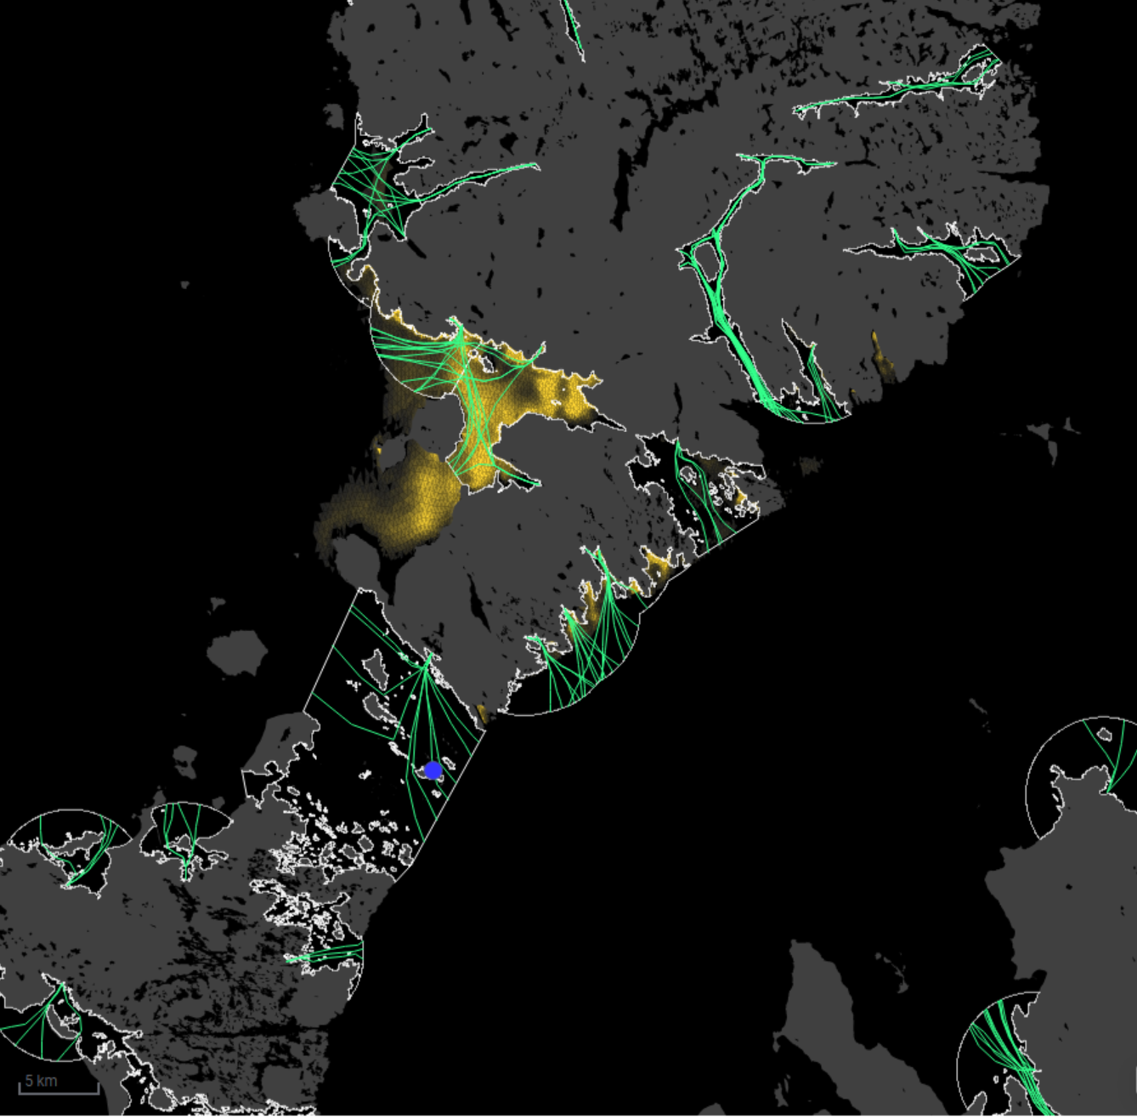

Sea Lice Conc. (lice/m2)



90th %ile (0.12)

Min. (0.01)

Figure 8. Map of the average modelled lice concentration over the simulated April and May period (in lice/m2) within the top two meters of the sea area. SOH1 site location shown as a blue circle. Fish tracks are shown as green lines with the WSPZs, which are highlighted by a white boundary.

### Modelled Sea Lice Concentrations – Single Site Influence on Exposure – SOH1

Table 2 shows information relating to the influence of modelled lice concentrations, from SOH1 alone, on fish track exposure levels within the relevant WSPZs.

Table : Influence of modelled sea lice from SOH1 on exposure in the relevant affected WSPZs.

| **Wild Salmon Protection Zone (WSPZ)** | **95th %ile of Fish Track Exposure (lice/m2 days)** | **% of Exposure Threshold (0.7 lice/m2 days)** |
| --- | --- | --- |
| Loch a Siar | 0.14 | 18.56 |
| Loch Stocinis / Loch Fleòideabhagh / Loch Fhionnsabhaigh | 0.08 | 11.13 |
| Loch Tarbert (Harris) | 0.03 | 3.43 |
| Braigh Mor | 0.01 | 1.90 |

#### WSPZ Influence

Two WSPZs are subject to a small influence and two a negligible influence.  Five other WSPZs are influenced but to a level which is extremely low. Exclusion of these from the table brings focus on the areas of highest influence. However, these influences are included in the combined exposure analysis below.

#### Exposure Threshold

The percentage of the exposure threshold is shown to illustrate the scale of a single site influence. The exposure influence of all sites is not simply the sum of the individual site percentages.  The overlapping influence of all sites on modelled screening exposure is shown below.

#### Assessment Matrix

An assessment matrix is presented on page 57 of the SEPA December 2023 response to consultation feedback: Managing interactions between sea lice from finfish farms and wild salmonids, SEPA response to [consultation feedback](https://consultation.sepa.org.uk/regulatory-services/detailed-proposals-for-protecting-wild-salmon/), December 2023.

Using the fish track exposure method, we establish the location of SOH1 within the assessment matrix framework of WSPZ screening capacity and site contribution.  To assess the capacity influence, we take the WSPZ which experiences the greatest influence, in this case it is Loch a Siar. Table 3 shows that SOH1 lies within cell B3 (Small, Little or none).

Table : Location of SOH1 within the assessment matrix framework of WSPZ capacity and site contribution.

| **Contribution to infective-stage sea lice exposure (% of exposure threshold)** | **Remaining available capacity in WSPZ** | | |
| --- | --- | --- | --- |
| **Large (1)** | **Intermediate (2)** | **Little or none (3)** |
| **Negligible (A) (<10)** | A1 | A2 | A3 |
| **Small (B) (10 to <20)** | B1 | B2 | B3  **SOH1** |
| **Moderate (C) (20 to <30)** | C1 | C2 | C3 |
| **Substantial (D) (>30)** | D1 | D2 | D3 |
| **Table Cell Colour Key (Permit conditions controlling on farm sea lice levels (19th March to 31st May)** | | | |
| A1 to A3, B1 to B2, C1 | No sea lice limit conditions. | | |
| B3, C2, D1 | Sea lice limits proposed by the developer and used in the screening assessment. | | |
| C3, D2 | Sea lice limits derived from an appropriate modelling assessment demonstrating that the farm will not compromise achievement of the sea lice exposure threshold. | | |
| D3 | Sea lice limits derived from an appropriate modelling assessment demonstrating that the farm will not compromise achievement of the sea lice exposure threshold. | | |

### Combined Influence of SOH1 on all Wild Salmon Protection Zones

Using the fish track exposure method, we can calculate the latest combined influence of all sources on the exposure threshold within all WSPZs, including the proposed at the time of its submission.  SOH1 mainly affects the Loch a Siar WSPZ.  Its inclusion has reduced some of the remaining capacity in Loch a Siar, but does not, on its own, cause the exposure threshold upper limit to be exceeded.  SOH1 has also reduced the screening capacity in a number of nearby WSPZs but to a very small degree of influence.

### Conclusion of Sea Lice Screening

SOH1 is replacing GRL1. The GRL1 results have been scaled to the tonnage of the new site. SOH1 replaces GRL1 in the original base screening matrix published in consultation documentation. The extra tonnage does not change the position of the new SOH1 site within the matrix.

The outcome of current screening is that current lice permitting approach taken for GRL1 will need to be applied to SOH1. However, no further modelling work is required, at this time.

### Risks identified from contextual site data

Table 4: Table of farms which should be included in any cumulative modelling.

| **Site Name** | **Location (Easting, Northing)** | **Biomass (Tonnes)** | **Last production Cycle** | **Include in solids marine modelling?** |
| --- | --- | --- | --- | --- |
| SOH1 | 101607, 879290 | 2805 (proposed) |  | No |
| CLP1 | 94830, 869330 | 900 | 2024 | No |
| FERR1 | 93700, 870048 | 750 | 2024 | No |
| GHC1 | 98450, 875450 | 1750 | 2024 | No |
| GHCO1 | 99312, 875450 | 2500 | 2024 | No |
| GRLI | 100980, 879450 | 2132 | 2024 | No |
| GRT1 | 97713, 873901 | 1500 | 2024 | No |
| ROD1 | 104400, 882600 | 300 | 2005 | No |
| VAC1 | 98196, 874584 | 800 | 2009 | No |

### Comparison between the existing site GRL1 with the proposed site SOH1

An assessment has been conducted to compare the potential impact or risk from the existing site GRL1 against the applied for single site (SOH1). SOH1 is to replace the existing site, which will be relinquished. In the first instance modelled cumulative sediment impact from GRL1 and other sites in the vicinity were assessed and then compared to modelled cumulative sediment impact from SOH1 and other sites (Figure 9). The comparisons show little difference between the two setups. The average cumulative intensity of the existing setup is slightly higher with 10.01g/m2 and the average cumulative intensity of the proposed setup is 8.99g/m2. The median of the existing setup is 5.20g/m2 and the median of the proposed setup is 5.24g/m2. These values are taking all the surrounding farms depicted in table 4 into consideration (minus the existing or proposed farm according to corresponding scenario).

The modelled cumulative Azamethiphos concentrations from GRL1 and other nearby sites were assessed and compared to those from SOH1 and surrounding sites (Figure 10). The comparison shows little difference between the two setups. The average cumulative concentration in the existing setup is slightly lower, at 16.29 ng/l, compared to 17.54 ng/l in the proposed setup. The median concentration is 12.74 ng/l for the existing setup and 15.87 ng/l for the proposed setup. These values include all surrounding farms listed in Table 4, excluding the farm being assessed in each respective scenario.

The values show, the modelled intensities and concentrations have likely a similar impact on the surrounding sea area.

Sediment Intensity (g/m2)

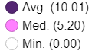

Sediment Intensity (g/m2)



Figure 9. modelled average sediment intensity over one month for the existing site (GRL1) and other relevant sites. Right figure: modelled average sediment intensity over one month for the proposed site (SOH1) and other relevant sites.

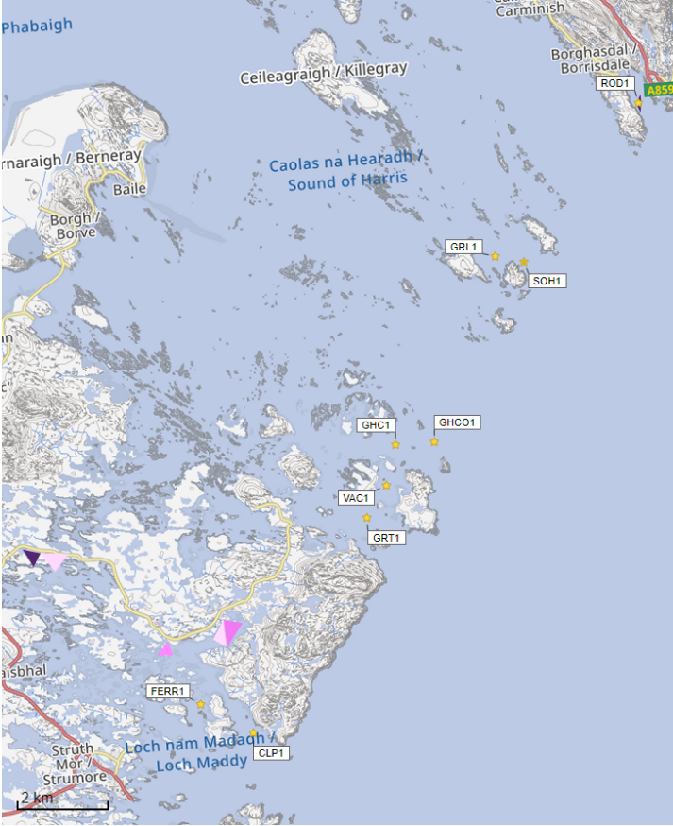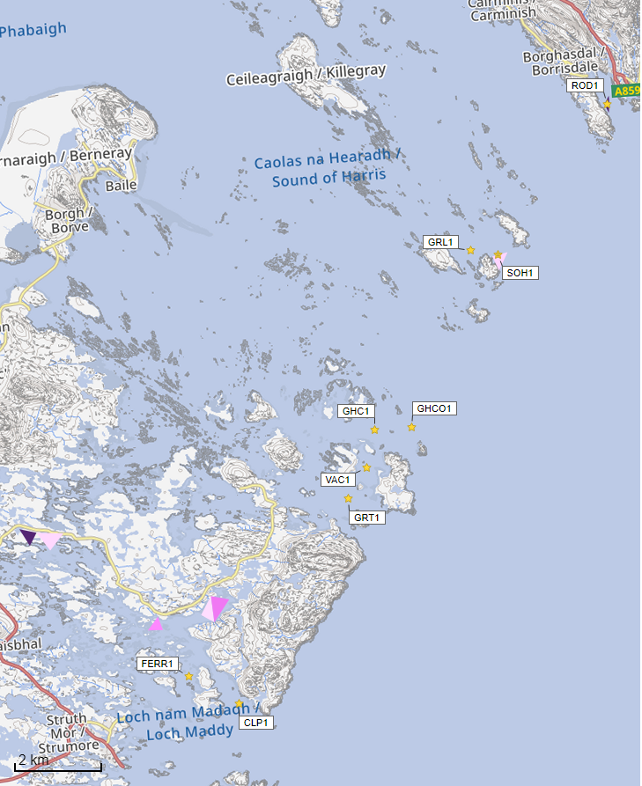

©Crown copyright. All rights reserved. SEPA lic. no. 100016991 (2019).

## 

©Crown copyright. All rights reserved. SEPA lic. no. 100016991 (2019).

## 

Azamethiphos Conc. (ng/l) 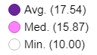

Azamethiphos Conc. (ng/l)

Azamethiphos Conc. (ng/l)

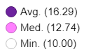

©Crown copyright. All rights reserved. SEPA lic. no. 100016991 (2019).

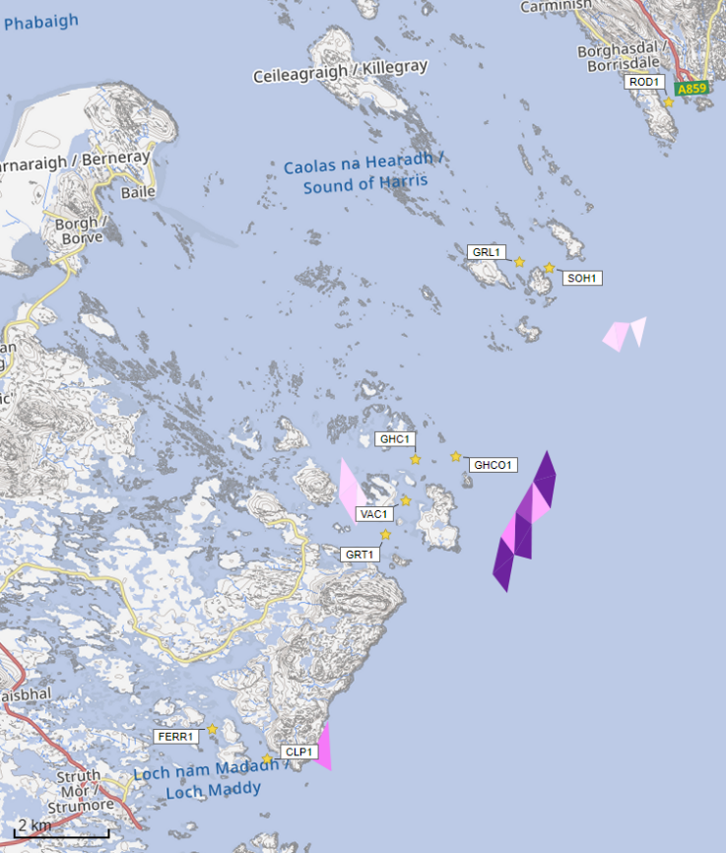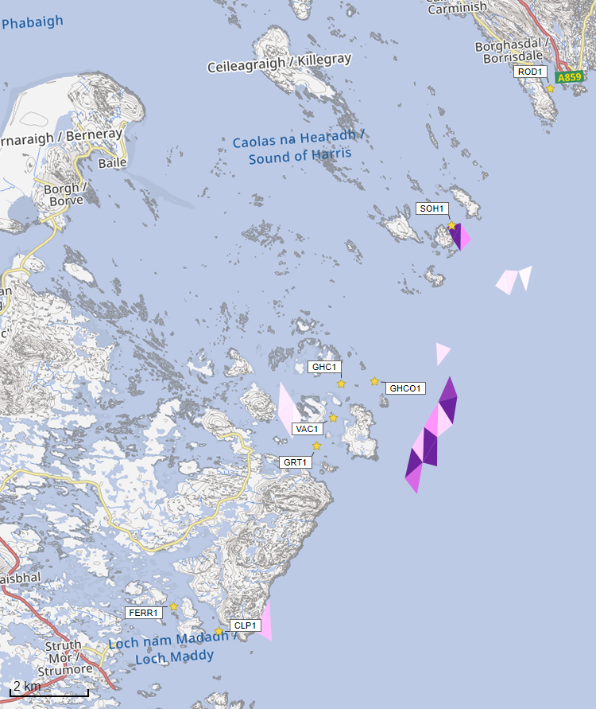

©Crown copyright. All rights reserved. SEPA lic. no. 100016991 (2019).

Figure 10. Left figure: Modelled average Azamethiphos concentration over four days from neap tide release for the existing site (GRL1) and other relevant sites. Right figure: Modelled average Azamethiphos concentration over four days from neap tide release for the proposed site (SOH1) and other relevant sites.

## SEPA: Conclusions

### Conclusions

* It is possible that discharges from Sound of Harris (SOH1) will be able to comply with the relevant aspects of the SEPA Aquaculture Regulatory Framework.
* According to screening modelling, the proposed site (Sound of Harris (SOH1)) is in an area of moderate dispersion and has a moderate capacity for erosion of material on the seabed.
* Comparison against observational current meter data indicates that the model provides a reasonable performance of the physical processes in the vicinity of the proposed site, with a slight underestimation of current speeds.

Sound of Harris (SOH1) is likely to be of similar influence and occupying similar areas as the existing site in the total influence of all sites modelled. Due to relinquishing of GRL1, which has a slightly lower combined biomass to the proposed site, nutrient discharges from Sound of Harris (SOH1) are unlikely to have a significant additional influence on the surrounding sea area.

### Recommendations and Further Modelling

Following the engagement meeting(s), this report may be revised and this should allow the applicant to submit a method statement which address the issues raised in this document.

Marine modelling for solids is not required for this site. However, marine modelling of baths may be used to get a less conservative bath medicine quantity compared to BathAuto. In which case, identified sensitive features should be considered.

Standard default NewDepomod modelling is required to demonstrate the proposed biomass can be supported.

The proximity to locational guidelines waterbodies has been assessed and is not considered a risk, however an Open Water ECE calculation will still be required.

Sea lice screening has shown that SOH1 leads to a small increase in influence in on the same WSPZs as GRL1. The sea lice permitting approach taken for GRL1 should be applied to SOH1. No further modelling work is required, at this time.

Sound of Harris (SOH1) is suitable to progress to the next stage of the pre-application process outlined on the SEPA website.

For information on accessing this document in an alternative format or language, please contact SEPA by emailing [equalities@sepa.org.uk](mailto:equalities@sepa.org.uk)

If you are a user of British Sign Language (BSL), the Contact Scotland BSL service gives you access to an online interpreter, enabling you to communicate with us using sign language. [contactscotland-bsl.org](http://contactscotland-bsl.org/)