Water Situation Report

11th March 2024

Scotland’s water resource has largely recovered over autumn and winter, reducing the risk of water scarcity this summer.

Introduction
Weather conditions over autumn and winter have a major influence on water resources and the risk of water scarcity in the following summer. Rainfall and snow over this time replenishes water stores in the ground, lochs and reservoirs. The stores that are built up in winter usually deplete over summer as more water is lost from the system than is put in, until the cycle begins again the next autumn.
This report reviews the conditions over this period to summarise the end of winter water situation.

Situation Summary
Areas along the east coast of Scotland have seen higher than average rainfall throughout autumn and winter. Elsewhere rainfall totals have been within the normal range. This has allowed a good recovery of water resources and natural water storage, in lochs and groundwater, is normal to high for this time of year. As a result, there is a reduced risk of water scarcity this summer. Conditions through spring and summer can still lead to water scarcity as was experienced following a very dry spring in 2023. Water users are urged to keep an eye on the situation and plan ahead to manage water supplies sustainably.

Forecast
Seasonal forecasting by the Met Office suggests there is a slightly increased chance that spring will be warmer than normal. The chance that conditions will be wetter or drier than average is similar. There is a moderately greater likelihood of high-pressure conditions in the north or northwest, bringing a slightly higher chance that the season will be calm.
© Crown copyright [2022], Met Office

Supporting information
There is currently no soil moisture deficit across the country.

Rainfall and river flows:
These maps show rainfall (top row) and river flow (bottom row) relative to the long-term average, for this time of year, over 30 days, 90 days, and 180 days. Overall, the picture has been one of predominantly wet conditions over the winter period, particularly in the east. This is reflected in the very high river flows in eastern catchments across the winter period. February has been relatively normal for rainfall across the country. The west and south has experienced normal rainfall overall, which is shown in predominantly normal river levels in these areas.

Natural water storage
In each river catchment there is some degree of natural water storage, which can maintain river flows even when it is not raining. This natural water storage is mainly held in lochs and groundwater. When storage has been depleted it will take a lot of rainfall for levels to recover.

The maps below show recent groundwater and loch level compared to the long-term record at each individual station. Level is reported as high or low compared to the typical (‘normal’) level range for the time of year. Level ranges are specific to each station and based on the long-term (minimum 10 years) record of mean monthly level values recorded at individual stations.

Groundwater levels:
Over the last three months groundwater levels have recovered to normal or above at all monitoring locations.
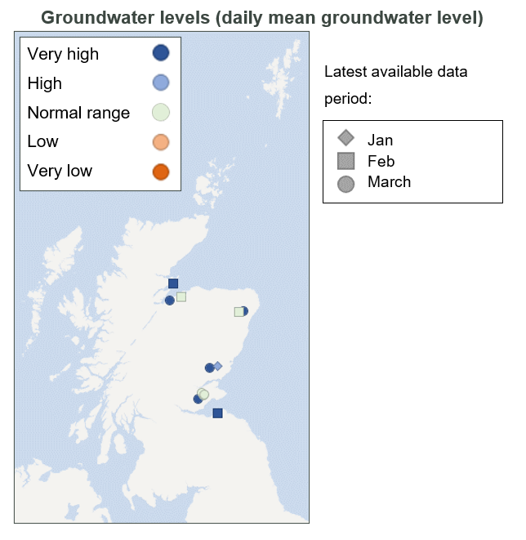

Loch levels:

Loch levels are broadly within the typical range for this time of year. All the monitored lochs have shown marked recovery from the low levels reached this summer and are at normal or higher levels.

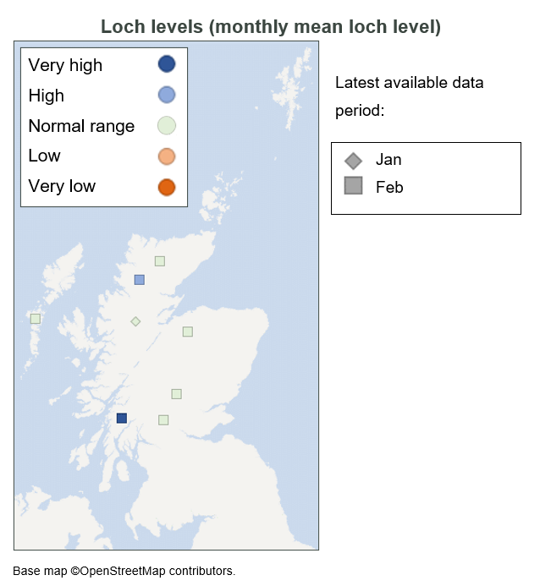

Flow, rainfall and groundwater data are accessed via SEPA’s time series data service (API). SEPA's live data are subject to ongoing quality control and periodic review.

For information on accessing this document in an alternative format or language, please contact SEPA by emailing equalities@sepa.org.uk

If you are a user of British Sign Language (BSL), the Contact Scotland BSL service gives you access to an online interpreter, enabling you to communicate with us using sign language. contactscotland-bsl.org

