#### 

**Summary note:**

May 2025

**SEPA input to Scottish Government Short Life Working Group on National Planning Framework 4 Policy 22: Flood Risk and Water Management**

Introduction 2

SEPA’s role in the Planning Process 3

SEPA Flood Maps 3

Consultation with SEPA 5

Our Responses 7

SEPA Objections 8

Appendix 1: SEPA Technical Note on Flood Risk Assessments 10

## Introduction

This document brings together the content of a series of four papers produced by SEPA and agreed as part of the Scottish Government Short Life Working Group on National Planning Framework 4, Policy 22: Flood Risk and Water Management. The papers were produced to provide clarity for participants of the Short Life Working Group on our advisory role in relation to flood risk, explain what our flood maps show, how they should be used, and how our consultation responses should be considered. In large part they reproduced information contained in existing SEPA guidance and Scottish Government regulations. Our existing published advice and guidance can be found on our [website](https://www.sepa.org.uk/environment/land/planning/guidance-and-advice-notes/).

This document brings this series of papers together in one place as a single record of SEPA’s contribution to the series of meetings. The original papers were entitled:

* Consultation with SEPA
* SEPA response letters
* SEPA use of objections
* SEPA technical note – Assessing the flood risk are and dealing with uncertainty

The three meetings took place online on the following dates:

* Tuesday 12th November 2024
* Wednesday 22nd January 2025
* Tuesday 4th March 2025

Attendees at the meetings were:

* Heads of Planning Scotland (HOPS) representatives
* Scottish Government planning, flooding and climate adaptation team representatives
* Representatives of SEPA’s flooding and land use planning teams

## SEPA’s role in the Planning Process

SEPA’s role and responsibilities in the planning process differ distinctly from the planning authority. Our role is narrowly prescribed, and our advice may only relate to a single aspect of a development, such as flood risk. The planning authority must balance this advice with all relevant policies and material considerations in determining planning applications. The Scottish Government’s Chief Planner highlighted this explicitly in a [June 2024 letter](https://www.gov.scot/publications/planning-for-housing-chief-planner-letter-june-2024/), stating: *“The Scottish Ministers have continued to reinforce that policies in NPF4 should be read and applied as a whole and that conflicts between policies are normal and to be expected. The planning system requires decision makers to weigh up all relevant policies, for example, quality homes, brownfield development and town centre living, as well as relevant material considerations in applying balanced planning judgement (section 25 of the Town and Country Planning (Scotland) Act, 1997, as amended). The introduction of NPF4 has not changed this”*.

​

## SEPA Flood Maps

We have produced flood maps designed to help planning authorities make an initial assessment of which sites need a more detailed flood risk assessment and when to consult SEPA for advice. Planning authorities should base those decisions on their interpretation of the policies set out in National Planning Framework 4 (NPF4) and use the SEPA flood maps to decide whether a development is likely to result in a material increase in the number of buildings at risk of being damaged by flooding, where development would be contrary to that policy.  SEPA’s flood hazard maps show the risk of flooding from rivers, the sea and surface water, and we make the following information on different likelihoods of flooding widely available:

* **​High flood risk** – 10-year return period, or a 10% chance of happening in any year.
* **​Medium flood risk** – 200-year return period, or a 0.5% chance of happening in any year.
* **​Low flood risk** – 1000-year return period, or a 0.1% chance of happening in any year.
* **​Future Flood Map (climate change)** – 200-year return period in a 2080s high emissions scenario2

It is important to consider this risk over the duration of time development is designed to exist. For example, if development takes place in a medium risk area, although it can have as little as 0.5% chance of flooding in any one year, it has at least a 5% chance of flooding at least once over 10 years, 14% over 30 years, 22% over 50 years and a 39% chance over 100 years. Technical information on the methods used to make our flood maps is available on our [website](https://www.sepa.org.uk/environment/water/flooding/developing-our-knowledge/).

​

SEPA’s future flood maps and advice are based on higher emissions climate scenarios. In our [guidance on climate change allowances for planning users,](https://www.sepa.org.uk/media/jjwpxuso/climate-change-allowances-guidance_v6.pdf) we use Representative Concentration Pathway 8.5 (RCP 8.5) from the 2018 Met Office data in which the best estimate global average temperature rise is 4.3°C above pre-industrial levels by 2100. The high emissions scenario is appropriate as our maps and guidance are used to inform significant and long-lasting land use planning decisions. This aligns with the recommendations of [research](https://www.climatexchange.org.uk/projects/using-future-climate-scenarios-to-support-todays-decision-making/) carried out by ClimateXChange on behalf of the Scottish Government which suggests the use of the 4-degree warming scenario is appropriate where the impacts of climate change present a higher physical risk.

​SEPA’s advice allows Planning Authorities to make land use decisions based on knowledge of the risks associated with 4 degrees of warming by the end of the century. Scientific evidence shows that climate change is already affecting Scotland, and that the impact will increase every year from now, it is not a future risk. NPF4 states that a precautionary approach should be taken regarding the calculated probability of flooding as a best estimate, not a precise forecast.

​In response to some concerns that the impact of climate change greatly increased the land area of Scotland unavailable for development, we undertook analysis of our flood hazard maps to compare how much of Scotland is indicated as being at risk now, compared with how much extra could be in future due to climate change. This analysis found that the addition of climate change (for the 2080s-time horizon) increases the land area of Scotland at risk of flooding by less than 1% compared with the present-day risk. **​**

Our [flood maps](https://map.sepa.org.uk/floodmaps) provide the most comprehensive Scotland wide information on flooding, showing where flooding might be expected now and in the future. They have been designed to support the protection of Scotland’s communities and assets. They identify areas at flood risk where flooding should be considered in more detail; they are not suitable to quantify the exact flood risk at a street or individual property level. ​The flood maps also inform flood risk management planning by Local Authorities, by identifying the highest risk communities and prioritising places where action is needed. ​The maps are also used to raise awareness with the public more generally on what the flood risk is in their area, to encourage them to find out more about their risk and how they can manage it. The maps are openly available to everyone on our website and can be zoomed in to make them easier to view and understand.

## Consultation with SEPA

We provide advice on Local Development Plans and flooding, and further guidance can be found in our [SEPA Strategic Flood Risk Assessment Guidance](https://www.sepa.org.uk/media/nckhycrj/flood-risk-standing-advice.docx). We encourage pre-application discussion on planning proposals, either as part of our regular triage meetings with planning authorities or on a case-by-case basis. Given that planning authorities are the decision makers it is important that they are part of all pre-application discussions, and we will not meet with developers unless this is the case. This keeps all parties sighted on relevant information and avoids potential misunderstandings. If your authority does not have regular liaison meetings with us and you would like to start, please contact us at [planning.north@sepa.org.uk](mailto:planning.north@sepa.org.uk) or [planning.south@sepa.org.uk](mailto:planning.south@sepa.org.uk).

The [Development Management Regulations](https://www.legislation.gov.uk/ssi/2013/155/schedule/5/) (DMR) set out the statutory triggers for consultation with SEPA on an application for planning permission.   For flooding this is: **where the development is likely to result in a material increase in the number of buildings at risk of being damaged by flooding.**   Our flood maps and other local information will be helpful in making this judgement. It may be helpful to consult with internal flood risk colleagues if this option is available before consulting further with SEPA.

For developments where the only potential source of flood risk is from a small watercourse we request that the local authority assess the proposal against any information they hold to determine whether it may be at risk. We should only be consulted if they recommend that our advice is required.

Regulation 25 of the DMR allow us to set out where consultation is not needed. We must inform the planning authority of this in writing.  This allows us to give standing advice on flood risk. Planning authorities can use this to determine some cases without the need to consult us.   In 2024 we referred planning authorities to our standing advice in 300 cases.

Where SEPA is consulted on a planning application, we review any information supplied by the applicant alongside our flood maps and any other information we hold on flooding. Based on that and with the principles of NPF4 in mind we provide advice to assist the planning authority in making an informed decision.

​Planning authorities need not consult us on developments where there is no evidence of flood risk.  For lower risk or smaller scale development, planning authorities should use our [standing advice](https://www.sepa.org.uk/media/nckhycrj/flood-risk-standing-advice.docx) on flooding along with our flood maps to determine applications without consulting us.

Small Scale Development covered by [SEPA Standing Advice](https://www.sepa.org.uk/media/nckhycrj/flood-risk-standing-advice.docx):

* Redevelopment of an existing building or site for an equal or less vulnerable use
* Small scale extensions and alterations to existing buildings where they do not significantly increase flood risk
* Small-scale addition of non-residential buildings within a site that are ancillary to the existing use and are equal or less vulnerable in use.
* New, altered or extended garages, sheds, conservatories and greenhouses
* Essential infrastructure or water compatible uses
* Permanently open-sided buildings used for storage or land cover such as agricultural buildings and polytunnels
* Sustainable drainage schemes (SuDS), including temporary for construction
* Where the only source of flood risk is surface or ground water
* Allotments and plant nurseries
* Mobile businesses and hot food vans
* Cemeteries
* Small scale street furniture
* Walls, fences and other enclosures
* Like-for-like replacement of watercourse crossings
* Hydro schemes
* Footpaths, access tracks, private roads, car parts and other landscaping proposals
* Septic tanks and soakaways
* Temporary construction accommodation
* Reverse vending machines

When consulting us on flood risk it is important that we know if one of the exceptions set out in NPF4 Policy 22 applies or not. This will have a significant effect on the advice we provide, and identifying the appropriate exception can avoid an objection. We have [guidance on our approach to Policy 22 exceptions](https://www.sepa.org.uk/media/xfkdqibf/statement-sepa-approach-national-planning-framework-4-policy-22-exceptions.docx) to help with this. Policy 22 does not make any differentiation between small and large-scale development. Therefore, if consulted, we provide detailed advice on flood hazard for developments of all scales in flood risk areas unless they are covered by standing advice.

Our [Triage Framework](https://www.sepa.org.uk/media/560848/sepa-triage-framework-and-standing-advice.pdf#:~:text=In%20March%202021%20we%20issued%20a%20triage%20framework,regular%20liaison%2C%20helped%20us%20to%20clear%20the%20backlog.) sets out all issues which we can be consulted upon, which is considerably wider than flood risk. It also provides standing advice for a range of other areas.

## Our Responses

We aim to make our response letters clear and helpful for all potential audiences.   They should always indicate our position up-front, explain that position and then highlight any information or action required to address the issues raised.  We appreciate the flooding is a complex issue and it may be underestimated. As part of the discussions at the short-life working group, we developed the following wording, which we will incorporate into our responses where appropriate to do so, to help explain flood risk more clearly.

* **The risk of flooding increases over time.** An 0.5% annual probability of flooding sounds very low, but where development takes place in this area of flood risk it has at least a 20% chance of flooding in the next 45 years. This is well within the design life of most buildings.

When climate change is factored into the risk the likelihood of flooding is even greater.  Where our maps and guidance indicate this **future flood risk**, they represent a flood hazard that may occur today, tomorrow, or at any point in the future. Our advice on this should not be interpreted as describing a risk that only takes effect after a fixed point in the long-term future, for example 2080.

To help with this we have produced a more detailed note on **assessing the flood risk area and dealing with uncertainty (Appendix 1).**

* **Flood Warning** is not an appropriate way to mitigate flood risk. The SEPA Flood Warning Service is intended for the owners and occupants of existing buildings and sites at risk. It does not prevent flooding; it only warns of it. Therefore, existing risk to life and damage to property is not fully negated. Flood warnings are also not failsafe. Lastly, in the case of residential development, where ownership/occupancy can change many times over its lifespan, there is no guarantee that all occupants will sign up, and neither could this be secured via the planning process.

## SEPA Objections

In 2009 an external audit looked at the effectiveness of our planning responses. It was found that where we did object, the flooding issues were resolved in 80% of the cases.  Where we didn’t object, it was less clear what was required and so the issues raised were only resolved in 46% of cases. Since 2009 we have used objections consistently. We surveyed planning authorities in 2012 and over 80% of respondents said that objections made responses clearer and supported them better to ensure that issues were resolved and not ignored.     We’ve adopted the following scheme of response levels for consistency and clarity:

1. No objection
2. Objection - Holding / Insufficient Information
3. Condition Request (objection if not applied)
4. Modification request (objection if not applied)
5. Objection – In Principle
6. Objection – Sustained

We do have other response types apart from objections.   For example, we will respond with directions to our standing advice on flood risk which may include additional information on the flood hazard at the request of the planning authority.

**Frequency of objections and their removal**

We are consulted on around 900 planning applications a year. In 30% of cases, SEPA do not object.   In the 66% of cases, objections are withdrawn on submission of required information.   We maintain an objection to the remaining 4%.  Our responses will clearly identify what policy area an objection relates to, and that we are only objecting to this aspect of the development. So, for flood risk we will state that the development is contrary to NPF4 Policy 22. **It is for the planning authority to consider other policy areas which relate to the development to consider if they support it or not.** Even if we do object, our advice is to allow the planning authority to clearly understand the flood risk so that they can make an informed judgement to either refuse or approve. If further assistance is required to do so, then we will provide this.

**Notification of SEPA Objections**

We recognise that planning authorities may wish to approve planning permission even if we have objected. Whilst some authorities have expressed a reluctance to recommend approval where the Scottish Government’s Notification Direction on flooding applies, half of planning authorities have used the direction recently.

Since NPF4 was adopted, 21 planning applications have been notified to Ministers on flood risk grounds, of which 13 have been cleared back for planning authorities to determine, 7 have been called in and 1 notified application is still live with PARD (figures accurate as of 22 November 2024).

## Appendix 1: SEPA Technical Note on Flood Risk Assessments

**Assessing the flood risk area**

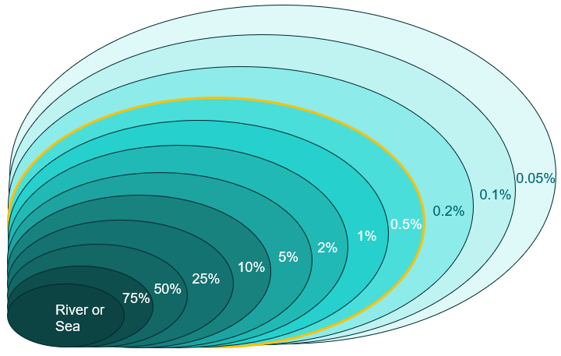As defined in the glossary of NPF4, for planning purposes, at risk of flooding or in a flood risk area means land or built form with an annual probability of being flooded of greater than 0.5% which must include an appropriate allowance for future climate change. This area is indicated on the SEPA flood maps but for most applications in or near flood risk areas, a site specific flood risk assessment is needed.

In the diagram on the right, if the darkest circle is the river or coast, the circles represent floods from that source of varying sizes that could happen. The labels give the probability of that size of flood happening in any given year, and the bigger the flood the less likely it is to happen.

The question of what probability of flooding new development in Scotland should be exposed to, is considered in national planning policy. It sets out what level of flood risk is big enough to be significant, and we therefore need to plan for it happening, and what level of flood risk is small enough, that it is an acceptable level to expose people to. In Scotland the policy decision since 2004 has been 0.5% annual probability, which is indicated by the yellow line on the diagram above. Larger floods still have a possibility of happening, but the probability is low enough that the risk is accepted, and planning policy does not require new development to be avoided in these areas.

The diagram also shows that not everything inside the yellow line has only a 0.5% annual probability of flooding – lots of the area is also exposed to smaller more frequent floods, but everything has *at least* a 0.5% probability.

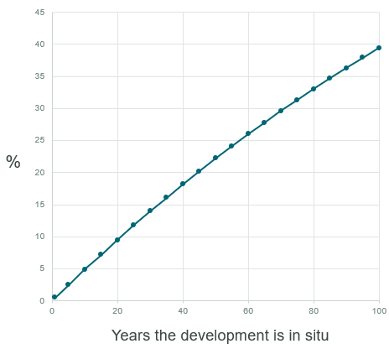When we quote the annual probability of larger floods, it can make them sound very unlikely to ever happen. Only a 0.5% annual probability sounds very low, but the key point is that this is the risk for each year. The annual likelihood accumulates over the time the development is in place. The graph on the right shows the probability of being flooded at least once over a lifespan, if your current probability of flooding is 0.5% per year and that stays exactly the same in future. By the time the development has been in place for 45 years it has reached 20% and by 100 years it is nearly 40% assuming a stationary climate. The table below is another way to display the same information.

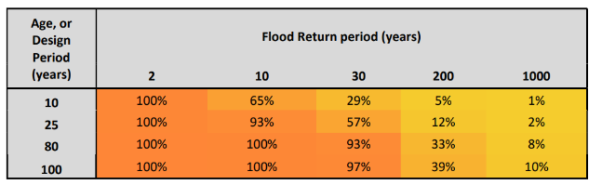

**Including an allowance for climate change**

Climate change is making all size of floods happen more often, the smaller ones and the larger ones. Climate change doesn’t just add an extra flood on to the end of the scale in the diagram, it increases the probability of all floods occurring. NPF4 refers to adding an appropriate allowance for **future** climate change, and we call our flood maps which have climate change included the **future** flood maps. This might create the sense that this is something that isn’t going to happen until a fixed point in future. However, it actually means that by the time we get to that future point, the risk of experiencing a larger flood may be the same as it is for a smaller flood now. That change is already happening and is ever increasing with each year. The projected changes are expected **by** the end of the century - it isn’t that they won’t happen until then. Climate change is now included in national planning policy to ensure that threshold of risk that we have decided marks the difference in Scotland between acceptable and unacceptable, remains the same in real terms rather than being eroded with the passage of time. This is important when considering long term land use planning decisions, where developments can be expected to exist for 50, 75 or even 100 years, depending on type.

**Other factors to be assessed for the flood risk area**

The quantity of water expected during flooding is the primary consideration in a flood risk assessment, but there are a number of factors that have a significant influence on where the water goes that also need to be assessed. Common (but not exhaustive) factors include waves at the coast, blockage of bridges or culverts, or where a feature like an embankment might fail. In any situation where a factor like this is **likely** to contribute to the risk at the site, it needs to be considered in the flood risk assessment.

The likelihood of these factors occurring during a flood is either independent of or likely to be increased by the size of the flood or the effects of climate change. For example, if a small culvert in an urban area regularly has a shopping trolley left in the channel nearby, the likelihood of that culvert being blocked to a degree during a flood is the same regardless of how big the flood or how much wetter the climate gets. In the case of an embankment failing, that is more likely to happen in a larger flood where it is overtopped for longer or by a greater height of water, thereby increasing the forces on the embankment that could cause it to breach. In places where there is a likelihood of these factors affecting flood risk, they cannot be considered as an either/or with other features of the flood, but instead must be an integral component of the assessment of risk and inform the flood risk area

**Dealing with uncertainty**

There is uncertainty in all aspects of flood risk assessment, including the water quantity, climate change and all other factors that are assessed. Industry standard modelling techniques are used, based on years of practice and research, but models are by definition a simplification of what happens on the ground in reality. In most cases, best efforts are made to quantify all the known features of flooding, and uncertainties will remain. The aim in a flood risk assessment is to bring the uncertainties within acceptable levels, and what is acceptable will depend on how close the development is to the flood risk area. The more ‘flood free’ space there is around the development, the more margin available for the uncertainties to be accounted for, and the less detailed the assessment generally needs to be.

Freeboard is a practical and long-established way to deal with uncertainty. It is usually built into the design of a development as a safety factor and is used for sources of uncertainty that cannot be measured or that we do not have information available on. These include modelling uncertainties, localised waves, turbulence and post-development settlement. We also use freeboard to handle the sensitivity of the assessment to things that we can assess, like the roughness of the channel or blockage of a bridge. The best estimate of what is likely for those things goes into the assessment, but it is not known exactly what will happen in practice, so the model is tested for a bit more and a bit less either side of the best estimate. The difference that makes to the water levels should be comfortably within the freeboard allowances.

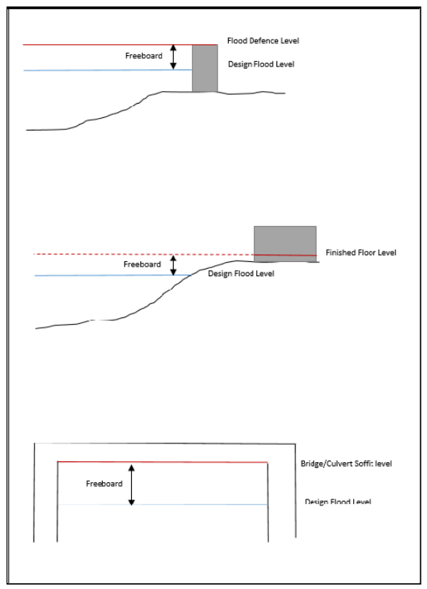

A freeboard allowance of 0.6m is standard, based on guidance from CIRIA[1]. In some cases, a larger freeboard is required where the model is particularly sensitive to some aspects of the assessment, or where there are known issues that exist that have not been quantified, such as waves at the coast but detailed wave modelling has not been done. This can also lead to a freeboard being added to the flood risk area (which needs to be avoided) rather than just to the development design e.g. the finished floor levels.

If you would like this document in an accessible format, such as large print, audio recording or braille, please contact SEPA by emailing [equalities@sepa.org.uk](mailto:equalities@sepa.org.uk)

1. CIRIA Guidance C624 Development and Flood Risk – Guidance for the Construction Industry 2004